Articles Contemporary Dance Theatre

2015-2016 Season Brigham Young University

Contact: Performing Arts Management
(801) 422-3576
perform@byu.edu

Article from Bangalore Mirror, in Bangalore, India (July 31, 2012)

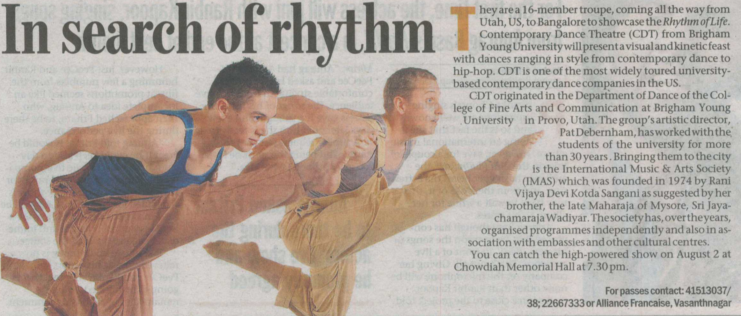

Article from Deccan Herald, in Bangalore, India (August 2, 2012)

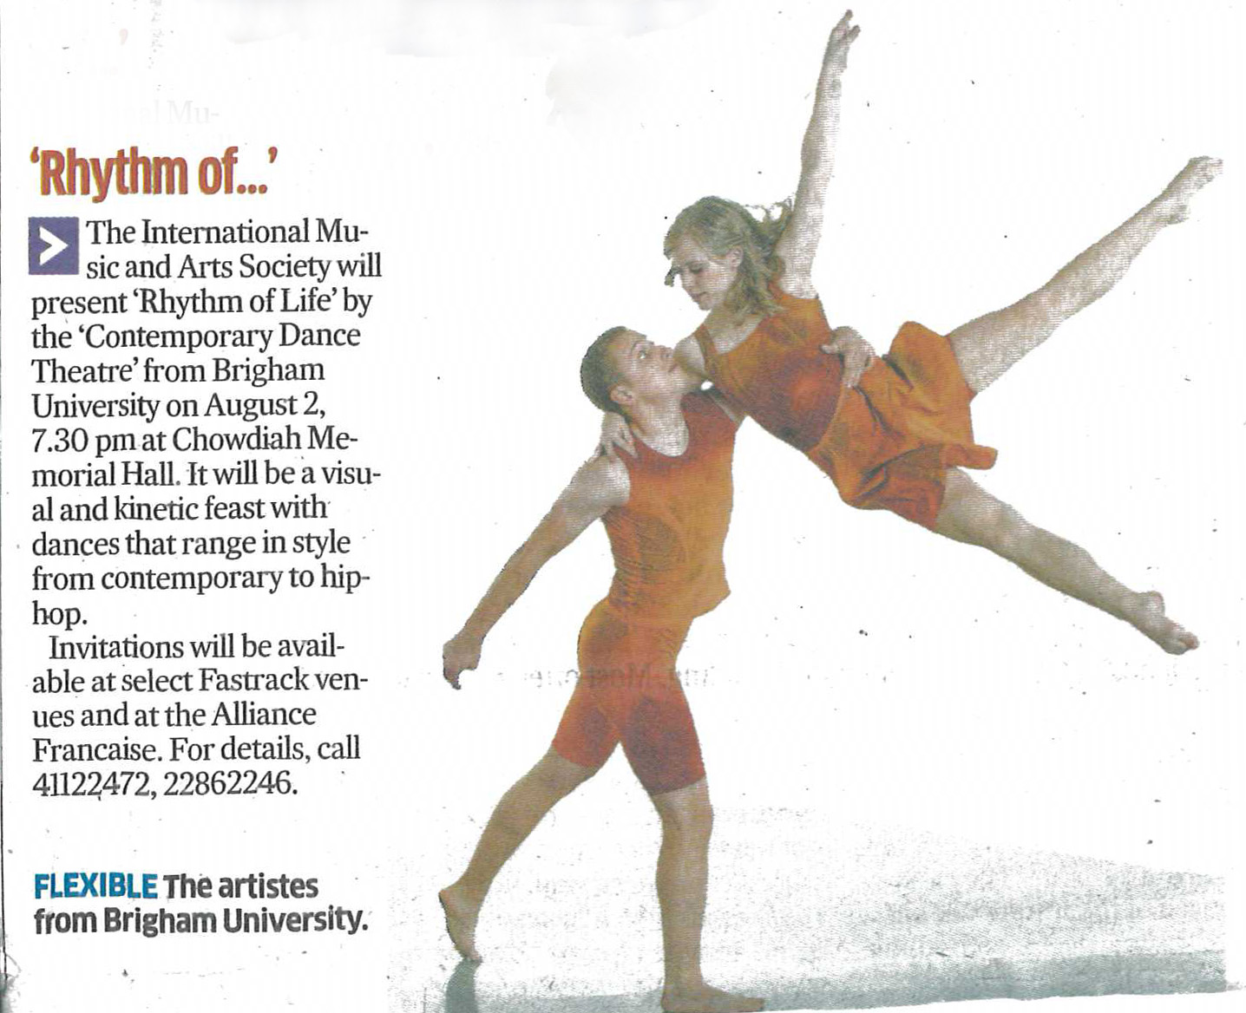

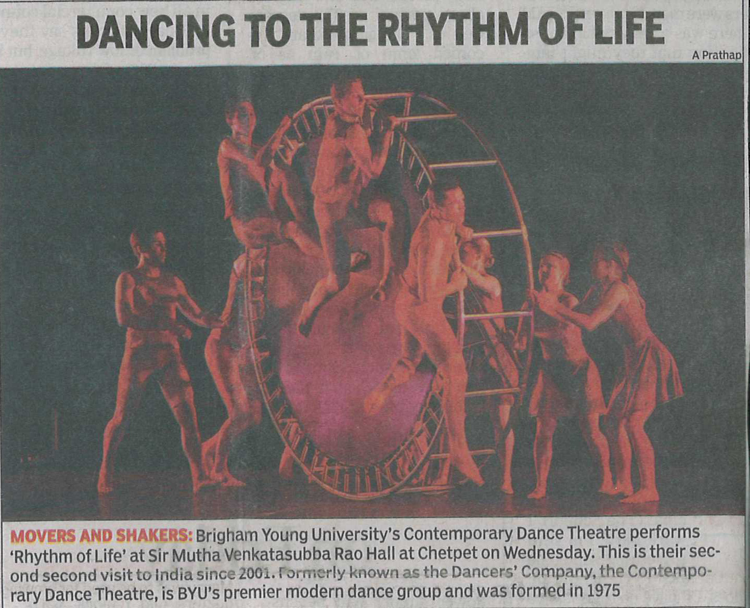
Article from The Times of India, in Chennai, India (August 9, 2012)

