News Release Ballroom Dance Company
2019-20 Season Performing Arts Management
801-422-3576 | pam.byu.edu

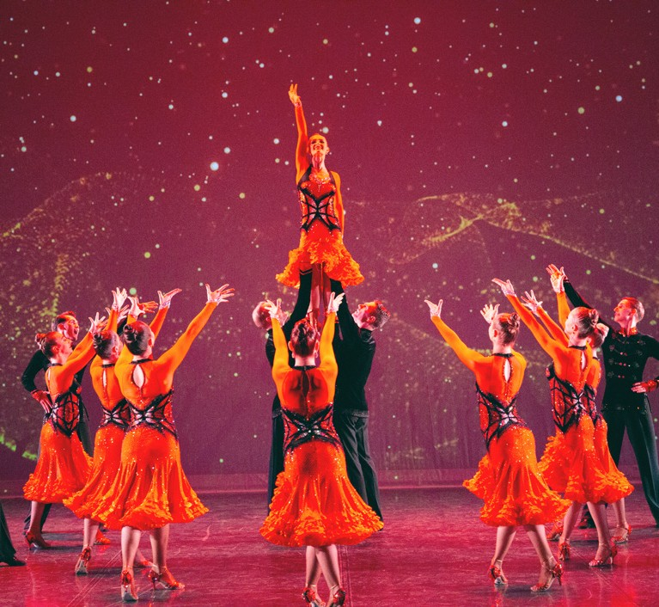
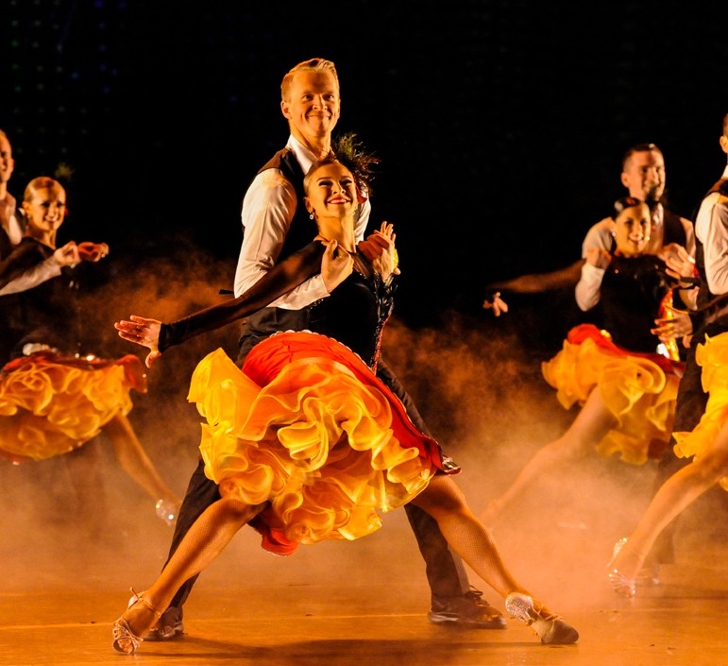

FOR IMMEDIATE RELEASE

(To get the text version of this file, visit pam.byu.edu/ballroom-dance-company)

BYU Ballroom Dance Company dazzles audiences

Brigham Young University’s Ballroom Dance Company (BDC) is one of the most distinctive and unique university dance companies in the world. Based in Provo, Utah, this company consists of 32 dancers, all of whom are full-time students at BYU. Their current show, Come Alive, delights spectators with compelling and creative choreography that seamlessly segues from romantic waltzes to rhythmical sambas and other unexpect- ed surprises. Colorful costumes and innovative, theatrical design give traditional ballroom dances a refreshing and relevant flare that engages the audiences of today. A hallmark of their show includes the performance of their award-winning and internationally acclaimed Ballroom and Latin competition medleys. The team will present their showcase Come Alive at (PLACE) on (DATE) at (TIME).

Awards and Acclaim

In 1972, the BYU Ballroom Dance Company burst onto the world’s stage competing at the famed British Championships in Blackpool, England. Crowned as the British Champions, they became the first American formation team to ever win this coveted title. Since then, competitive ballroom dance has become an integral part of the BYU program. The Ballroom Dance Company regularly returns to England to compete for the prestigious British crown and annually defends their U.S. championship title in the States. This focus on competition dance drives and inspires the students to reach for higher levels of artistry and technical prowess. Most recently, the BYU Ballroom Dance Company won the 2017 United States and 2019 British Latin Formation Championships with their stunning piece, Carmen.

Performance Tours

Since its inception in 1970, BYU’s Ballroom Dance Company has performed for millions of people in over 35 countries. Highlights include extensive travel throughout China, Europe and Russia and a command performance for the Royal Princess of Thailand. Recently, they returned from a rigorous performance tour throughout Chile and Argentina and have recently toured to California, Nevada, England, Scotland, and Wales. In the 2019-20 season, the group will tour cities in Montana, South Dakota, Wyoming, and internationally in Botswana and South Africa.

International and National Press

“They excel not just in formation maneuvers but in unison step-work that’s smooth as honey. Their partnering is seamless
for swings and lifts.”
George Jackson, Washington Post
“Bravo BYU Ballroom Dance Company! This show is a visual artistic masterpiece! Stunning costumes, moving music and exquisite choreography leave you feeling divinely inspired. At the conclusion of the performance I was compelled to leap to my feet!”
Bill Moir, Deputy Mayor of Durham, England
“It was a joy watching them from the audience. These American dancers are so professional and involved in their dancing. They bring such nuance to ballroom and also popular dance moves. As someone in the field, I find this most enjoyable and respectable.”
Chi Anh, Vietnam Dance Sport Champion, Vietnam
“As president of the St. Petersburg Humanities University, I have traveled around the world — to London, Tokyo, Paris — and have never seen a production of your high artistic standard and spirit. You are welcome again and again.”
Dr. Alex S. Zapesotski, Russia
“I just wanted to thank the BYU Ballroom Dance Company for coming to L’viv. It was truly an amazing event, and without question it was the finest show that has ever come to L’viv...The bar has truly been raised as far as entertain- ment is concerned.”
David Gleason, L’viv, Ukraine

Artistic Director

Professor Curt Holman directs and produces the Ballroom Dance Com-pany’s showcase, Come Alive. As a professional dancer, he and his wife, Sharon, were twice honored with an invitation to dance as soloists at the prestigious British Championships in Blackpool, England and the World Cabaret Championships in Holland. A seasoned artist, his choreographic expertise is now sought by top level professional and amateur ballroom dance couples who regularly present his choreography at prestigious ball-room dance competitions throughout the world. His distinctive style, artistic vision and intuitive approach results in a fast paced show that is both entertaining and artistically engaging. Holman holds a Master’s degree in dance is a dual licentiate with the ISTD and is the Chair of the Department of Dance at BYU.

Contributing Choreographers

In addition to his own choreography, Holman regularly collaborates with top ballroom dance experts in creating new works for the company. Guest choreographers include: World Latin Champions Eugene Katsevman and Maria Manusova, Andre and Natalie Paramonov, and World Class Ballroom Dancers Marat Gimaev and Alina Baysuk, to name a few. These collaborations result in choreography that is forward thinking, relevant and fresh.

Ballroom Dance at BYU

The ballroom dance program at BYU is the largest of its kind in the world. With over 60 different courses taught each semester, nearly 4000 students take some type of ballroom dance class each year. It is also the home to the largest Amateur Dancesport competition in the United States. The president of the National Dance Coun- cil of America, Brian McDonald, calls BYU’s Ballroom Dance Company “one of the Ballroom world’s greatest treasures”.

The Ballroom Dance Company resides in the Department of Dance of the College of Fine Arts and Commu- nications at Brigham Young University in Provo, Utah. BYU is one of the nation’s largest private universities with an enrollment of more than 30,000 full-time students from throughout the United States and 100 foreign countries.

Upcoming Performances

February 21, 2020 at 7:00 p.m.
Conference Center Theater
Salt Lake City, Utah

February 22, 2020 at 2:00 p.m.
Conference Center Theater
Salt Lake City, Utah

February 22, 2020 at 7:00 p.m.
Conference Center Theater
Salt Lake City, Utah

March 21, 2020 at 7:00 p.m.
Cox Auditorium- Dixie State University
St. George, Utah

Artist Manager Karson B. Denney 801-422-3575
karson_denney@byu.edu
Performing Arts Management
306 Hinckley Center Provo, UT
801-422-3576
perform@byu.edu
pam.byu.edu
Ballroom Dance Company originates in the Department of Dance
of the College of Fine Arts and Communications at Brigham Young University in Provo, Utah.

