
News Release Ballroom Dance Company
2024-2025 Season 801-422-3576 | pam.byu.edu
Performing Arts Management
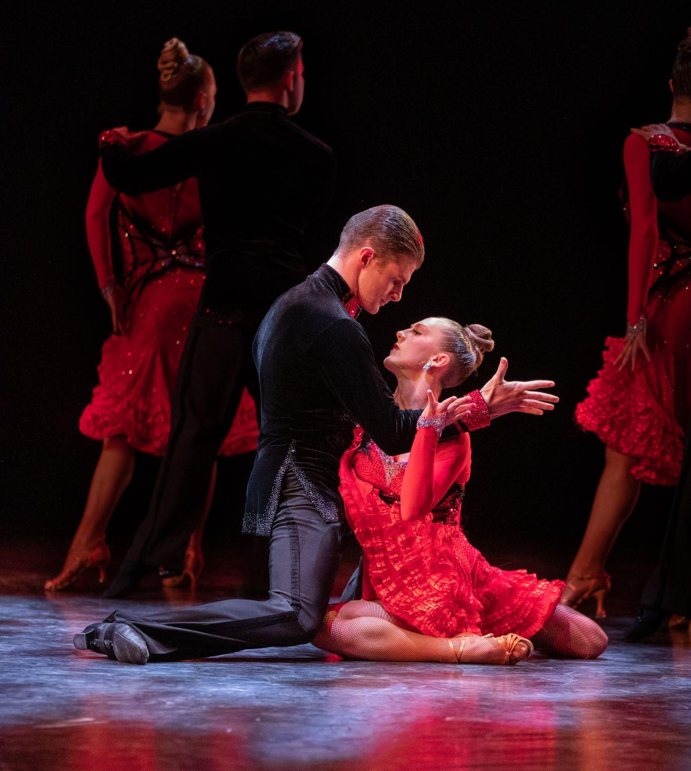

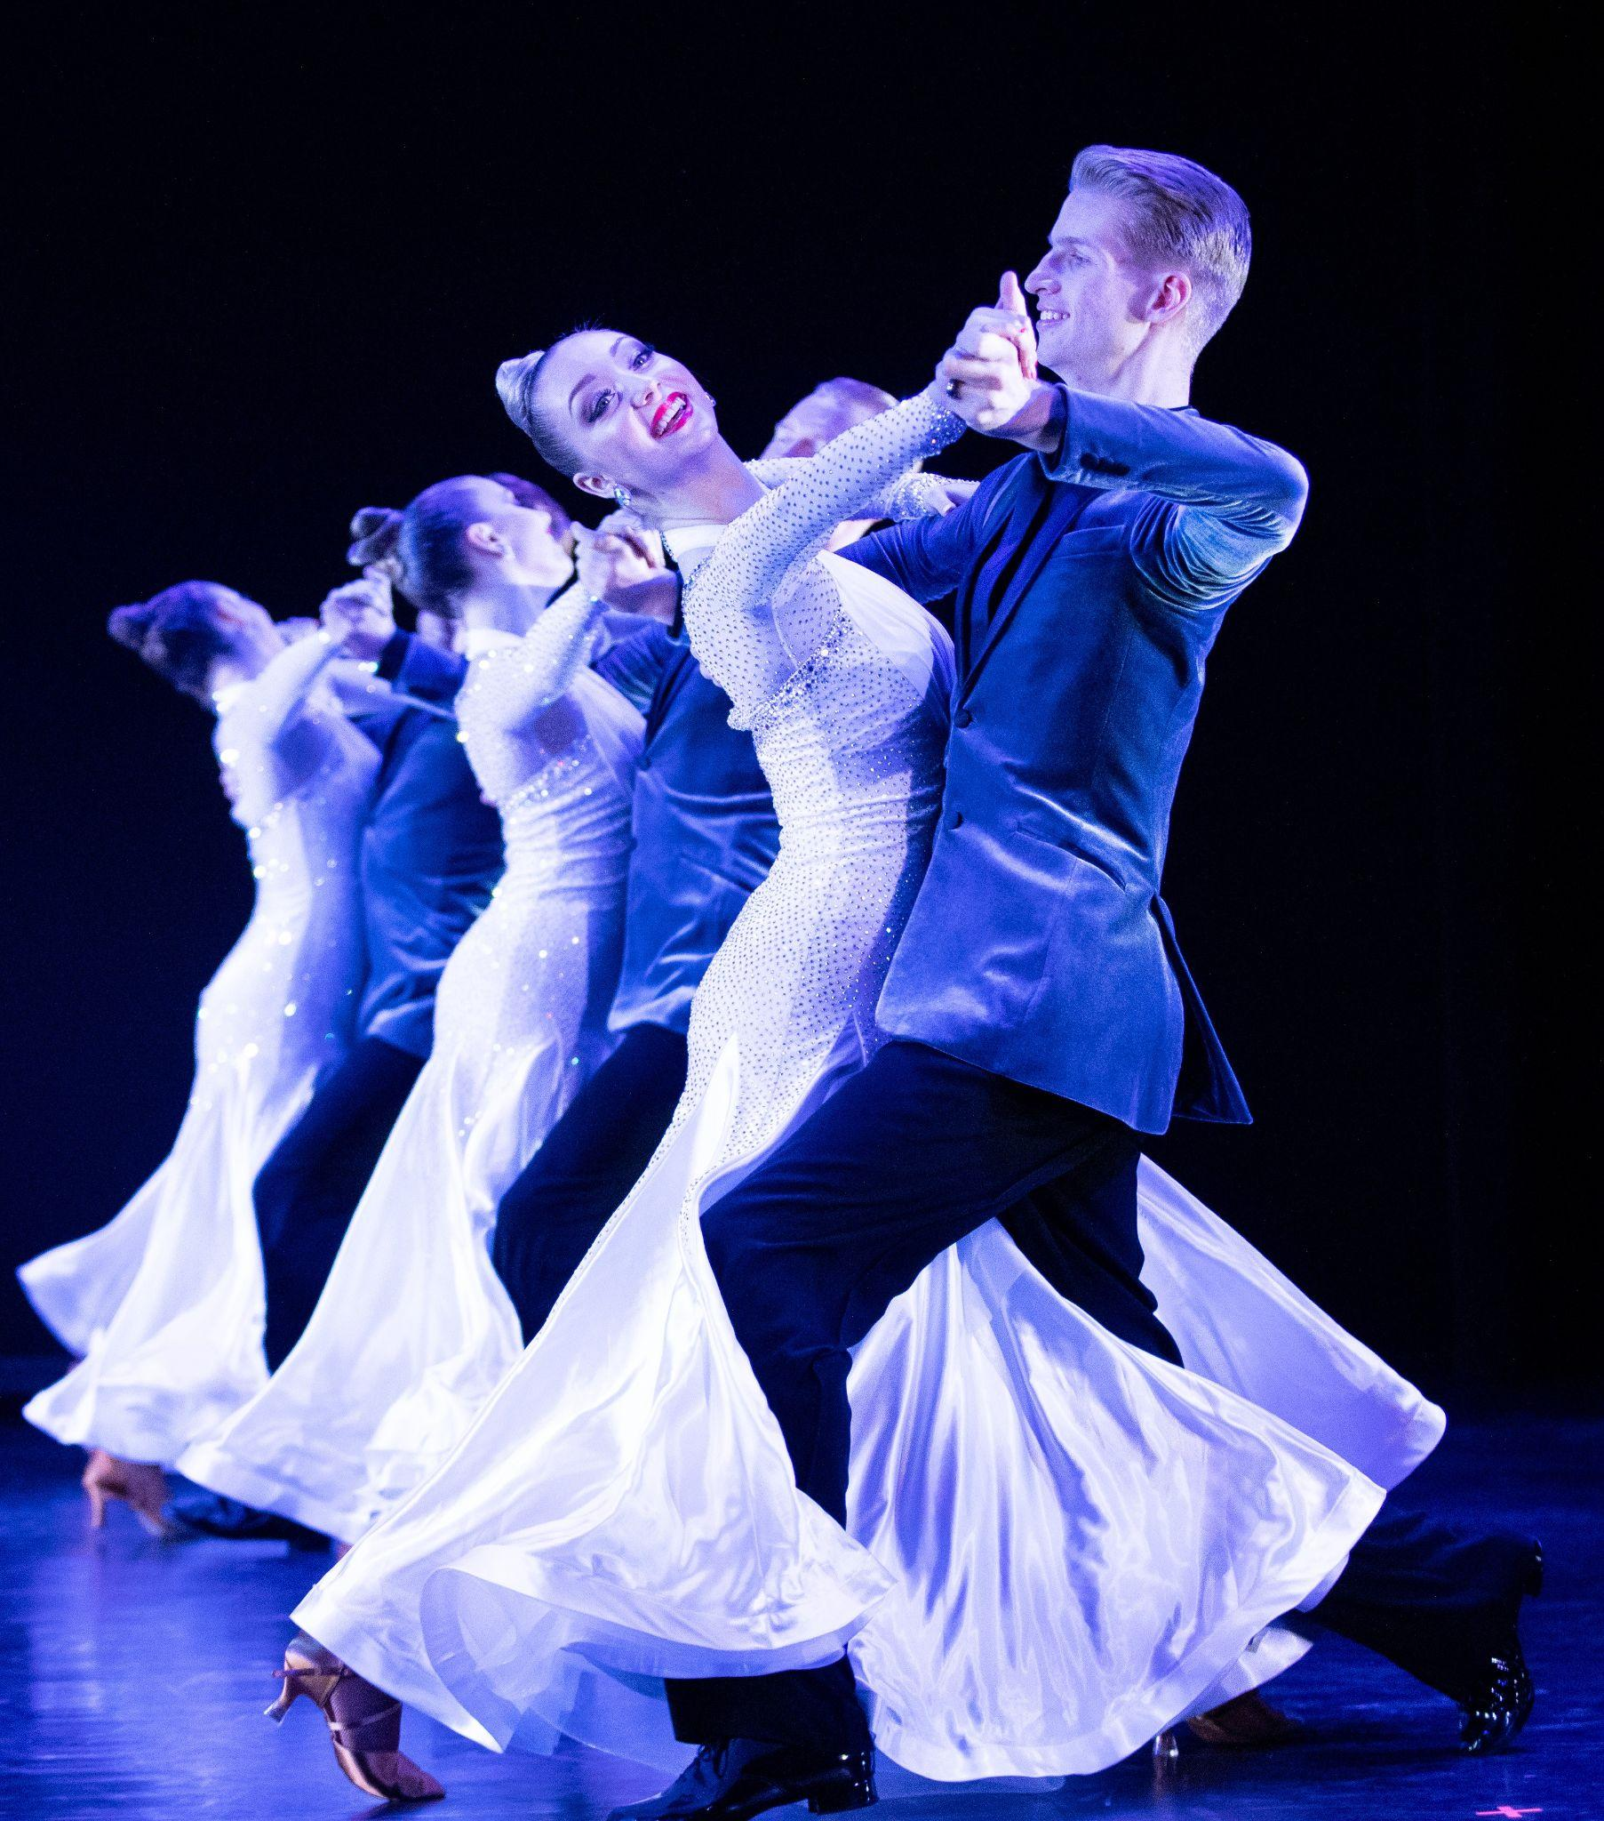
FOR IMMEDIATE RELEASE

To get the text version of this file, visit pam.byu.edu/ballroom-dance-company

BYU Ballroom Dance Company Dazzles Audiences

Brigham Young University’s Ballroom Dance Company (BDC) is one of the most distinctive and unique university dance companies in the world. Based in Provo, Utah, this company consists of 32 dancers, all of whom are full-time students at BYU. Their current show, Rhythm, delights spectators with compelling and creative choreography that seamlessly segues from romantic waltzes to rhythmical sambas and other unexpected surprises. Colorful costumes and innovative, theatrical design give traditional ballroom dances a refreshing, relevant and engaging flare. A hallmark of their show includes the performance of their award-winning and internationally acclaimed Ballroom and Latin competition medleys.
The team will present their showcase Rhythm across the United States and multiple countries across Eastern Asia for the 2024-2025 season.
Awards and Acclaim
In 1972, the BYU Ballroom Dance Company burst onto the world’s stage competing at the famed British Championships in Blackpool, England. Crowned as the British Champions, they became the first American formation team to ever win this coveted title. Since then, competitive ballroom dance has become an integral part of the BYU program. The Ballroom Dance Company regularly returns to England to compete for the prestigious British crown and annually defends their U.S. championship title in the States. This focus on competition dance drives and inspires the students to reach for higher levels of artistry and technical prowess. Most recently, in August 2024, the BYU Ballroom Dance Company defended their title as the U.S. National Amateur Latin and Ballroom Formation Champions with their stunning pieces, Somebody to Love and Fiddler on the Roof.

Performance Tours
Since its inception in 1970, BYU’s Ballroom Dance Company has performed for millions of people in over 35 countries. Highlights include extensive travel throughout China, Europe and Russia and a command performance for the Royal Princess of Thailand. Recently, they have toured across Washington, Idaho, South Africa, Botswana, Mozambique, and Zimbabwe. In the 2024-2025 season, the group will tour cities throughout Utah, Nevada, and Northern California before touring internationally in Cambodia, Thailand, and Vietnam.

International and National Press
“They excel not just in formation maneuvers but in unison step-work that’s smooth as honey. Their partnering is seamless for swings and lifts.”
George Jackson, Washington Post
“Bravo BYU Ballroom Dance Company! This show is a visual artistic masterpiece! Stunning costumes, moving music and exquisite choreography leave you feeling divinely inspired. At the conclusion of the performance, I was compelled to leap to my feet!”
Bill Moir, Deputy Mayor of Durham, England
“It was a joy watching them from the audience. These American dancers are so professional and involved in their dancing. They bring such nuance to ballroom and also popular dance moves. As someone in the field, I find this most enjoyable and respectable.”
Chi Anh, Vietnam Dance Sport Champion, Vietnam
“As president of the St. Petersburg Humanities University, I have traveled around the world — to London, Tokyo, Paris — and have never seen a production of your high artistic standard and spirit. You are welcome again and again.”
Dr. Alex S. Zapesotski, Russia
“I just wanted to thank the BYU Ballroom Dance Company for coming to L’viv. It was truly an amazing event, and without question it was the finest show that has ever come to L’viv...The bar has truly been raised as far as entertainment is concerned.”
David Gleason, L’viv, Ukraine

Artistic Director

Professor Curt Holman directs and produces the Ballroom Dance Company’s showcase, Rhythm. As a professional dancer, he and his wife, Sharon, were twice honored with an invitation to dance as soloists at the prestigious British Championships in Blackpool, England, and the World Cabaret Championships in Holland. A seasoned artist, his choreographic expertise is now sought by top level professional and amateur ballroom dance couples who regularly present his choreography at prestigious ball- room dance competitions throughout the world. His distinctive style, artistic vision and intuitive approach results in a fast-paced show that is both entertaining and artistically engaging. Holman holds a master’s degree in dance and is a dual licentiate with the ISTD.

Contributing Choreographers

In addition to his own choreography, Holman regularly collaborates with top ballroom dance experts in creating new works for the company. Guest choreographers include: World Latin Champions Eugene Katsevman and Maria Manusova, Andre and Natalie Paramonov, and World Class Ballroom Dancers Marat Gimaev and Alina Baysuk, to name a few. These collaborations result in choreography that is forward thinking, relevant and fresh.

Ballroom Dance at BYU

The ballroom dance program at BYU is the largest of its kind in the world. With over 60 different courses taught each semester, nearly 4000 students take some type of ballroom dance class each year. It is also the home to the largest Amateur Dancesport competition in the United States. The president of the National Dance Council of America, Brian McDonald, calls BYU’s Ballroom Dance Company “one of the Ballroom world’s greatest treasures”.

The Ballroom Dance Company resides in the Department of Dance of the College of Fine Arts and Communications at Brigham Young University in Provo, Utah. BYU is one of the nation’s largest private universities with an enrollment of more than 30,000 full-time students from throughout the United States and 100 foreign countries.

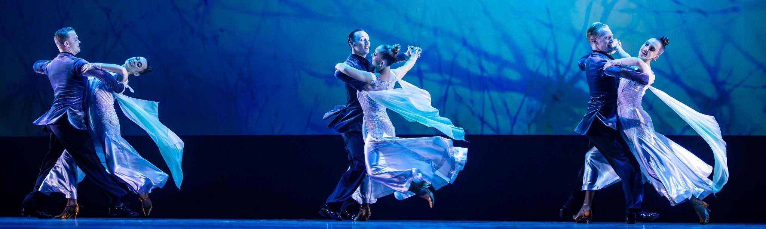
Upcoming Performances

October 17-19, 2024 at 7:30pm
BYU Richards Building
Provo, UT

February 25, 2025 at 7:00pm
Reno, NV

February 26, 2025 at 7:00pm
Pleasant Valley High School
Paradise, CA

February 27, 2025 at 7:00pm
The Gallo Center
Modesto, CA

February 28, 2025 at 7:00pm
Harris Center at Fulsom Lake College
Sacramento, CA

March 1, 2025 at 7:00pm
Temple Hill
Oakland, CA

April 29-May 16, 2025
Cambodia, Thailand, Vietnam

Artist Manager Performing Arts Management Ballroom Dance Company
Karson Denney 306 Hinckley Center originates in the Department of
801-422-3575 Provo, UT Dance in the College of Fine Arts karson_denney@byu.edu 801-422-3576 and Communication at Brigham
perform@byu.edu Young University in Provo, Utah.
pam.byu.edu

