News Release Chamber Orchestra

2019-20 Season Performing Arts Management 801-422-3576 | pam.byu.edu
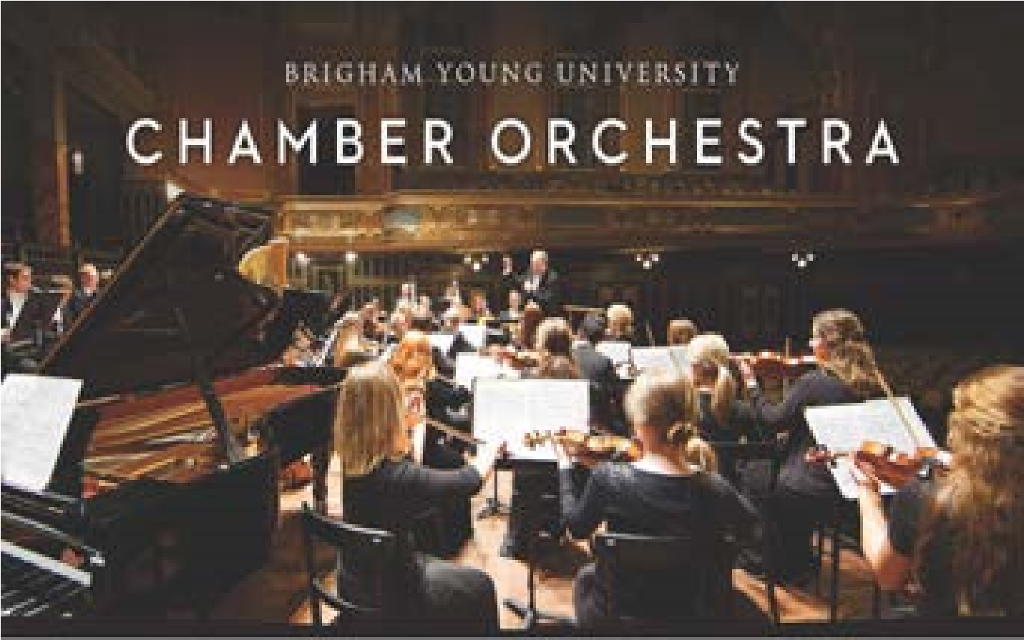
FOR IMMEDIATE RELEASE
(To get the text version of this file, visit pam.byu.edu/chamber-orchestra)

From Baroque to the 21st Century, BYU Chamber Orchestra plays it all
The Chamber Orchestra’s first note can whisper, shock, surprise, and even thrill you. No matter which emotion is elicited, one thing to be sure of is that the performance will be breathtaking. With 49 of the most advanced student musicians the school has to offer, the Brigham Young University Chamber Orchestra is, in one word, inspiring. This widely-acclaimed ensemble, known for its energetic, impressive, and exciting performances, will present a concert at (place) on (date) at (time).
Conducted by Professor Kory Katseanes, the Chamber Orchestra programs feature the great classical repertoire written for small orchestra from all musical periods--Baroque to 21st Century. The vast variety of music the orchestra performs is a showcase for the refinement and energy especially suited to this compact ensemble.

BYU Chamber Orchestra
Comprised of 49 musicians, the Chamber Orchestra is one of the most traveled university orchestras in the world. It includes string, woodwind, brass, and percussion players. Most of the students are pursuing professional degrees in music performance or education.
The Chamber Orchestra follows a demanding performance schedule that includes the preparation of their campus concerts, in addition to regional and international tours. For tours, the Chamber Orchestra also prepares material specifically designed to accompany well-known artists.
In 2017, the orchestra performed twice with Broadway star Lea Salonga; once in at BYU and then the Chamber Orchestra joined Salonga in her hometown in Manila, Philippines during their tour. The orchestra performed in Quezon City, Manila, Bohol, and Cebu while there and also shared a stage with The Voice Philippines star Tim Pavino.
In 2019 the Chamber Orchestra performed as a part of BYU’s Spectacular in China. While there, they traveled to Beijing, Shanghai, and Xi’an to celebrate 40 years of friendship with China. In 2020, they will travel to the European countries of Belgium, Czech Republic, Austria, and Italy. Their performance will include epics from the classical music world. While the Chamber Orchestra enjoys learning from classical composers, they are no strangers to some of the best modern composers. Their concerts please all tastes—from young to old and from classics to modern.
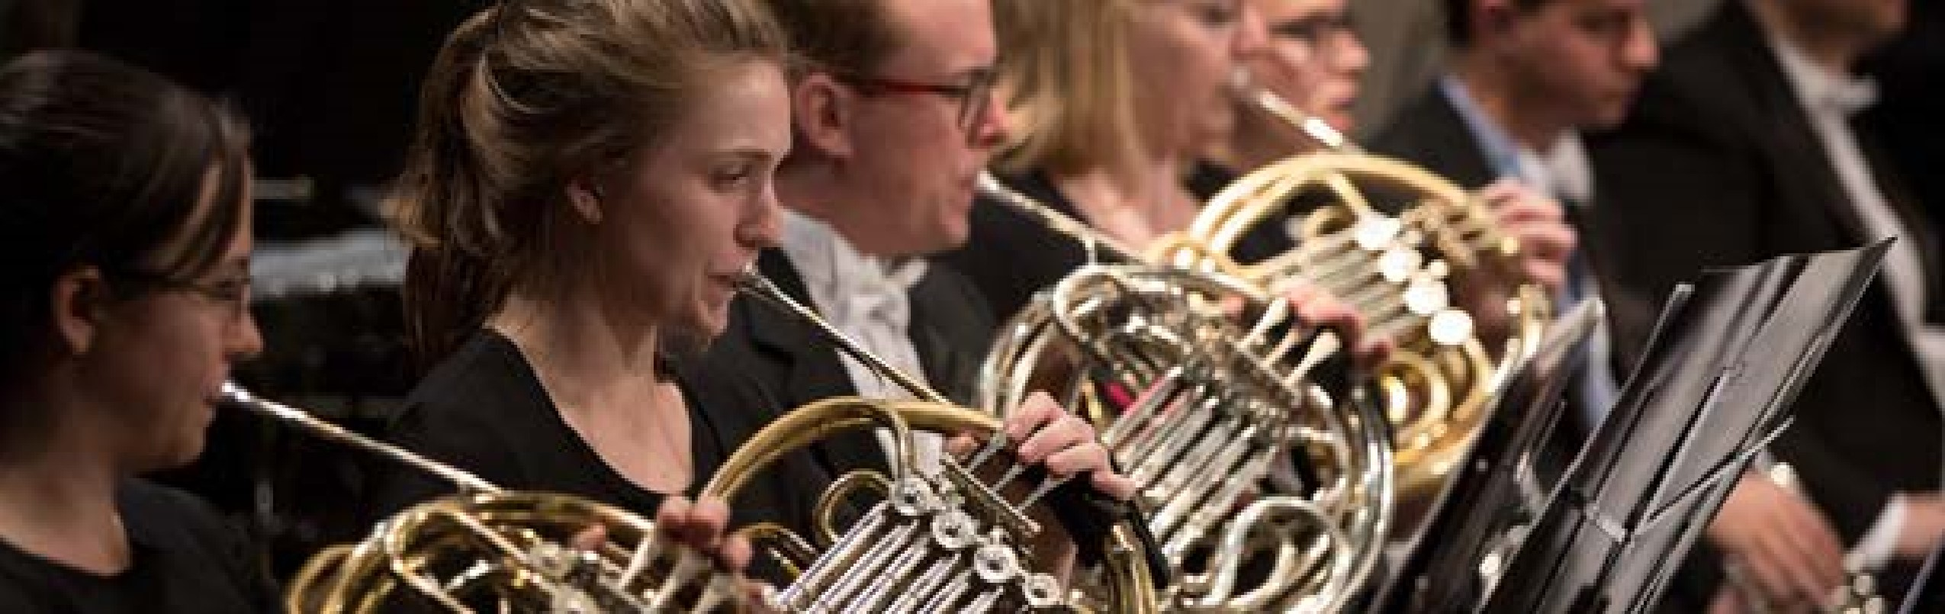
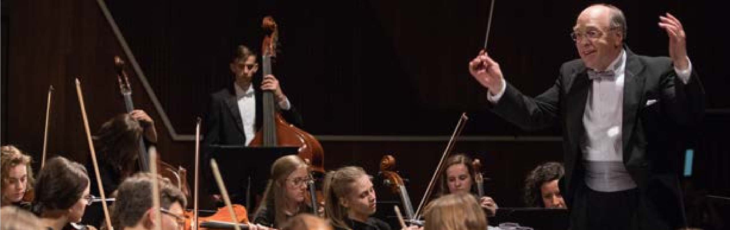
BYU Chamber Orchestra originates in the School of Music in the College of Fine Arts and Communications at Brigham Young University in Provo, Utah. BYU is one of the nation’s largest private universities with an enrollment of more than 30,000 students from throughout the United States and over 100 foreign countries.

Artistic Director
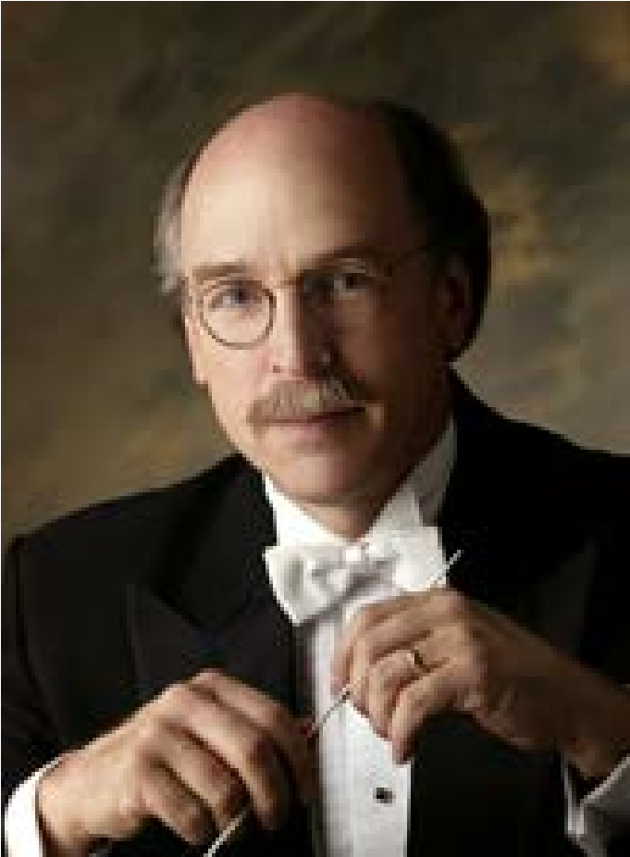
From the moment Kory Katseanes drops the tip of his baton, audiences know that the next 90 minutes will be sensational. Director of both Chamber Orchestra and Philharmonic Orchestra, Katseanes oversees many students whose talents rest in musicianship.
In addition to conducting studies with renowned conductor Joseph Rosenstock, Katseanes has degrees in violin performance from the University of Utah and was a member of the Utah Symphony for 26 years, serving 17 of those as assistant conductor.
While conducting the Utah Symphony, he collaborated with artists including The King’s Singers, Kathy Mattea, Nanci Griffiths, Judy Collins, Art
Garfunkel, among others. His work with dance companies includes Rudolph Nureyev and Friends, Repertory Dance Theatre, and the Twin Cities Ballet.
He was the founder and music director of The Utah Virtuosi, a professional chamber orchestra in Salt Lake City, where many acclaimed performances included guest artists: Joann Ottley, Reid Nibley, Andres Cardenes, and the Jenson-Woodbury Duo. Katseanes also serving as a guest conductor, performed choral and orchestral concerts with the community and student orchestras in Utah, Illinois, and Florida.
Katseanes is also a founding member of College Orchestra Directors Association (CODA) and works as a frequent guest conductor and clinician.

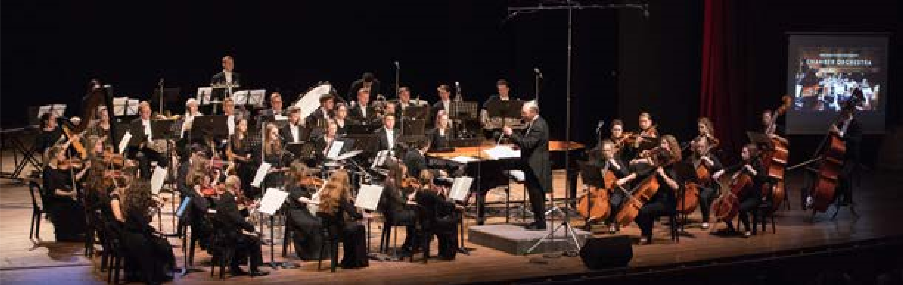
Upcoming Performances
January 26, 2018 at 7:00pm
Conference Center
Salt Lake City, Utah
February 23, 2018 at 7:00pm
Davis Middle School
Evanston, Wyoming
Artist Manager  Justin T. Smith  801-422-3573 justin_smith@byu.edu | Performing Arts Management  306 Hinckley Center  Provo, UT  801-422-3576 perform@byu.edu pam.byu.edu | Chamber Orchestra  originates in the School of Music in the  College of Fine Arts and  Communications at Brigham Young University in Provo, Utah.

