News Release International Folk Dance Ensemble
2023-2024 Season 801-422-3576 | pam.byu.edu
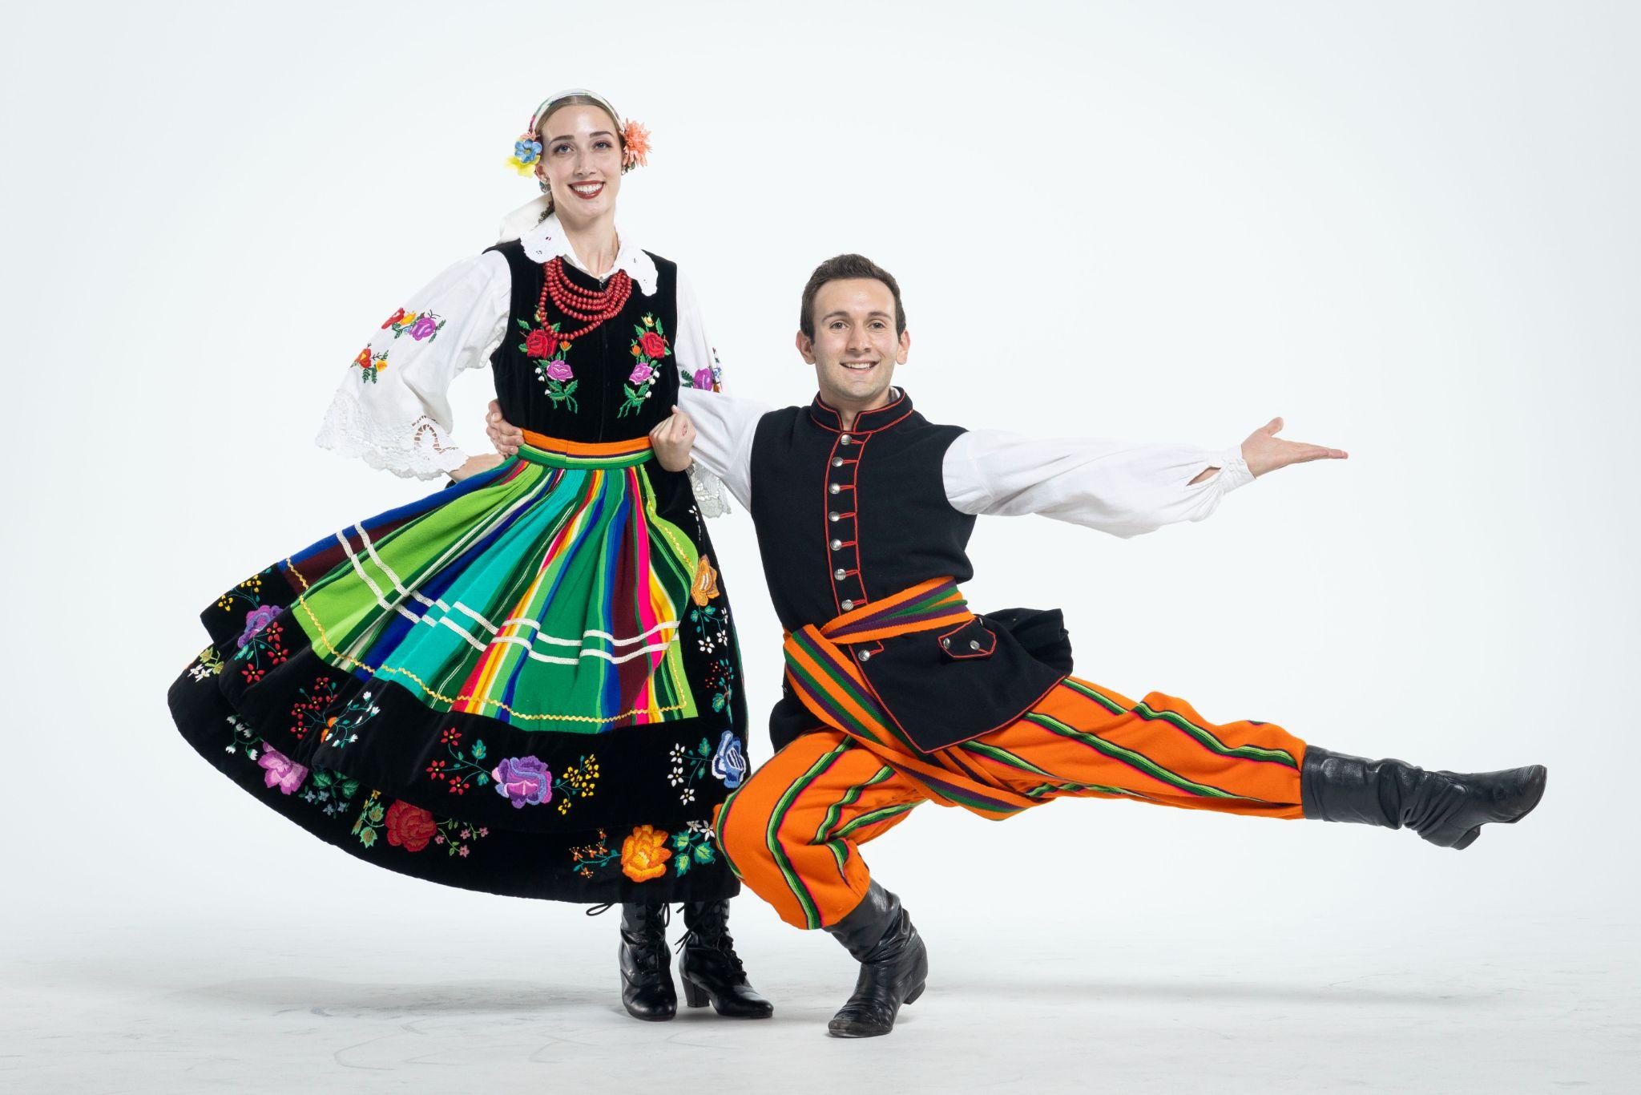
Performing Arts Management

FOR IMMEDIATE RELEASE

(To get the text version of this file, visit pam.byu.edu/international-folk-dance-ensemble)

International Folk Dance Ensemble Travels the World
Combining ethnic traditions with exquisite costuming, Brigham Young University’s International Folk Dance Ensemble (IFDE) showcases the dance styles of the world and features the traditions of the United States at international folklore festivals. The Ensemble offers one of the broadest spectrums of folk dance performed by a single group of its kind. Its extensive repertoire includes music and dance from all over the world including Europe, the Caribbean, and Asia. Members of IFDE are chosen by audition from among the most skilled performers involving more than 200 students.
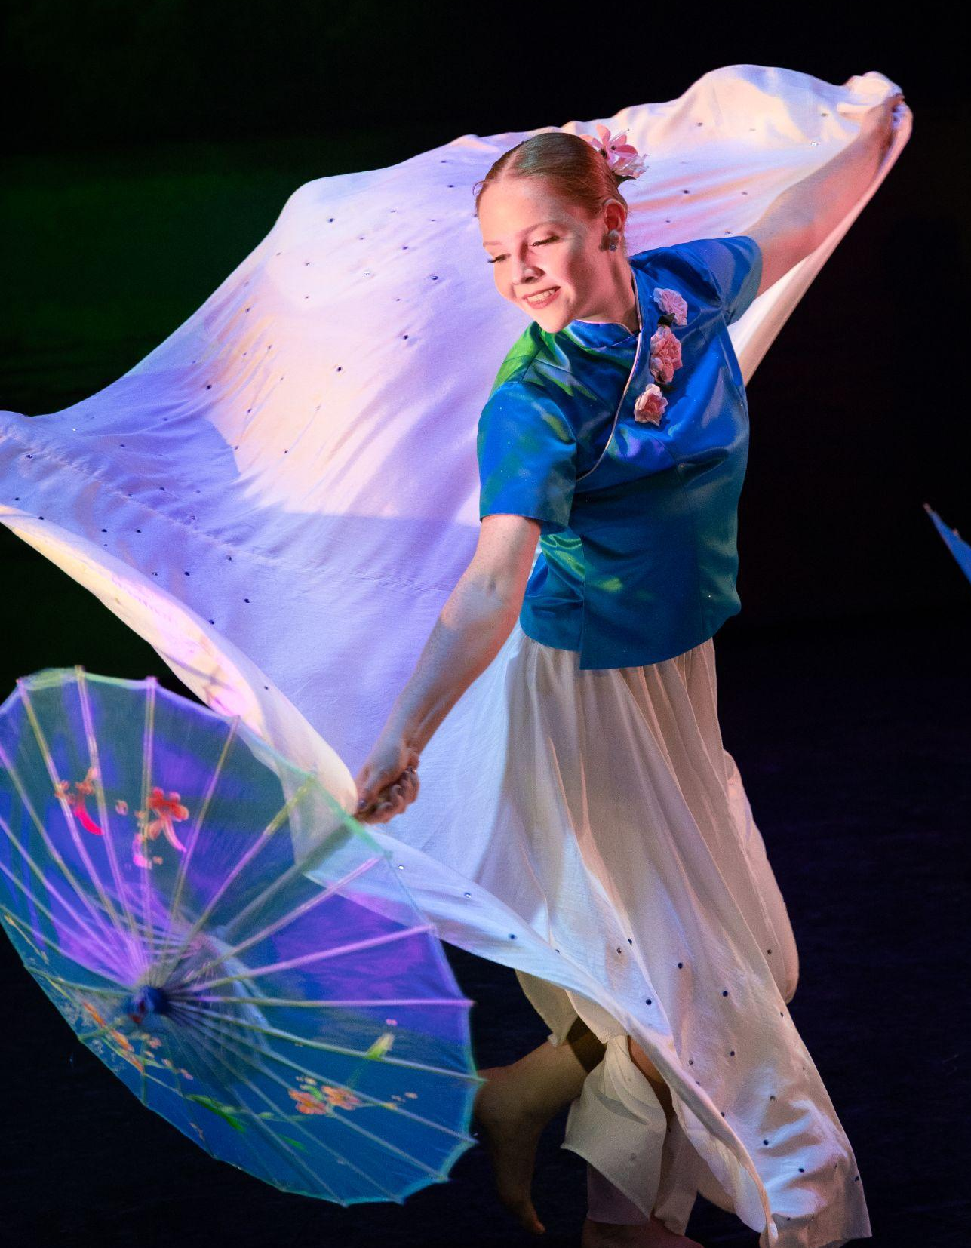
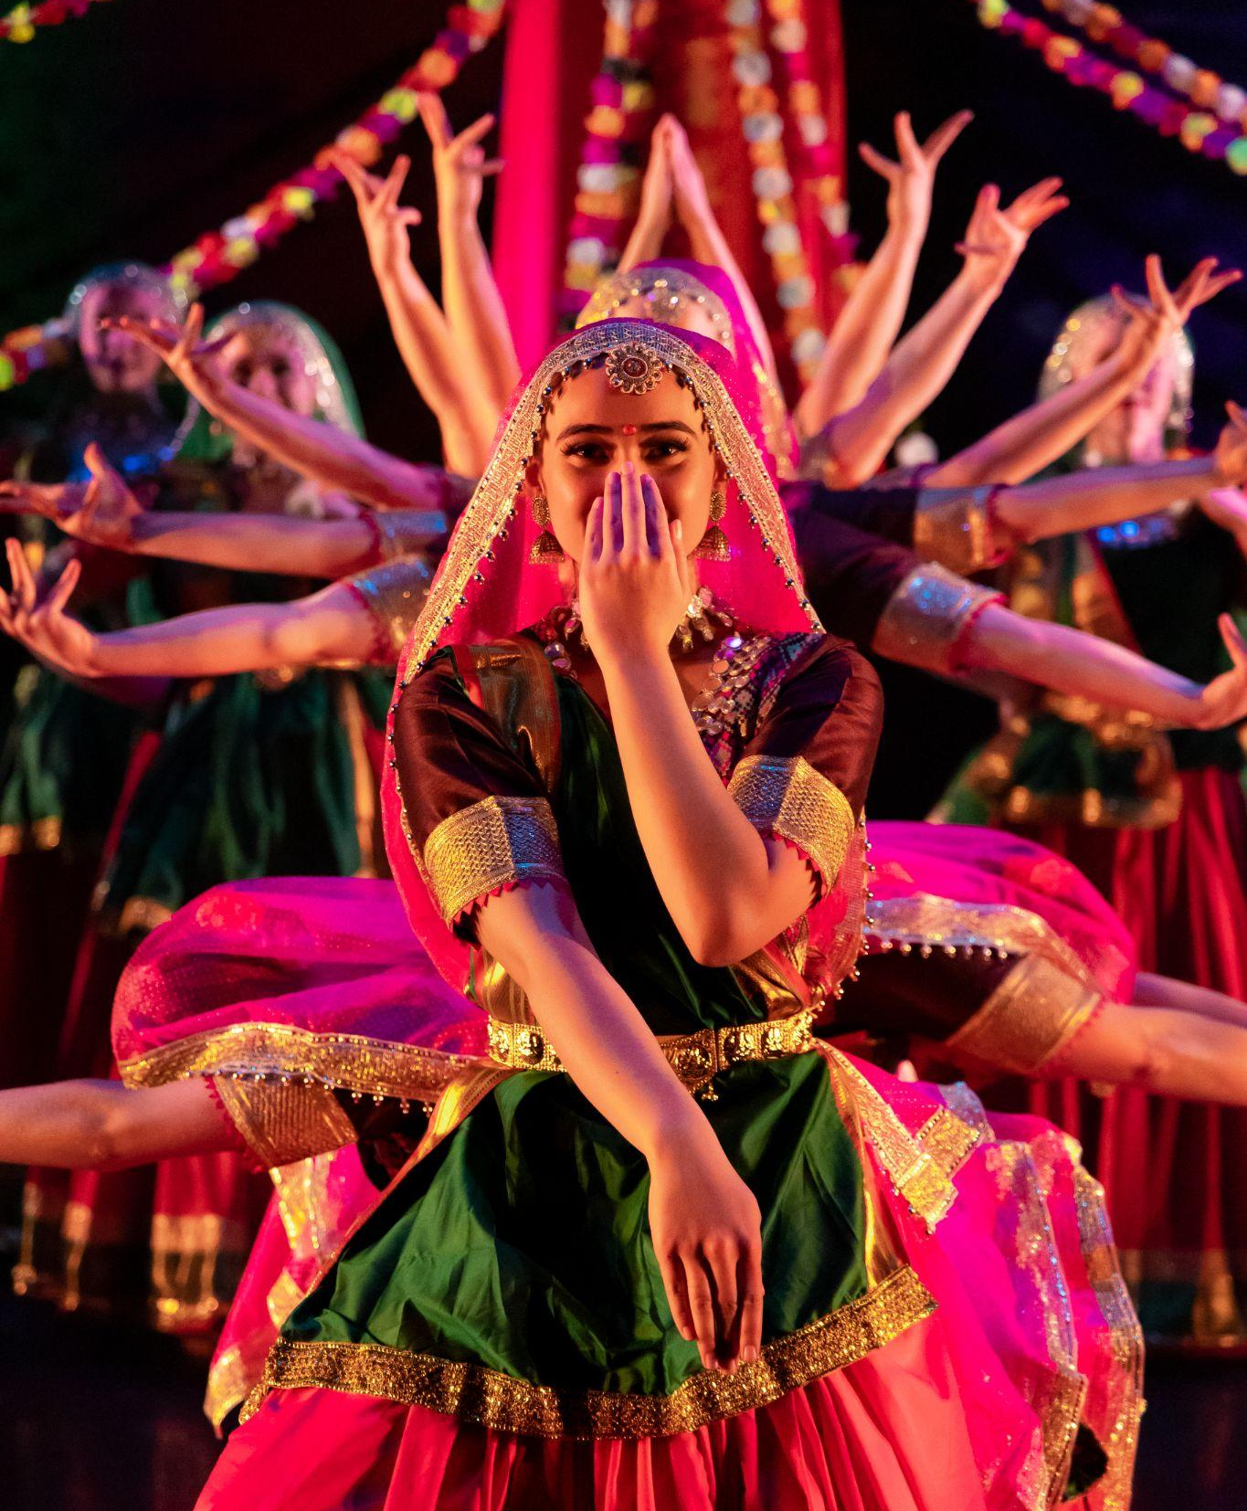
International Folk Dance Ensemble
The International Folk Dance Ensemble has achieved a global reputation for professionalism throughout the United States and in more than 40 countries worldwide. As an emissary of the United States and American traditions, the group has become internationally famous at the most prestigious folk dance festivals abroad and had the opportunity to perform with many of the world's finest dance companies. The Ensemble was founded in 1956 and continues to perform on international stages. In 2023, the group participated in the international CIOFF folk festivals in Czechia and the Danube Carnival Festival in Hungary. In 2022, they performed at Hello!Schoten Folk Festival and festivals throughout Belgium, Cacak, Serbia, and Bitola, Macedonia. Additionally, they enjoyed a cultural exchange with Folklorni Ansambl "Vila" in Novi Sad, Serbia. Other prestigious festivals have invited the group back at least five times, including International Folklore Festival in Haifa, Israel; the Festival de Confolens in Confolens, France; and the Billingham International Folklore Festival in Stockton-on-Tees, England.
The ensemble is made up of 28 dancers, 7 musicians, and 4 technicians. Combined, they form one of the most unique groups of performing arts in the United States. Directed by Mark Geslison, IFDE's folk music ensemble Mountain Strings provides the magic of live music for the group. Its traditional approach to music includes the banjo, the fiddle, and other acoustic instruments Specializing in American, French-Canadian, and Celtic styles of music, the distinct sounds of spoons, bones, and bodhrans add percussive variety. The performers, all students at Brigham Young University, come from throughout the United States.
Careful attention is given to every detail of cultural representation in choreography. A spectacular variety of beautiful costumes recreate regional dress from throughout the country.

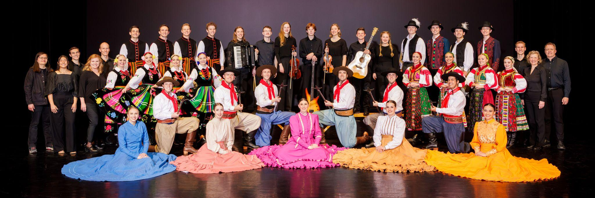
Artistic Director

Working behind the scenes of the International Folk Dance Ensemble’s dazzling showcase of music and dance from around the world is artistic director Jeanette Geslison. Geslison is from Odense, Denmark where she was trained in classical ballet, jazz, and theatre. She attended Brigham Young University and performed with International Folk Dance Ensemble, from 1987-1991, and again from 1993-94.
Geslison has strong ties with the group; she has coordinated and directed program ensemble classes, has been a rehearsal specialist with IFDE since 1995, and has directed the group since 2011. Geslison received a Masters in Fine Arts from the University of Wisconsin Milwaukee, where she specialized in Hungarian dance. Her diverse background and wide array of experience has helped her to expand the International Folk Dance Ensemble's repertoire and reach new horizons. Geslison currently serves as a committee chair for membership services in CIOFF-USA, an organization dedicated to safeguarding traditional and cultural folk arts as well as sponsoring international folk festivals.

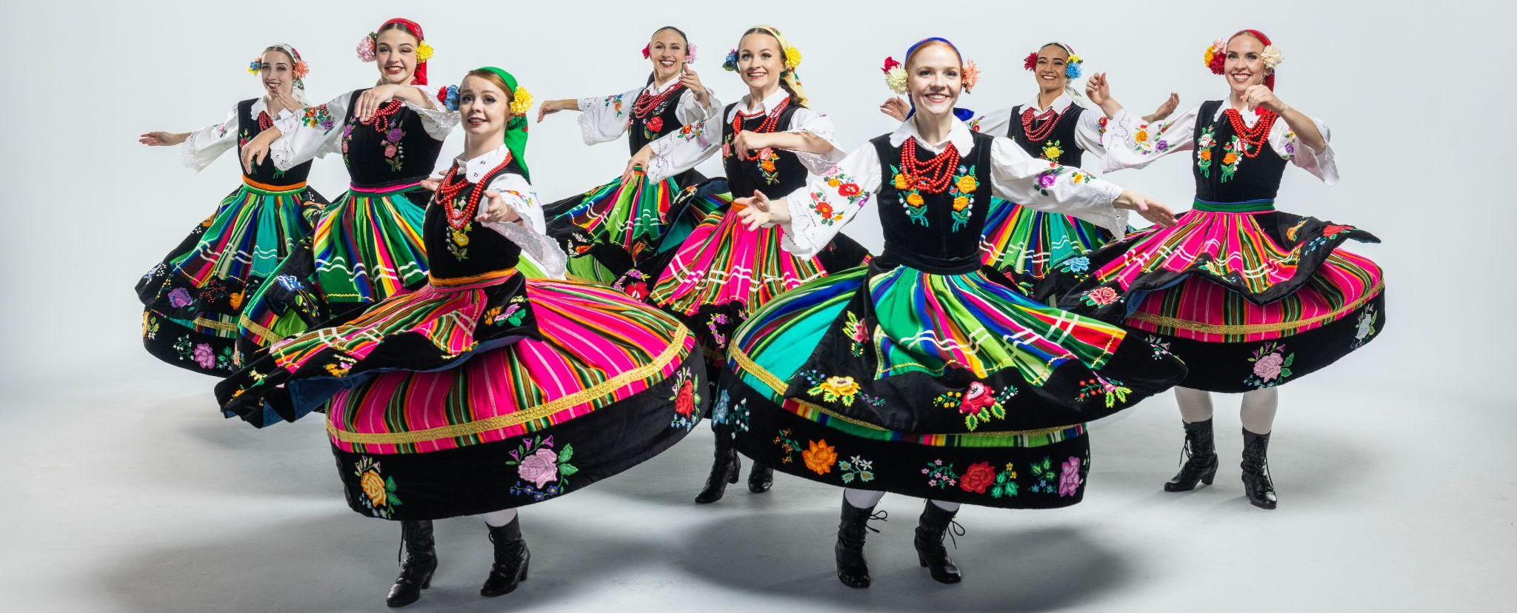
Upcoming Performances

April 28-May 5, 2024
Vallarta Azteca International Folk Dance Festival
Puerto Vallarta, Mexico

May 8, 2024 at 7:00pm
Carolina Theatre
Greensboro, North Carolina

May 10, 2024 at 7:00pm
Battery Creek High School
Beaufort, South Carolina

May 13, 2024 at 7:00pm
Nolensville High School
Nolensville, Tennessee

May 14, 2024 at 7:00pm
Thompson High School
Alabaster, Alabama

May 16, 2024 at 7:00pm
Lawton Chiles High School
Tallahassee, Florida

Artist Manager Performing Arts Management International Folk Dance Ensemble
Stacey Christensen 306 Hinckley Center originates in the School of Dance
801-422-3574 Provo, UT in the College of Fine Arts stacey_christensen@byu.edu 801-422-3576 and Communication at Brigham
perform@byu.edu Young University in Provo, Utah.
pam.byu.edu

