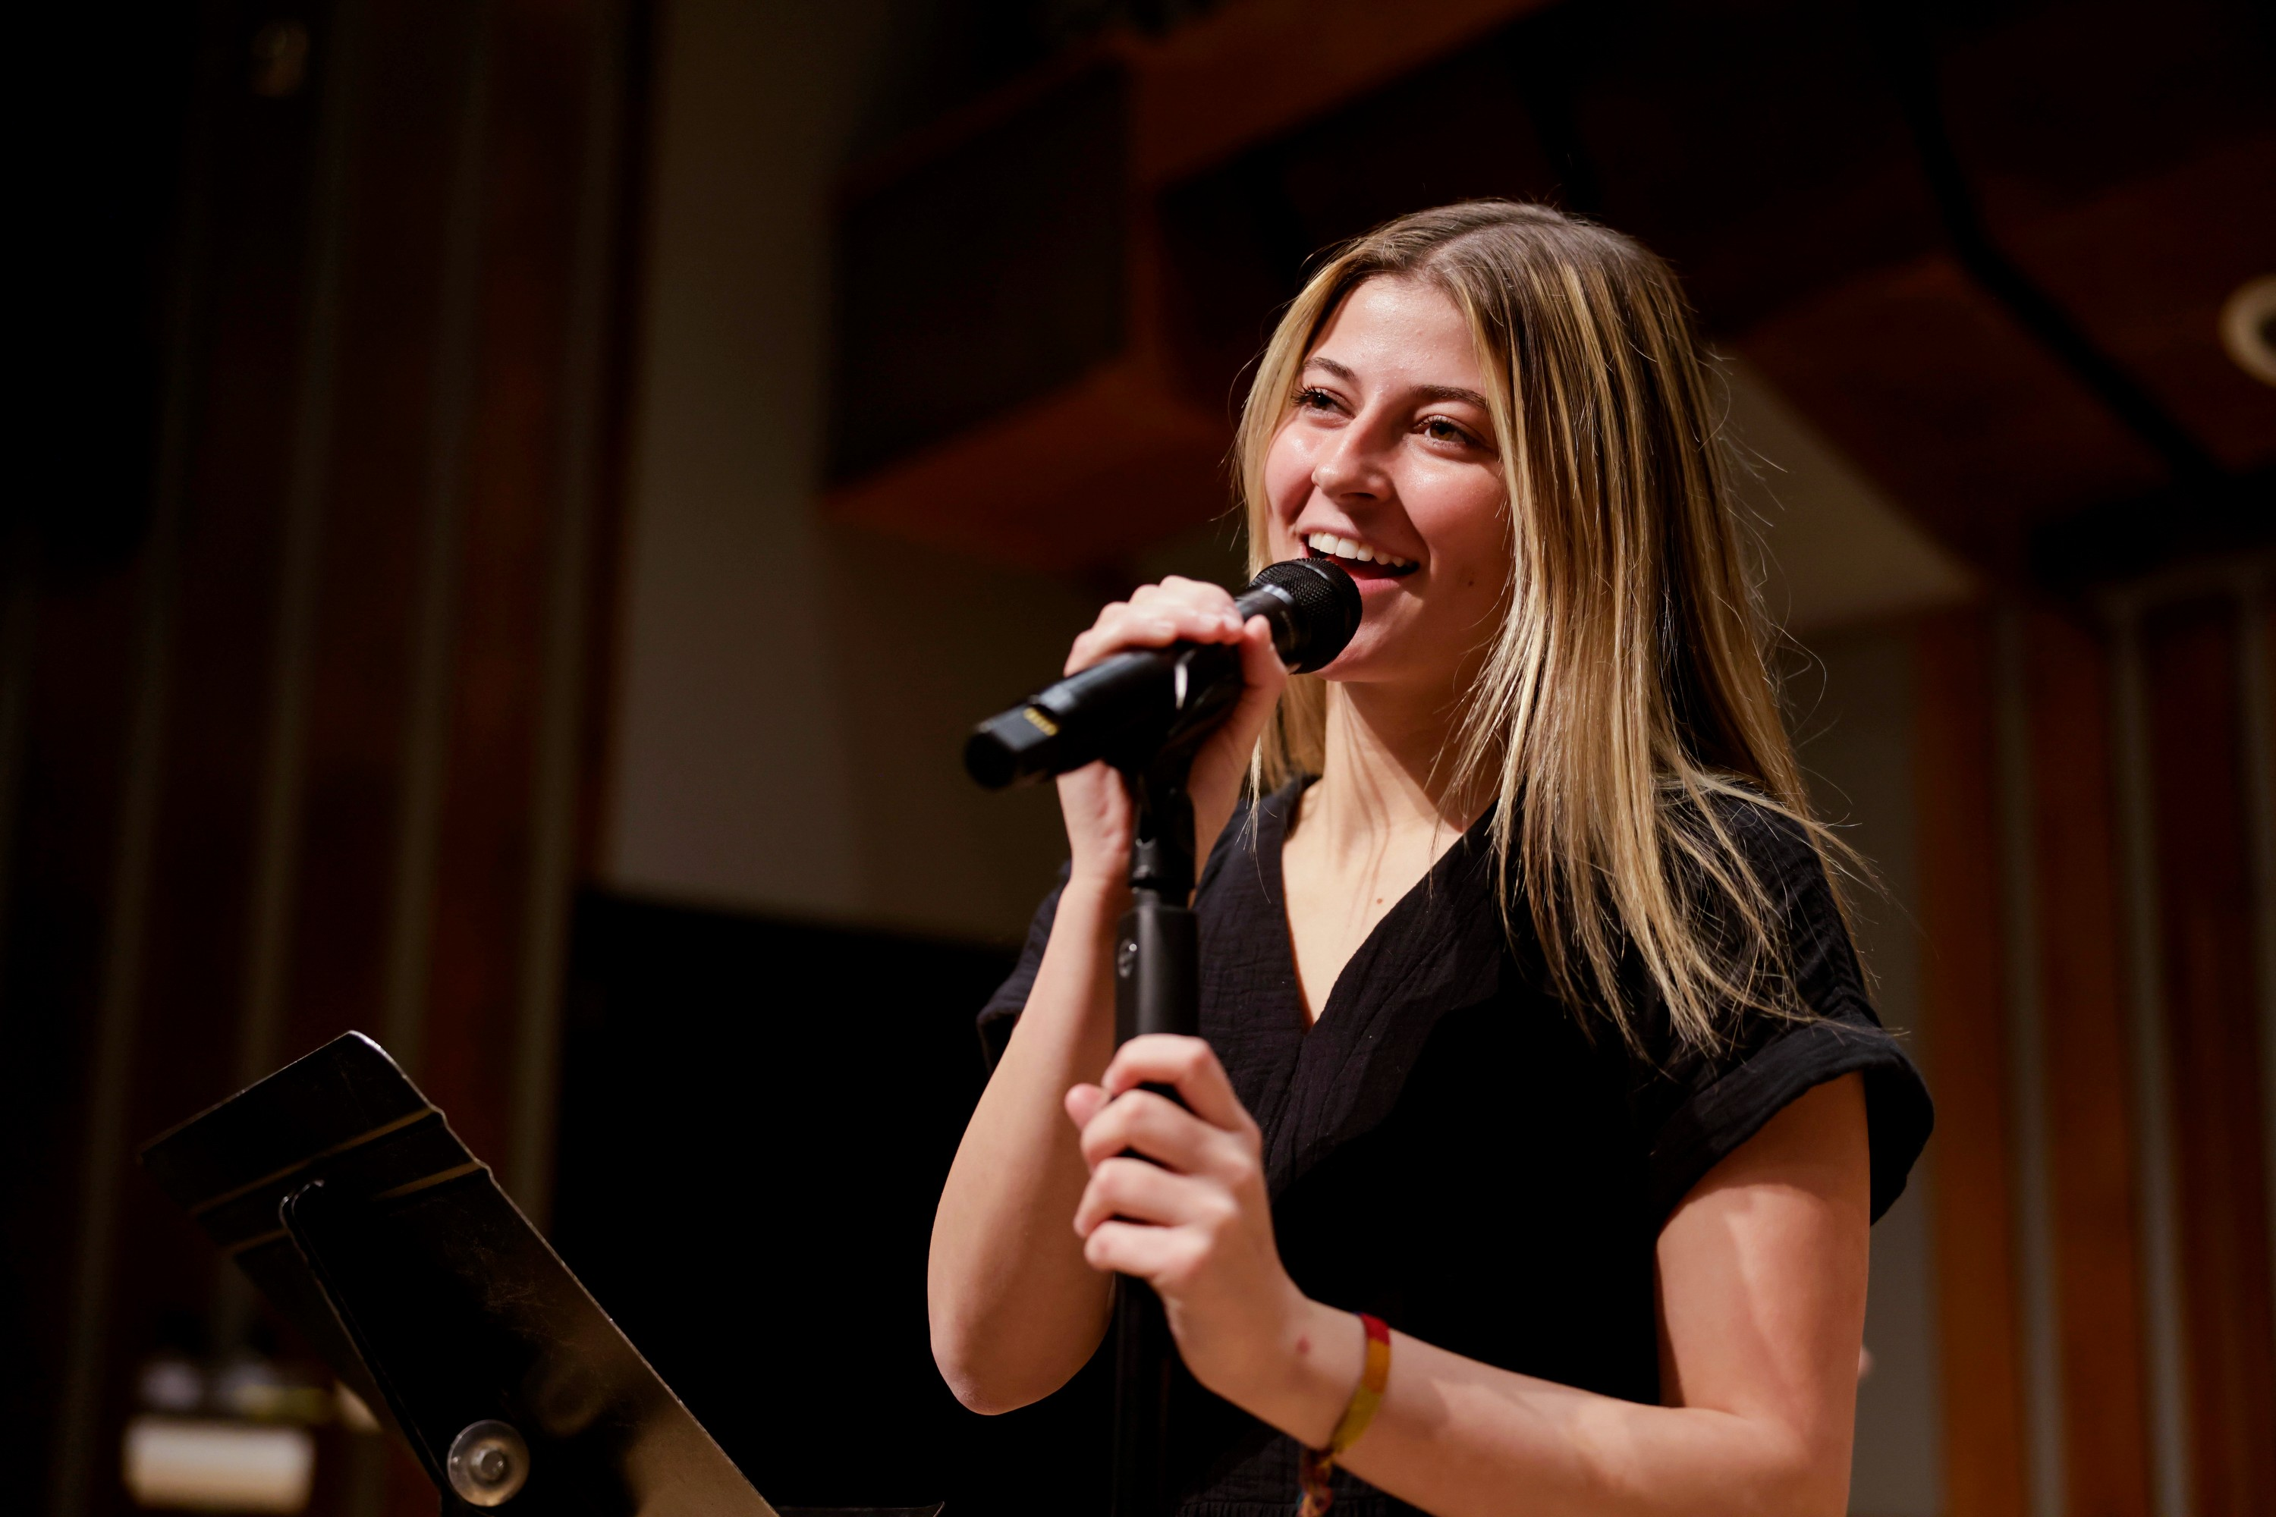
FOR IMMEDIATE RELEASE

News Release

2021-22 Season
Jazz Legacy Band
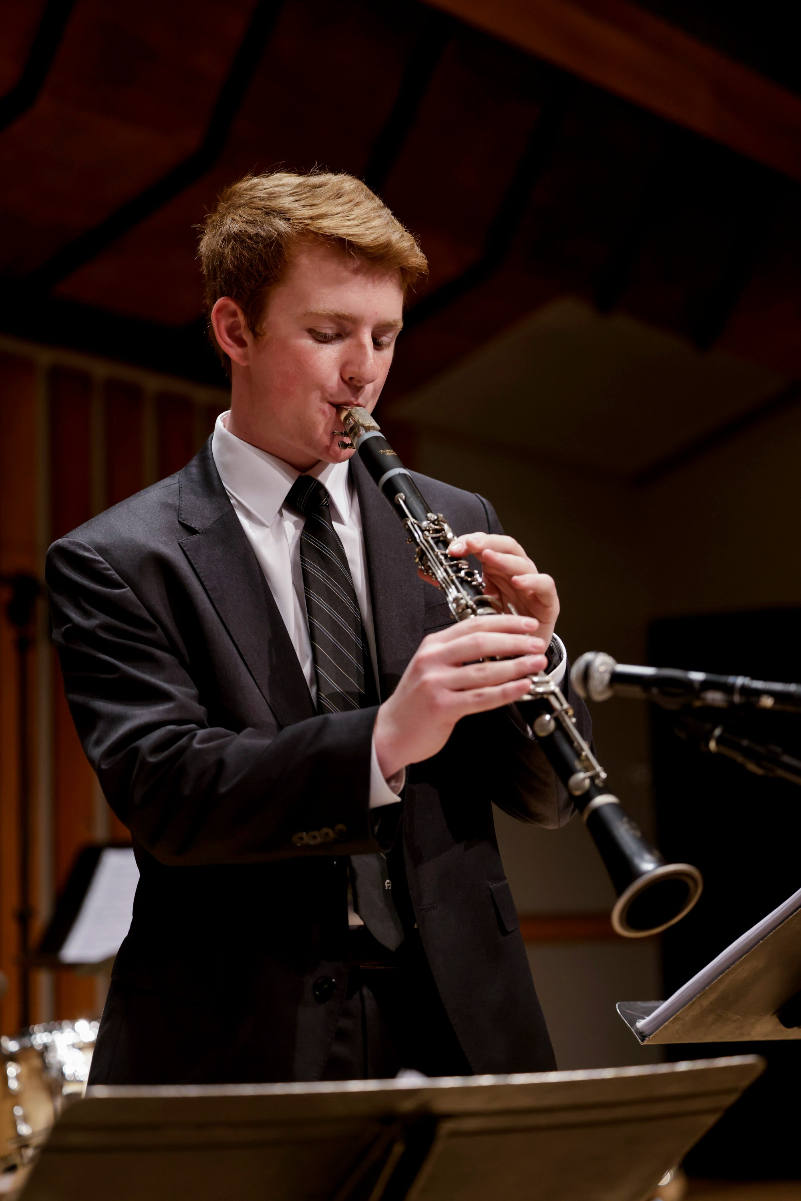
Performing Arts Management 801-422-3576 | pam.byu.edu

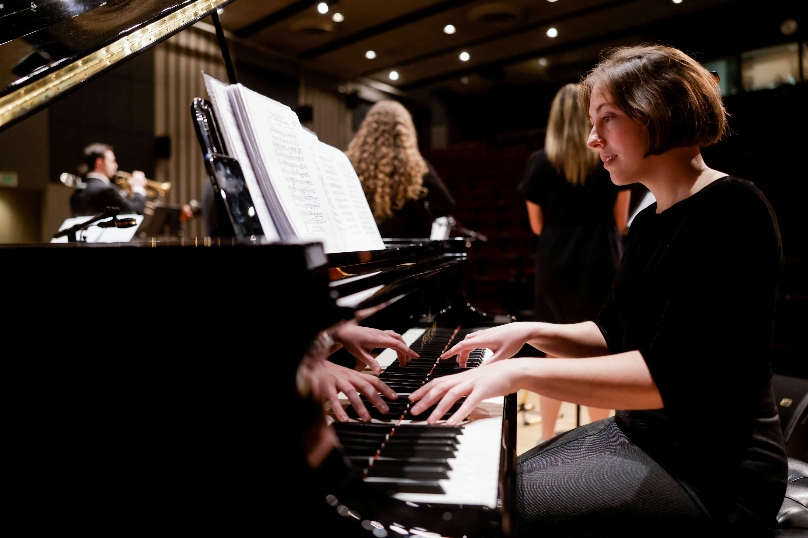

(To get the text version of this file, visit pam.byu.edu/group-name)

Jazz Legacy Band shares the rhythms of the South with the world

Brigham Young University’s Jazz Legacy Band sweeps audiences back in time to the
toe-tapping tunes of America in the 1920s. The band will play a variety of jazz favorites at (PLACE) on(DATE) at (TIME).
“It’s joyful music,” says director, Dr. Kristen Bromley. "[It's] so fun and uplifting. From the moment the band starts playing, until the end of the show, you can expect to be tapping your toes and dancing in your seats." The Jazz Legacy Band prepares for performances by listening to and copying recordings of great musicians of the past. Improvisation is a big part of traditional jazz and each musician has a role. The trumpet plays an embellished melody, the trombone creates a lower counter melody, the clarinet is responsible for higher-pitched obbligato melodies, while the piano, banjo, tuba, and drums lay down a solid beat.
(more)

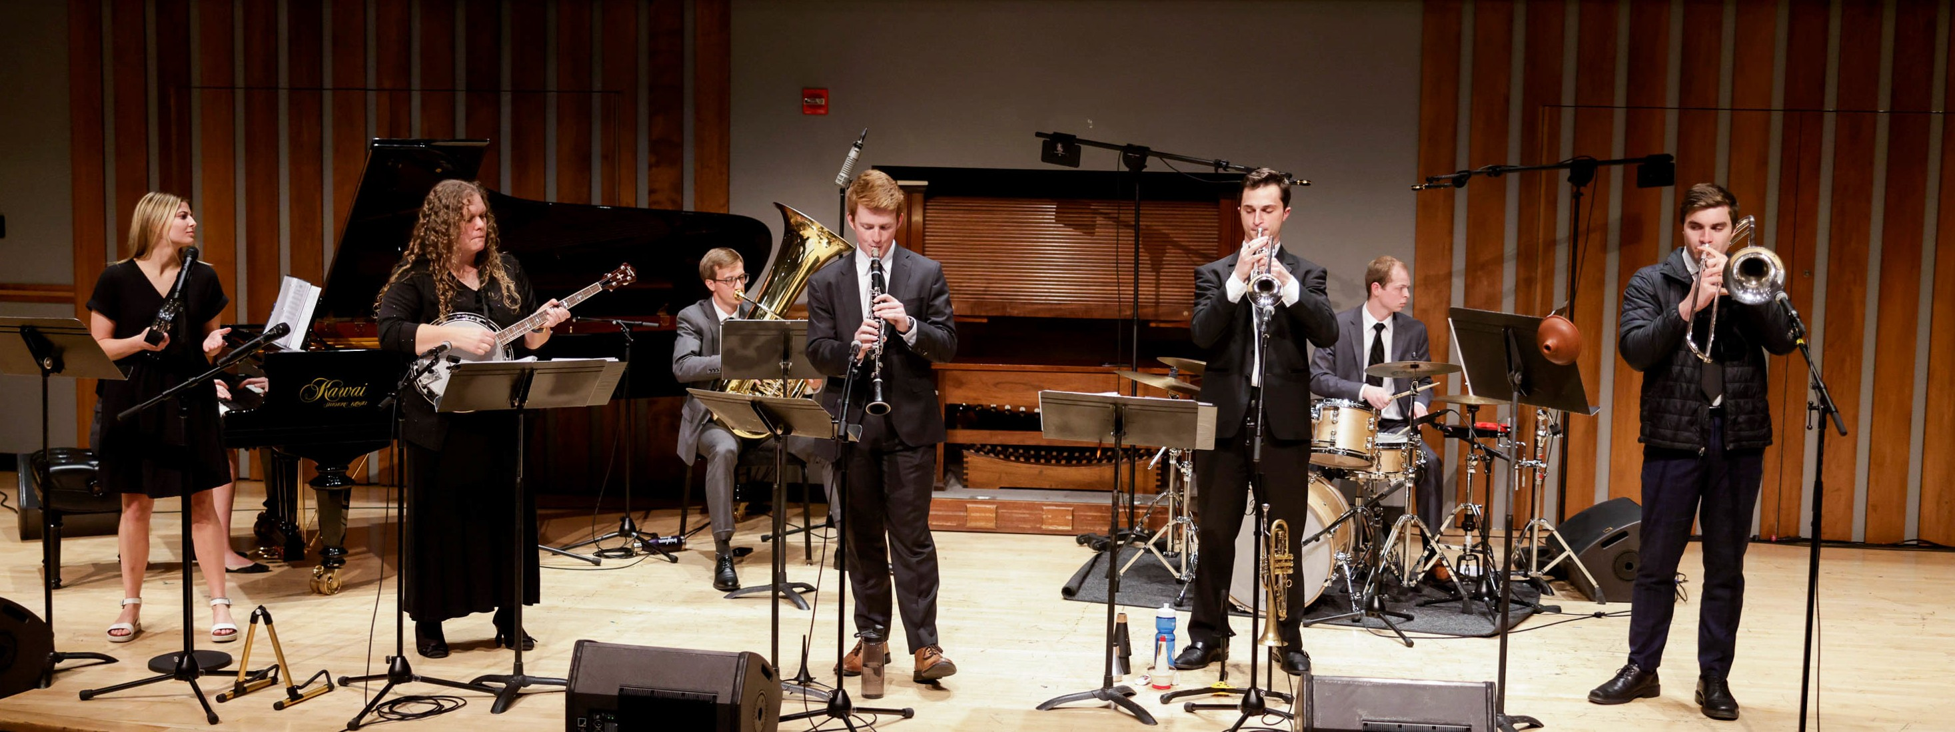

Jazz Legacy Band
Jazz is uniquely indigenous to the United States and is certainly an American treasure. Jazz originated in New Orleans during the first two decades of the twentieth century. It dominated the popular music scene of
the 1920s and eventually evolved into swing and big band music during the 1930s. As musicians looked back to discover the music’s origins in the late ‘30s, traditional jazz was re-born in a southern revival.
Few collegiate ensembles are performing such early jazz forms and BYU’s Jazz Legacy Band provides a rare opportunity for listeners to enjoy America’s musical heritage. The band members, many of whom have performed professionally, are among BYU’s most talented student musicians. Jazz Legacy also presents concerts and workshops to school groups and other interested regional audiences.
The Jazz Legacy Band was invited by Utah’s Senatorial and Congressional Delegation to represent the state of Utah at the Kennedy Center’s State Days concert series in July 1998. During the summers of 2016 and 2017, the Jazz Legacy Band performed at several different venues in New Orleans, including Preservation Hall. In January 2020 the band performed in New Orleans at the annual Jazz Education Network Conference, the largest jazz festival held in the United States. This was the group's third trip to New Orleans as well as their 8th performance at a festival of this stature, having previously performed at seven different international Association of Jazz Educators' Conferences. Moving beyond the U.S., the band is scheduled to perform at several prestigious Jazz festivals in Europe during the summer of 2022, including the Umbria Festival in Italy.
Jazz Legacy originates in the School of Music in the College of Fine Arts and Communications at Brigham Young University in Provo, Utah. BYU is one of the nation’s largest private universities with an enroll- ment of more than 30,000 students from throughout the United States and 120 foreign countries.
(End)

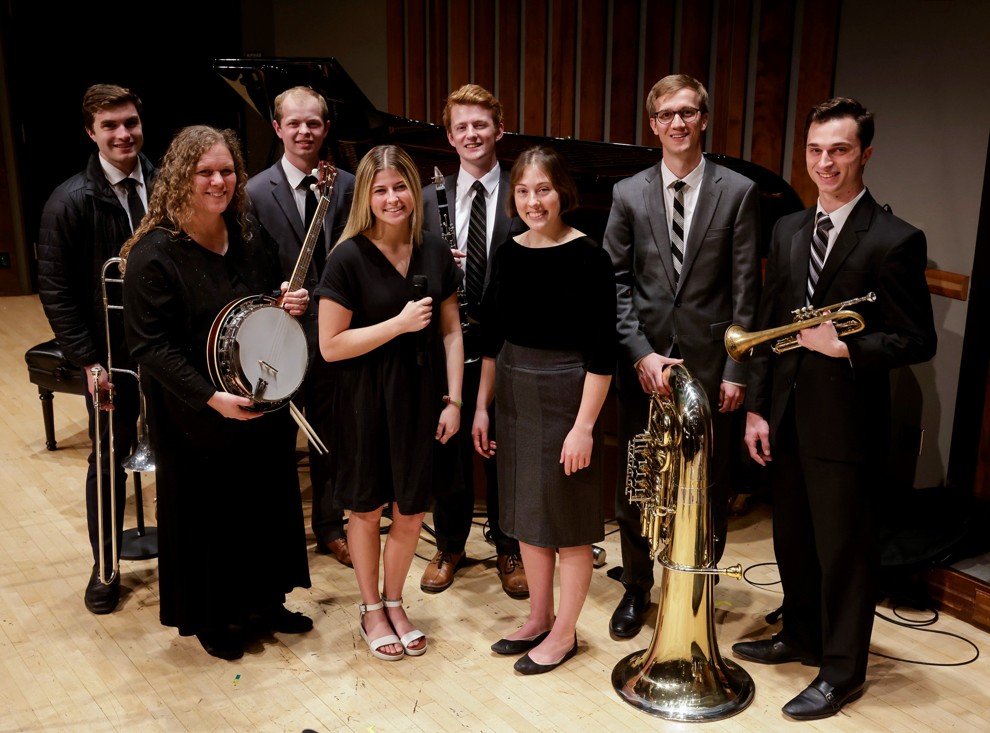

Artistic Director
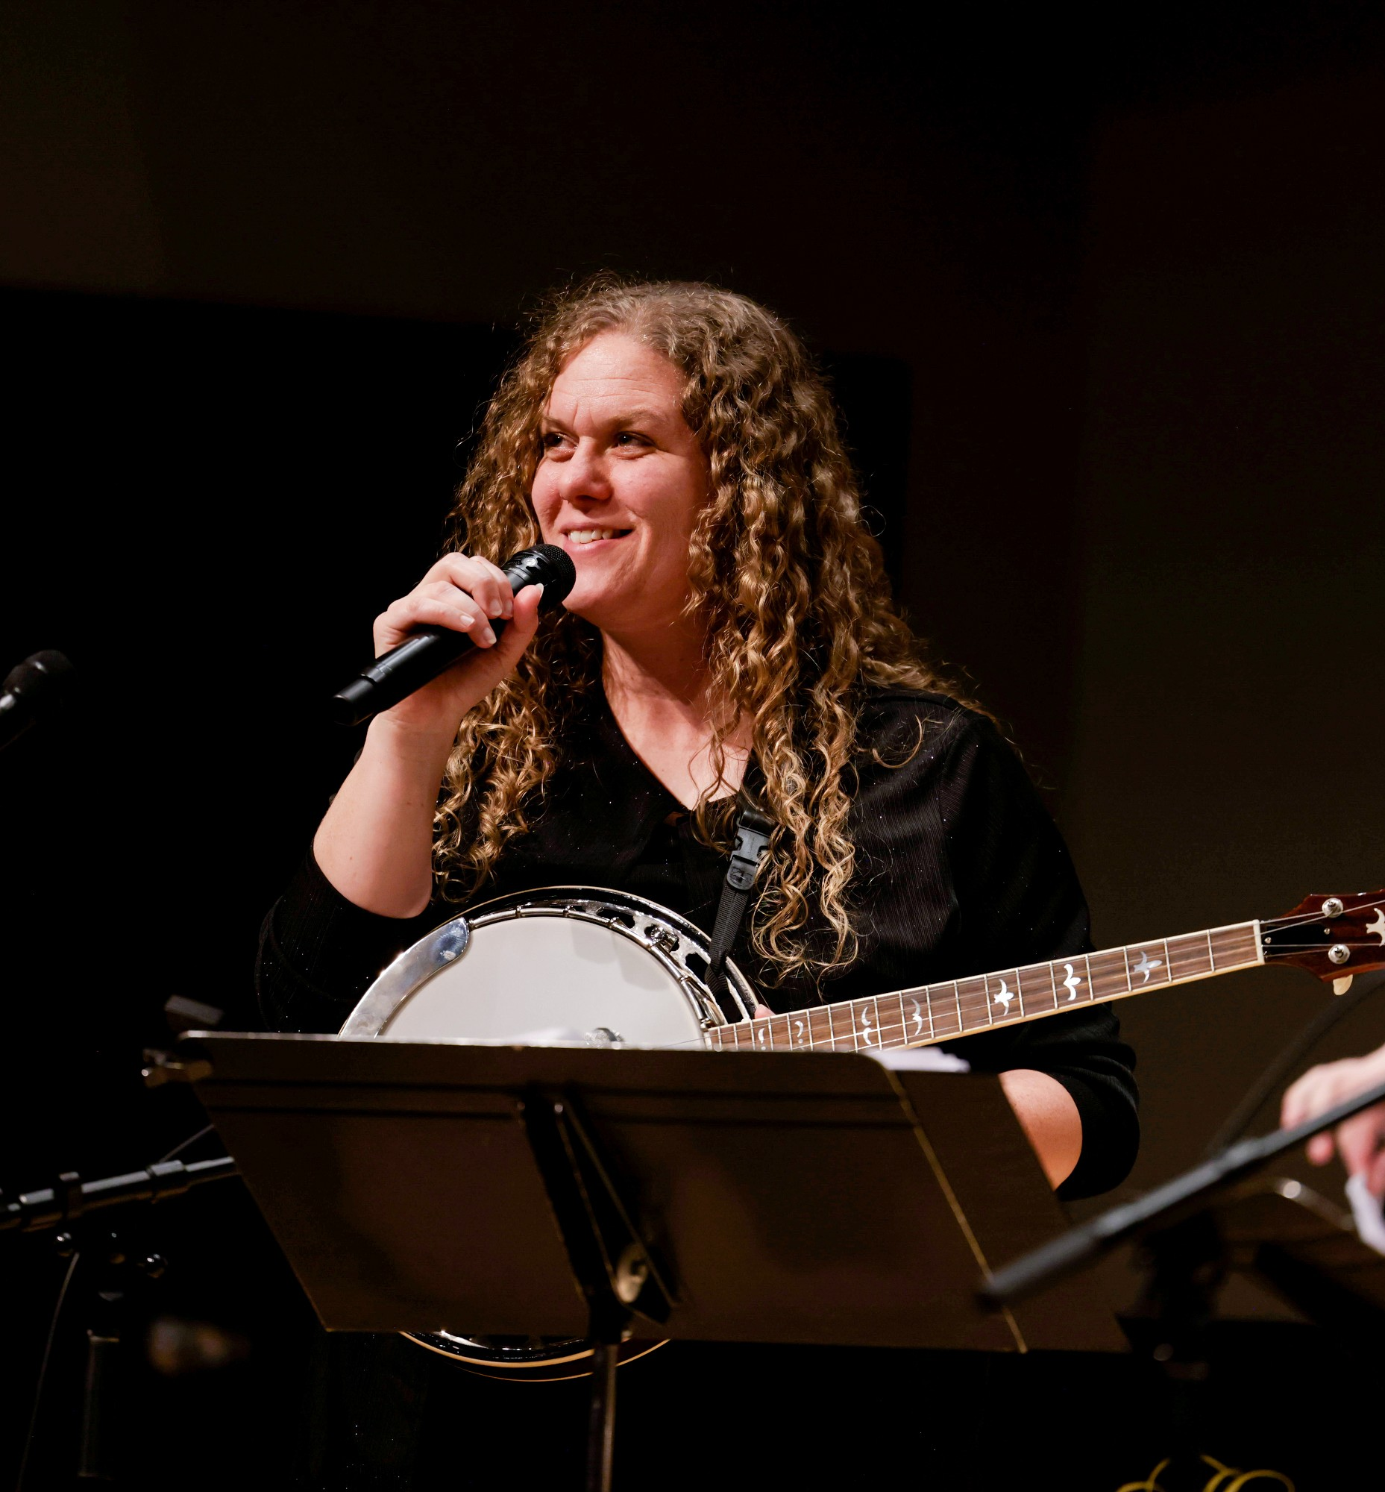
Founded in 1980 by Dr. Steve Call, the ensemble is one of the few collegiate groups in the nation still performing early jazz music. Currently under the direction of Dr. Kristen R. Bromley, the band will play a variety of traditional jazz favorites at (PLACE) on (DATE) at (TIME).
A performing jazz artist herself, Dr. Kristen R. Bromley is a gifted and sought-after instructor, as well as a composer. Kristen has a Doctor of Musical Arts degree in Music Education from Boston University, a Master of Music degree in Jazz Studies from Indiana University's Jacobs School of Music, and a Bachelor of Music degree in Jazz Studies, with an additional BA major in Family History and Genealogy from Brigham Young University.
Dr. Bromley is the author of several guitar method books and is featured on various recordings. She has toured parts of North America and Europe, and has performed at several highly prestigious jazz festivals, such as the Edinburgh International Jazz Festival in Scotland, the Marlborough International Jazz Festival in England, the San Sebastian International Jazz festival in Spain, and the Ezcaray Jazz Festival in Spain. Dr. Bromley has also performed and presented clinics at Jazz Education Network and International Association for Jazz Education conferences. In 2006 and 2007, she was named the outstanding guitar soloist at the Lionel Hampton International Jazz Festival.
As a scholar, Dr. Bromley has focused much of her research on discovering ways to create more interactive and person-centered educational environments wherein individuals experience whole-person learning outcomes as they grow through cognitive, emotional, and experiential means, develop greater self- discipline, and become more fully-functioning persons.

Upcoming Performances

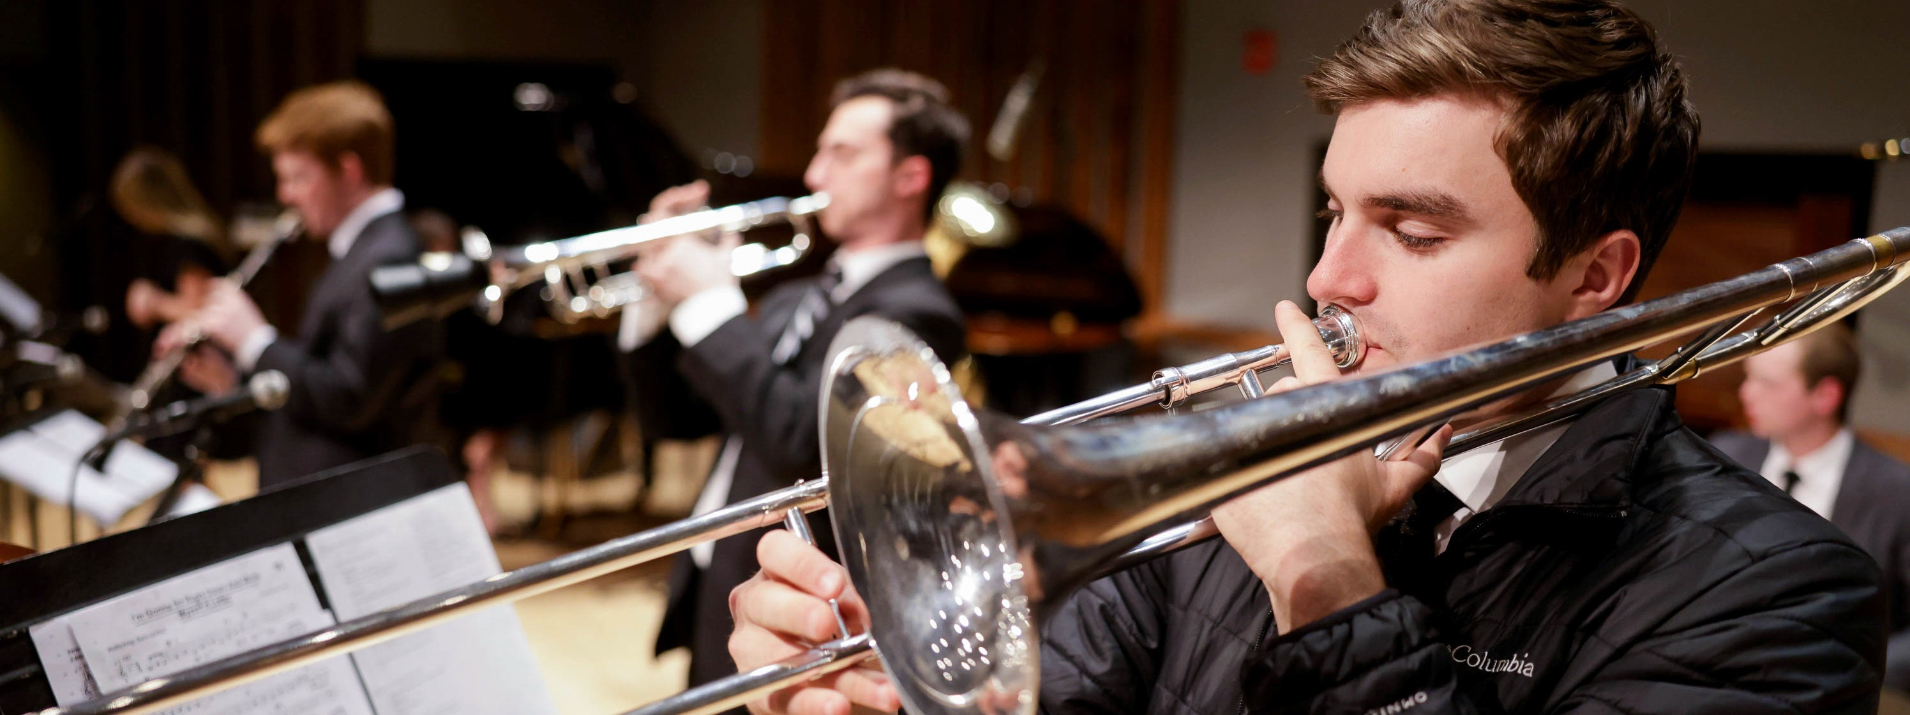
Artist Manager Justin Smith 801-422-3573
justin_smith@byu.edu
Performing Arts Management 306 Hinckley Center
Provo, UT 801-422-3576
perform@byu.edu pam.byu.edu
Jazz Legacy Band originates in the office of Performing Arts Management at Brigham Young
University in Provo, Utah.

