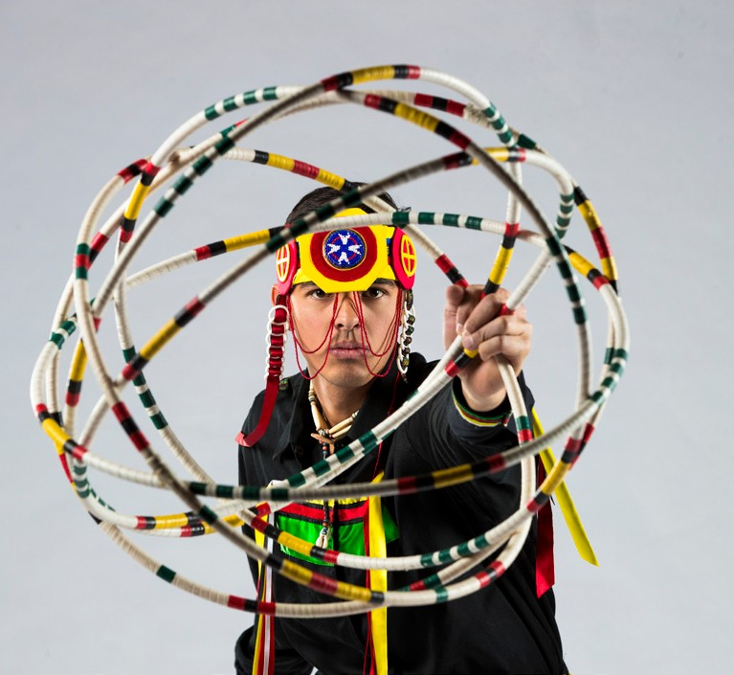
FOR IMMEDIATE RELEASE

News Release Living Legends
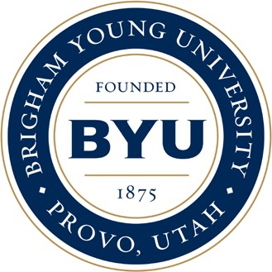
2018-19 Season Performing Arts Management
801-422-3576 | pam.byu.edu

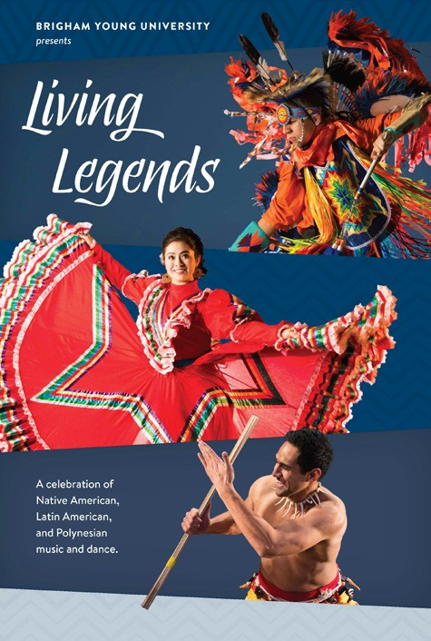
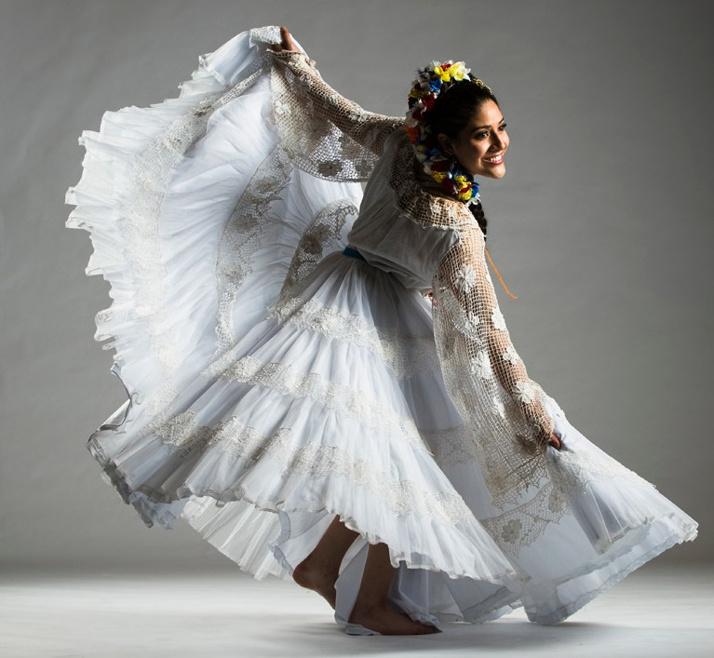

(To get the text version of this file, visit pam.byu.edu/living-legends)

Living Legends celebrates heritage and culture

In a performance of culturally inspired dance, music, and costumes, Brigham Young University’s Living Leg- ends celebrates the Latin American, Native American, and Polynesian cultures in their show, Seasons. Each year, hundreds of BYU students audition for the opportunity to pay tribute to their ancestors through music and dancing. The audition process is competitive—accepting only the best singers and dancers—and all Living Leg- ends members are of Native American, Latin American, or Polynesian heritage.

Spectacular choreography, colorful costumes, and heart-pounding music brings to life the skill, beauty, and authenticity of these traditional cultures. Seasons reflects the cycle of civilizations through the portrayal of changing seasons, weaving together the legends of the past with the reality of today. From the exciting Polyne- sian haka and poi and the graceful Mexican Fiesta dances to the expertise behind the Native American Hoop Dance, this is an experience you won’t want to miss at (PLACE) on (DATE) at (TIME).

Living Legends
Living Legends has toured around the globe to places such as the Pacific Islands, Australia, Canada, Eu- rope, and South America. In 2020 the group will take their show to the Southwest United States where they will perform in Arizona. In 2019, the group went on an international tour to the Brazil and performed in Sao Paulo, Brasilia, Campinas, Curitiba, Foz do Iguacu, Manaus, Goiania, and Belo Horizonte.
During the summer of 2013, Living Legends traveled to Central America and performed for enthusi- astic crowds in Guatemala, Honduras, and Nicaragua. One of the highlights was a performance in Nicaragua, where the President of the National Assembly, Santos René Núñez Téllez, and his council were present in the audience. The next day, Mr. Téllez expressed he was profoundly moved and impressed with the previous night’s show, and told them that “a culture does not die when it dies, it dies when it is forgotten. Your show rescues culture and heritage.”
On tour, besides sticking to their normal scheduled performances, Living Legends also participate in community services and perform in school assemblies, where they encourage students to pursue higher educa- tion.
One of the main goals of Living Legends is to encourage all to take pride in their individual heritage and to continuously better themselves, as illustrated by a statement from the Office of Culture in Guatemala: “Your performance was wonderful. Your presence here teaches our people something—to have high ideals and to talk proudly as a people. We hope this community will not be the same after tonight.”

Artistic Director
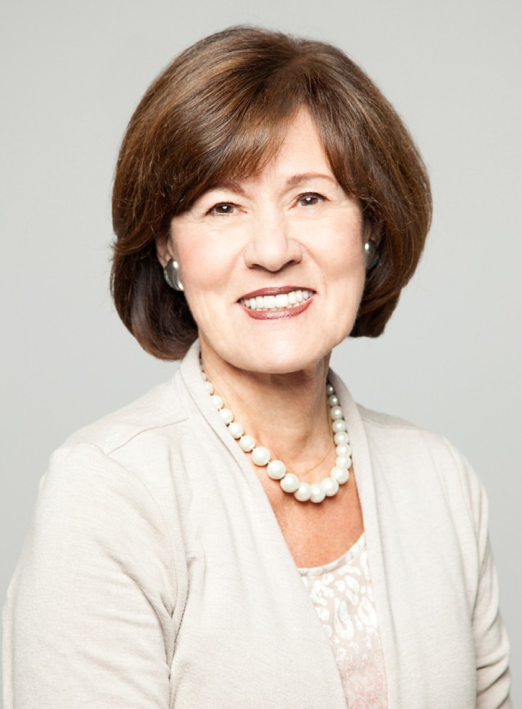
The colorful and authentic presentation of Latin
American, Polynesian, and Native American music and dance by BYU’s Liv- ing Legends would not be possible without the dedication, talent, and exper- tise of artistic director Janielle Christensen.
Christensen became active in professional theater and music early in her life, co-hosting a daily television show at age 12 and playing with the Musicians’ Union at age 14. She proceeded to gain extensive experience producing and directing summer theatres, performing groups, and trade shows, as well as directing a television series and a large outdoor pageant featuring members of the St. Louis Symphony Orchestra.
As an artistic director of Living Legends and a producer for Young Ambassadors, both performing groups at BYU, she has traveled around the world, bringing uplifting family entertainment to millions through live and televised productions. Under Christensen’s direction, Living Legends has toured and performed throughout Europe, China, the Pacific Islands, Australia, Canada, Central and South America, South Africa, and the United States. “It is a moving experience to work with these performers because I see the sincere respect they each hold for one another’s ancestry as well as their own,” Christensen said.
Living Legends originates in the Department of Dance, College of Fine Arts and Communications, at Brigham Young University in Provo, Utah. BYU is one of the nation’s largest private universities with an en- rollment of 30,000 students from throughout the United States and 100 foreign countries.

Upcoming Performances

January 20 at 7:00 pm College of Southern Idaho Twin Falls, Idaho

2018 Performances

May 3 at 8 :00 pm Stadthalle Theatre Neumünster, Germany

January 26 at 7:00 pm
Monument Valley High School Gym Kayenta, Arizona

January 27 at 7:00 pm
Many Farms High School Auditorium
Many Farms, Arizona

January 30 at 7:00 pm Adams State University Gym Alamosa, Colorado

January 31 at 7:00 pm
Shuler Theatre Raton, New Mexico

February 3 at 7:30 pm Longmont High School Longmont, Colorado

March 9 at 7:00 pm
LDS Conference Center Theater Salt Lace City, Utah
May 4 at 8:00 pm Kongressund Eventpark Hagen, Germany

May 7 at 5:00 pm Konstablerwache Public Square Frankfurt, Germany

May 9 at 7:00 pm Festhalle Baumhain-halle Luisenpark, Mannheim

May 11 at 8:00 pm Meistersingerhalle Nürnberg, Germany

May 12 at 8:00 pm Congress Hall Augsburg, Germany

May 16 at 7:30 pm Schinzenhof Horgen Horgen, Switzerland

May 19 at 7:00 pm
Berlin University of the Arts, Concert Hall
Berlin, Germany

Artist Manager Justin T. Smith 801-422-3573
justin_smith@byu.edu
For ticket information, please visit tix.byu.edu.
Performing Arts Management 306 Hinckley Center
Provo, UT 801-422-3576
perform@byu.edu pam.byu.edu

Living Legends
in the Department of Dance, College
of Fine Arts and Communications, at Brigham Young University in Provo, Utah.

