News Release

2023-2024 Season

Men's Chorus
Performing Arts Management
801-422-3576 | pam.byu.edu

FOR IMMEDIATE RELEASE

(To get the text version of this file, visit pam.byu.edu/mens-chorus)

Men's Chorus Presents 190 Talented Voices

With 190 strong voices and regular extended tours, the Brigham Young University Men's Chorus is the largest and one of the most popular men's choirs in the United States. Conducting this critically acclaimed choir is Dr. Brent Wells, a graduate from BYU's music education and choral conducting programs, with a host of accolades to his name. Men's Chorus is known for concerts spanning all genres with pieces featuring Gregorian chants, classical, hymns spirituals traditional arrangements, and contemporary music. The BYU Men's Chorus will bring its dynamic performance to Ogden, Utah in February 2024.
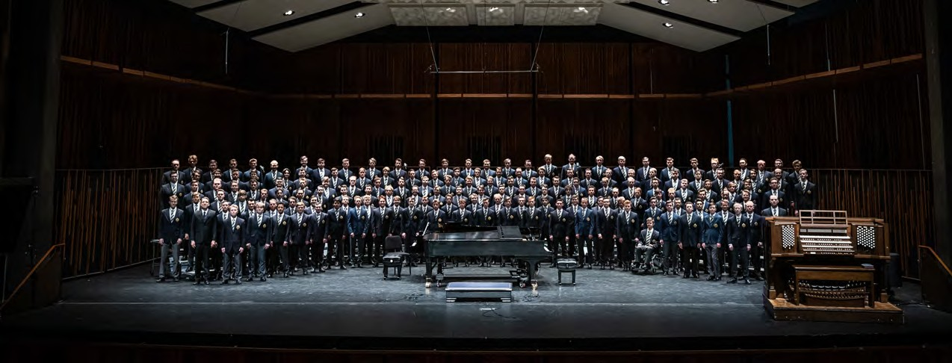

Men's Chorus

The Men's Chorus earned a place as one of BYU's most popular choirs because of their rich sound, eclectic performances, and powerful style. As their reputation grows, so does the demand for performances throughout the West, where they repeatedly sell-out to both new and loyal fans. The choir has performed in California, Nevada, Idaho, and throughout Utah. The group has been featured in popular venues, including the American Choral Director's Association, the Celebrity Concert Series, and other prestigious events.

For the past several years, Men's Chorus has traveled around the West, mostly performing in local venues in Utah and in Idaho. The choir released its first free album in the spring of 2013, "Set Apart." which features well-known missionary hymns. The group's charitable spirit had carried over from the previous year, during which the Men's Chorus produced a free concert to benefit the victims of Hurricane Sandy.

In 2009, Deseret Book re-released the popular Men's Chorus albums "Awake My Soul" and "Shout with Glory," two of Men's chorus eight album releases. In the fall of 2005, Men's Chorus released their third volume of anthems, folk songs, and hymns, entitled "Praise Him."

The Men's Chorus originates in the School of Music in the college of Fine Arts and Communications at Brigham Young University in Provo, Utah. BYU is one of the nation's largest private universities with an enrollment of 30,000 full-time students from throughout the United States and 100 foreign countries.

Artistic Director

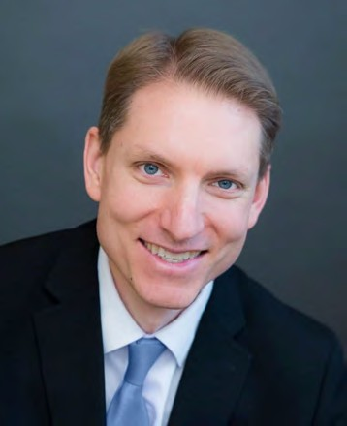
Dr. Brent Wood brings experience, training, and a love of music to the choir. Prior to his appointment at BYU, he served as director of Choral Activities at the College of Idaho and as conductor of Treasure Valley Millennial Choirs and Orchestras. He has also lead choral programs at the secondary level.
Dr. Wells received his DMA in choral conducting at Michigan State University, where he studied with David Rayl, Sandra Snow, and Jonathan Reed. He earned his BM in music education and MM in choral conducting at Brigham Young University under the tutelage of Ronald Staheli, Mack Wilberg, and Rosalind Hall.
Well's scholarship and creative activity focus primarily on hymnody and the folksong. He has published a series of articles in the Choral Journal discussing the folk-based compositions and collecting methodology of Percy Grainger, and is also active as a composer and arranger. Wells is published by Walton Music and Earthsongs, having arranges selections from the sacred harp repertory, the treasury of the African-American spiritual, and the folk traditions of Appalachia, England, Germany, Poland, Vietnam, China, Armenia, and the country of Georgia.
As a bass vocalist, Dr. Wells has performed as a featured soloist and enjoyed membership in many acclaimed choral ensembles. He has sung professionally with the Santa Fe Desert Chorale, Tennessee Chamber Chorus, Boise Baroque Orchestra, and Redlands Choral Artists. He also performed the Berlioz Grande Messe des morts, Op. 5 with the Carnegie Hall Festival Chorus under the direction of Robert Spano.

Upcoming Performances

BYU Men’s Chorus will join with the BYU Women’s Chorus for an evening of beautiful hymn arrangements,
stirring folk songs, and extraordinary new works in Ogden, Utah on February 3, 2024.

Artist Manager
Stacey Christensen
801-422-3574
stacey_christensen@byu.edu

Performing Arts Management 306 Hinckley Center
Provo, UT 801-422-3576
perform@byu.edu pam.byu.edu

Men’s Chorus
originates in the School of Music in the College of Fine Arts and Communications at Brigham Young University in Provo, Utah.

