
News Release Men’s Chorus
2024-2025 Season 801-422-3576 | pam.byu.edu
Performing Arts Management

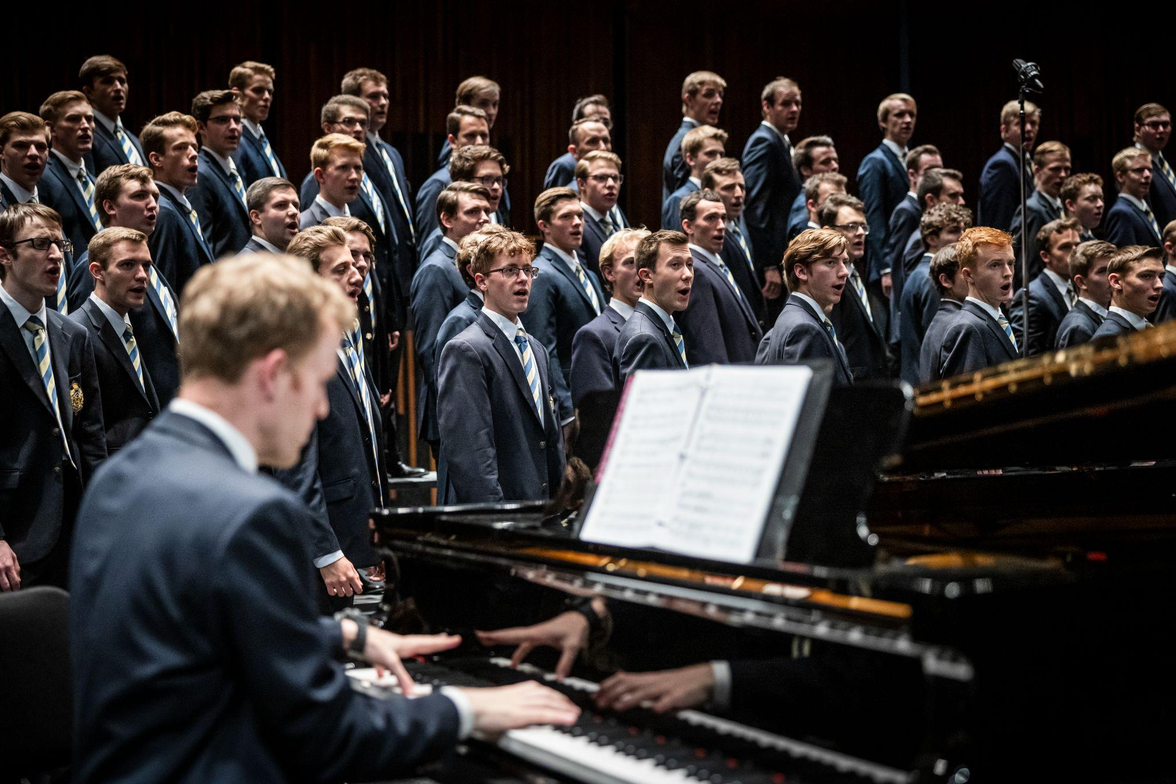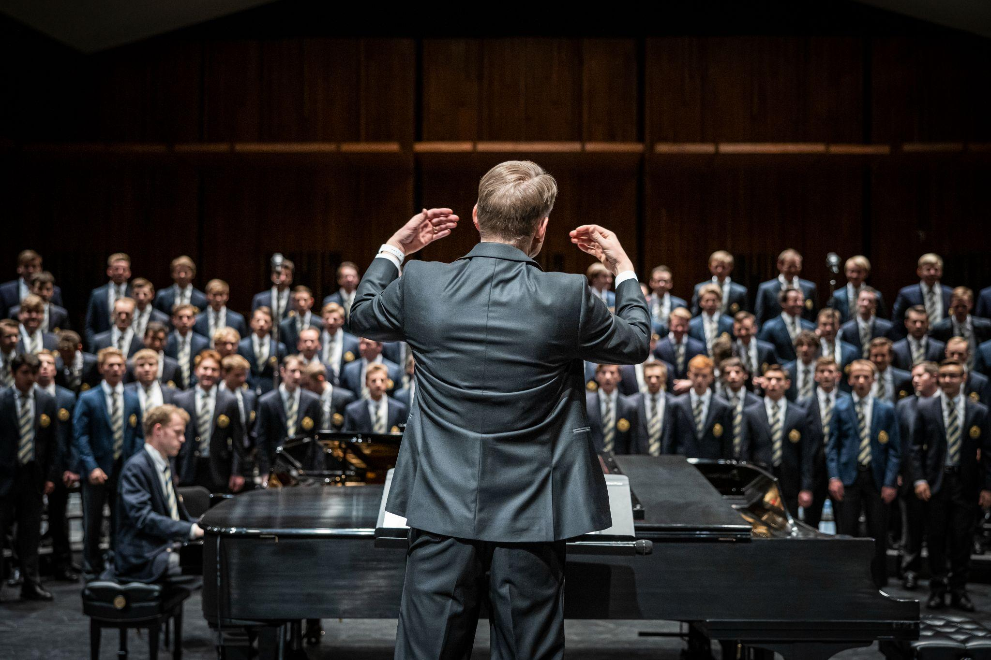

FOR IMMEDIATE RELEASE

(To get the text version of this file, visit pam.byu.edu/mens-chorus)

Men's Chorus Presents 190 Talented Voices
With 190 strong voices the Brigham Young University Men's Chorus is the largest and one of the most popular men's choirs in the United States. Conducting this critically acclaimed choir is Dr. Brent Wells, a graduate from BYU's music education and choral conducting programs, with a host of accolades to his name. Men's Chorus is known for concerts spanning all genres with pieces featuring Gregorian chants, classical hymns, spirituals, traditional arrangements, and contemporary music.

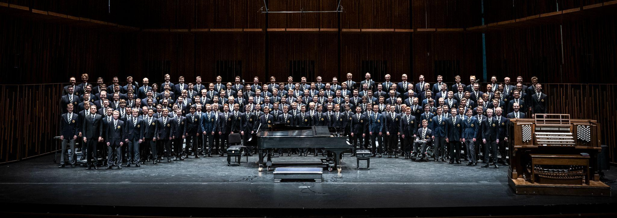
Men's Chorus
The Men's Chorus earned a place as one of BYU's most popular choirs because of their rich sound, eclectic performances, and powerful style. As their reputation grows, so does the demand for performances throughout the West, where they repeatedly sell-out to both new and loyal fans. The choir has performed in California, Nevada, Idaho, and throughout Utah. The group has been featured in popular venues, including the American Choral Directors Association, the Celebrity Concert Series, and other prestigious events.
For the past several years, Men's Chorus has traveled around the West, mostly performing in local venues in Utah and in Idaho. In 2024, the choir released their latest EP, "He Sent His Son," featuring four Christ-centric tracks that resonate with themes of faith, strength, and the redemptive power of Jesus Christ. Dr. Brent Wells, the choir’s director, emphasized the significance behind the EP, stating that “[this EP] aligns with the Men's Chorus legacy of creating accessible music for not only church members but for all of Christianity.”
BYU Men's Chorus joined BYU Vocal Point in their moving rendition of "Nearer, My God, to Thee," which has captivated audiences and accumulated over 39 million views on YouTube. Additionally, the music video for "Baba Yetu," featuring BYU Men's Chorus and Alex Boyé, has also gained widespread acclaim, with over 23 million views. Both performances highlight the remarkable talent and collaborative spirit of BYU's choral ensembles.
The choir released its first free album in the spring of 2013, "Set Apart." which features well-known missionary hymns. The group's charitable spirit had carried over from the previous year, during which the Men's Chorus produced a free concert to benefit the victims of Hurricane Sandy.
The Men's Chorus originates in the School of Music in the college of Fine Arts and Communications at Brigham Young University in Provo, Utah. BYU is one of the nation's largest private universities with an enrollment of 30,000 full-time students from throughout the United States and 100 foreign countries.

Artistic Director

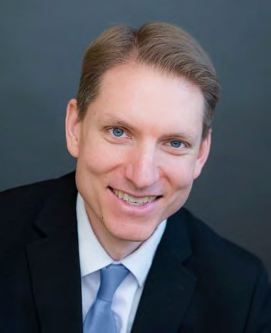
Dr. Brent Wood brings experience, training, and a love of music to the choir. Prior to his appointment at BYU, he served as director of Choral Activities at the College of Idaho and as conductor of Treasure Valley Millennial Choirs and Orchestras. He has also lead choral programs at the secondary level.

Dr. Wells received his DMA in choral conducting at Michigan State University, where he studied with David Rayl, Sandra Snow, and Jonathan Reed. He earned his BM in music education and MM in choral conducting at Brigham Young University under the tutelage of Ronald Staheli, Mack Wilberg, and Rosalind Hall.

Well's scholarship and creative activity focus primarily on hymnody and the folksong. He has published a series of articles in the Choral Journal discussing the folk-based compositions and collecting methodology of Percy Grainger, and is also active as a composer and arranger. Wells is published by Walton Music and Earthsongs, having arranges selections from the sacred harp repertory, the treasury of the African-American spiritual, and the folk traditions of Appalachia, England, Germany, Poland, Vietnam, China, Armenia, and the country of Georgia.

As a bass vocalist, Dr. Wells has performed as a featured soloist and enjoyed membership in many acclaimed choral ensembles. He has sung professionally with the Santa Fe Desert Chorale, Tennessee Chamber Chorus, Boise Baroque Orchestra, and Redlands Choral Artists. He also performed the Berlioz Grande Messe des morts, Op. 5 with the Carnegie Hall Festival Chorus under the direction of Robert Spano.

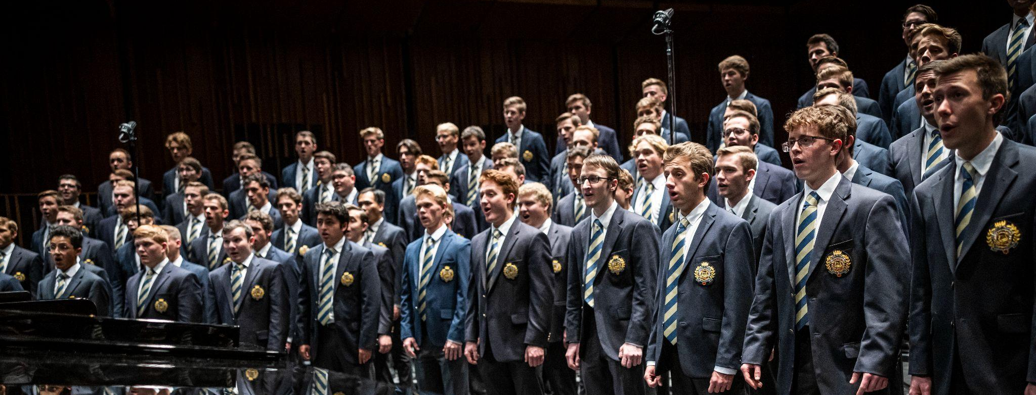

Upcoming Performances

October 3, 2024 at 7:30pm
Concert Hall- BYU Music Building
Provo, UT

October 4, 2024 at 7:30pm
Concert Hall- BYU Music Building
Provo, UT

November 12, 2024 at 7:30pm
Concert Hall- BYU Music Building
Provo, UT

March 28, 2025 at 7:30pm
Concert Hall- BYU Music Building
Provo, UT

Artist Manager Performing Arts Management Men’s Chorus
Stacey Christensen 306 Hinckley Center Originates in the School of Music
801-422-3574/ 480-586-1555 Provo, UT in the College of Fine Arts stacey_christensen@byu.edu 801-422-3576 and Communication at Brigham
perform@byu.edu Young University in Provo, Utah.
pam.byu.edu

