FOR IMMEDIATE RELEASE

News Release
2022-23 Season

Synthesis
Performing Arts Management 801-422-3576 | pam.byu.edu

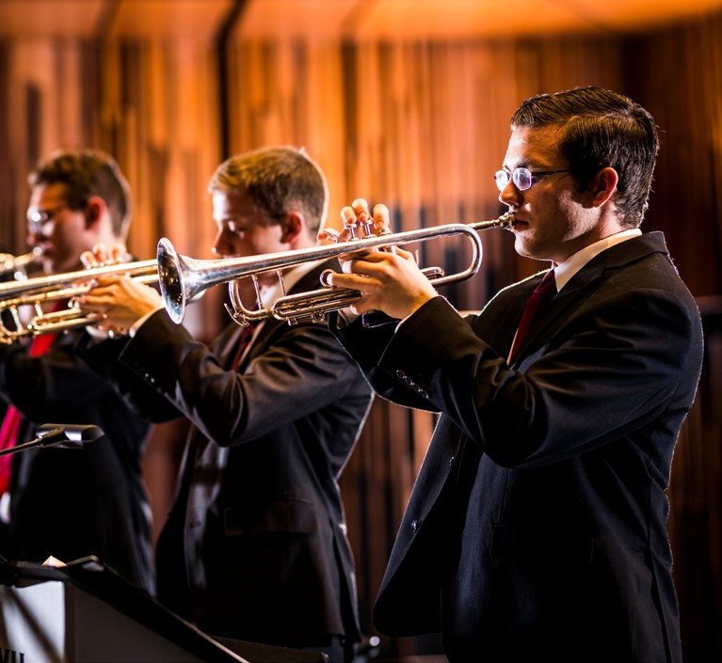

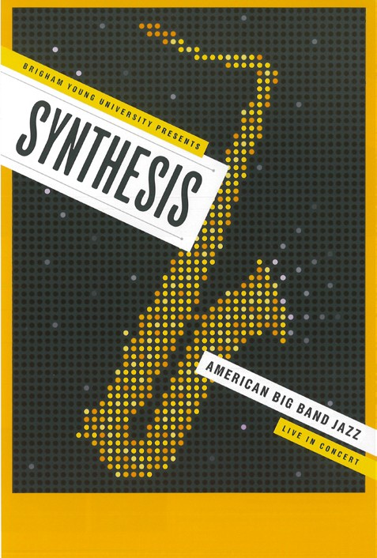
(To get the text version of this file, visit pam.byu.edu/synthesis)

Synthesis is Jazzing Things Up
Synthesis continues to dazzle audiences around the globe, leaving their mark on the world of jazz music.
With a repertoire that has the band as well as audience members dancing, each performance is one to be re- membered. From Brigham Young University, the award-winning instrumental jazz ensemble frequently travels throughout the world presenting a wide variety of popular musical styles, while also exhibiting their first-class musicianship and professionalism.
The group’s repertoire consists of a variety of jazz styles including: swing, jazz, blues, rock, fusion, gospel, and Latin. Synthesis takes you on a journey through the timeless numbers from jazz legends like Count Basie, Duke Ellington, Glenn Miller, and Louis Armstrong as well as modern numbers from current legends like Gordon Goodwin, Alan Baylock, and Mike Tomaro. They also perform professional-level original pieces composed by members of the group. Synthesis musicians create an engaging night of jazz music you’ve been waiting to hear, join us at (PLACE) on (DATE) at (TIME).

Synthesis
Synthesis plays throughout the world as peers to professional artists and groups at jazz festivals, con- certs, and events. In 2018, Synthesis performed in Cuba, Puerto Rico, and the Dominican Republic during their three-week tour. In 2016, the group went on an extended tour to the Baltic States, covering Estonia, Latvia and Lithuania as well as Sweden and Finland. On tour, the group made history at the Saulkrasti Jazz Festival, where they played multiple encores and the audience stayed even after the venue shut off the lights. While on tour, Synthesis also performed at the Festinord Young Adult Conference, and during various performances was accompanied by guest performers, including Louise Ringheim Ross and Lembit Saarsalu.
In 2013, Synthesis toured Brazil, bringing their smooth jazz sounds to one of the most prestigious show- cases of its kind – the Rio das Ostras Jazz and Blues Festival, where they performed for thousands of people. In 2013, the group was the winner of DownBeat Magazine’s Top College Big Band award. In July 2010, Synthesis toured in Denmark and Norway. They played at the Copenhagen, Kongsberg, and Aarhus Jazz Festivals, sharing stages with some of the best jazz talent in the world. They toured England and Scotland in 2008, where they opened at the Edinburgh Jazz Festival and the Wigan Jazz Festival, and also played with world-renowned tenors Stephen Duffy, Freddie King, and Todd Gordon. The group visited Spain and Portugal where they were the highlight of national television; they were showcased on the Big Band Night at the International Jazz Festival in Montreux, Switzerland along with Gerry Mulligan’s New York Big Band and have performed at the prestigious international jazz festival two other times since then; and the list goes on.
No matter where in the world they entertain, their passion and music never need a translator. Transcend- ing language barriers through their music, Synthesis touches the hearts of audience members around the globe, as expressed by John Galbraith of Novosibirsk, Russia: “Everyone who attended the concert felt the magic of (their) mood as (they) lit up the room with enthusiasm and energy. For two hours we were treated to something much more than a well done concert. (We) were swept away in the power of oneness…. Each one sensed a uni- ty…. Each was proud to be a part of it.”
Synthesis is produced by the School of Music at Brigham Young University in Provo, Utah. BYU is one of the nation’s largest private universities with approximately 30,000 students from across the United States and 100 foreign countries.

Artistic Director
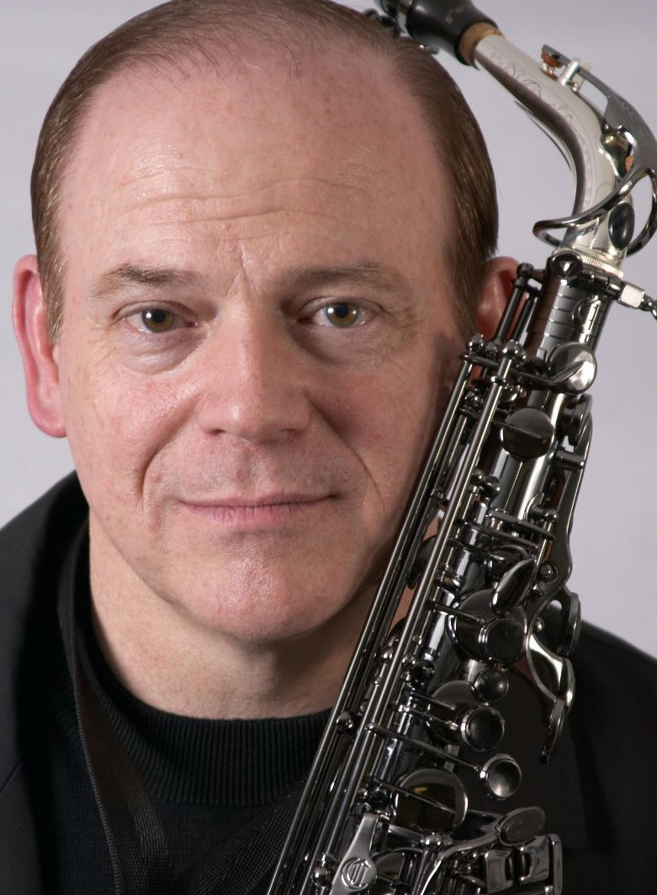
Ray Smith, director of Synthesis, performs and records music professionally in addition to serving as the director of jazz studies and a professor of woodwinds at BYU. Smith’s talents have been requested by recognized artists such as Kurt Bestor, Johnny Mathis, and The Supremes. Having an experienced musician like Smith at the band’s helm is crucial to the success that Synthesis has enjoyed throughout the years. Smith recalls the ex- citement of being part of the jazz world: “There’s something in our music that bespeaks the freedoms we enjoy that is appealing to people all over the world. Music brings us all together—we’re more the same than we are different. And once the similarities are uncovered, we can all rejoice together.”
Following a 1998 tour through Russia and Finland, Victor Tregoubov, of Novosibirsk, Russia praised Smith, saying, “Ray [was] not only a super conductor and soloist, but as a master of ceremonies created such a special atmosphere and warm contact with the audience.”
Smith’s dedication to Synthesis extends beyond his experience as the
ensemble’s artistic director. As an undergraduate at BYU, Smith played lead alto saxophone with Synthesis. He also played first clarinet with the Wind Symphony and Philharmonic Orchestra. After graduating from BYU with a Bachelor of Music degree in 1975, Dr. Smith enrolled at Indiana University, where he earned both a Master’s and a Doctoral degree and had the privilege of studying under many great musicians, including David Baker—one of the top jazz educators in the world.
Upon leaving Indiana, Smith taught at Murray State University in Kentucky for three years before re- turning to BYU to accept a faculty position in 1982. Smith is currently the director of jazz studies and a profes- sor of woodwinds at BYU.
Smith has recorded music on numerous occasions as well, including back-up music for Frank Sinatra, a stage presentation for Dick Tracy at Disneyland and Walt Disney World, and for national ads such as Buick ‘92, Chevy Heartbeat of America, Chevrolet GEO, and The Children’s Television Network. He also contributed to the theme for Good Morning America.
Smith has toured and recorded with a number of artists, including Sam Cardon, Mike Dowdle, Kurt Bestor, and Lex de Azevedo. He has performed with numerous traveling entertainers, such as Johnny Mathis, The Supremes, John Davidson, and The Fifth Dimension.

Artist Manager Justin Smith 801-422-3573
justin_smith@byu.edu
Performing Arts Management 306 Hinckley Center
Provo, UT 801-422-3576
perform@byu.edu pam.byu.edu
Synthesis
originates in the School of Music of the College of Fine Arts and Communications at Brigham Young University in Provo, Utah.

