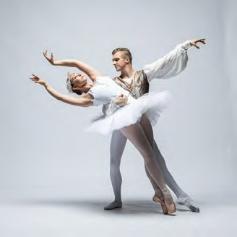
FOR IMMEDIATE RELEASE

News Release
2022-23 Season

Theatre Ballet
Performing Arts Management 801-422-3576 | pam.byu.edu

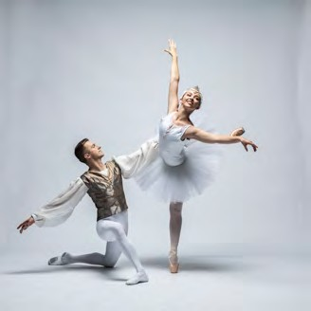

(To get the text version of this file, visit pam.byu.edu/theatre-ballet)

BYU Theatre Ballet Exhibits Artistic Excellence

BYU Theatre Ballet exists to foster love and appreciation for ballet, recognizing it as an artistic means of expression and communication. Striving for unequivocal excellence, Theatre Ballet seeks to be a gospel- oriented catalyst for students to achieve their highest potential. In seeking excellence, Theatre Ballet performs full-length story ballets in addition to works by George Balanchine, Gerald Arpino, Paul Taylor, Eva Stone, and José Limón. Original works are also choreographed on the company by visiting choreographers and BYU professors. Through generous experiential learning funds provided by the university, BYU Theatre Ballet will travel to Florence, Italy in the summer of 2022 to study the Cecchetti technique and baroque dance forms

Theatre Ballet
Brigham Young University’s ballet program is one of the largest university dance programs in America, with approximately 350 students enrolled in ballet classes each semester alone. The faculty includes three full- time ballet faculty members and six adjunct faculty members. The ballet program not only provides students with a complete course of study but also supports two performing companies—those being Theatre Ballet and Ballet Showcase.
Performing both traditional full-length ballets as well as modern contemporary works, the Theatre Ballet performers’ talents extend to multiple artistic spheres. In addition to their performances, Theatre Ballet creates an opportunity to meet with the cast. The performers love to interact with audience members and provide time during different events to connect with them. With a renowned director, impressive repertoire, and dedicated performers, Theatre Ballet presents a show that you won't forget.
The company often takes their shows on tour and have performed in many US states, including California, Washington, Nevada, New Mexico, and Oregon. Internationally, Theatre Ballet has toured South Africa and Canada. In 2018, they took their show, Carnival of the Animals, to New Mexico and Texas.
Brigham Young University’s top ballet company, Theatre Ballet originates in the Department of Dance in the College of Fine Arts and Communications. BYU is one of the nation’s largest private universities, with an enrollment of approximately 32,000 students from all 50 states and more than 100 countries.

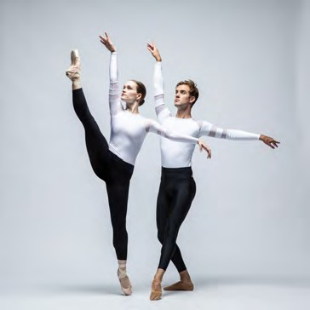

Artistic Director
As the director of Theatre Ballet and assistant professor at Brigham Young University, Shayla Bott brings over 20 years of experience teaching in both private and classroom settings, creating and producing original choreography, and performing with various ballet companies.
Shayla graduated from the University of Utah with a BFA in ballet performance and a MFA in music, choreography, and pedagogy. After retiring from Utah Regional Ballet, Shayla continued on to focus on producing
chore-ography as well as teaching in professional and academic venues. Bott’s work has won many choreographic awards, including Utah
Regional Ballet’s Choreography Design Project (2008, 2010 and 2nd place in
2012) and the National Choreographic Recognition Award from Regional Dance America in Montreal in 2012 for her work “Weaker”. Her original works have been showcased by Utah Regional Ballet, BYU Theatre Ballet, BYU Showcase Company, UVU’s Repertory Ballet Ensemble, Ballet West Summer Intensive, Idaho Regional Ballet, Ballet Arkansas, Santa Cruz Ballet Theatre, University of Utah’s Ballet Ensemble, and on Shayla Bott & Company for Chop Shop: Bodies in Motion contemporary dance festival in Bellevue, Washington.
As director, Shayla incorporates historical ballets into the group's repertoire and supports the development of both the dancers and technicians to prepare them for their future careers, all while presenting the highest quality of work for the company’s various audiences.

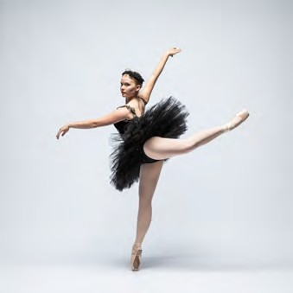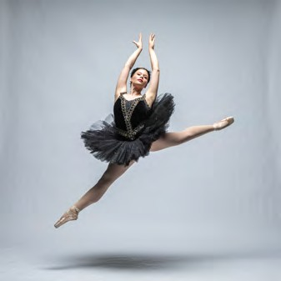

Upcoming Performances

Artist Manager Karson B. Denney 801-422-3575
karson_denney@byu.edu
Performing Arts Management 306 Hinckley Center
Provo, UT 801-422-3576
perform@byu.edu pam.byu.edu
Theatre Ballet
originates in the Department of Dance in the College of Fine Arts and Commu- nications at Brigham Young University in Provo, Utah.

