News Release Vocal Point
2023-2024 Season 801-422-3576 | pam.byu.edu
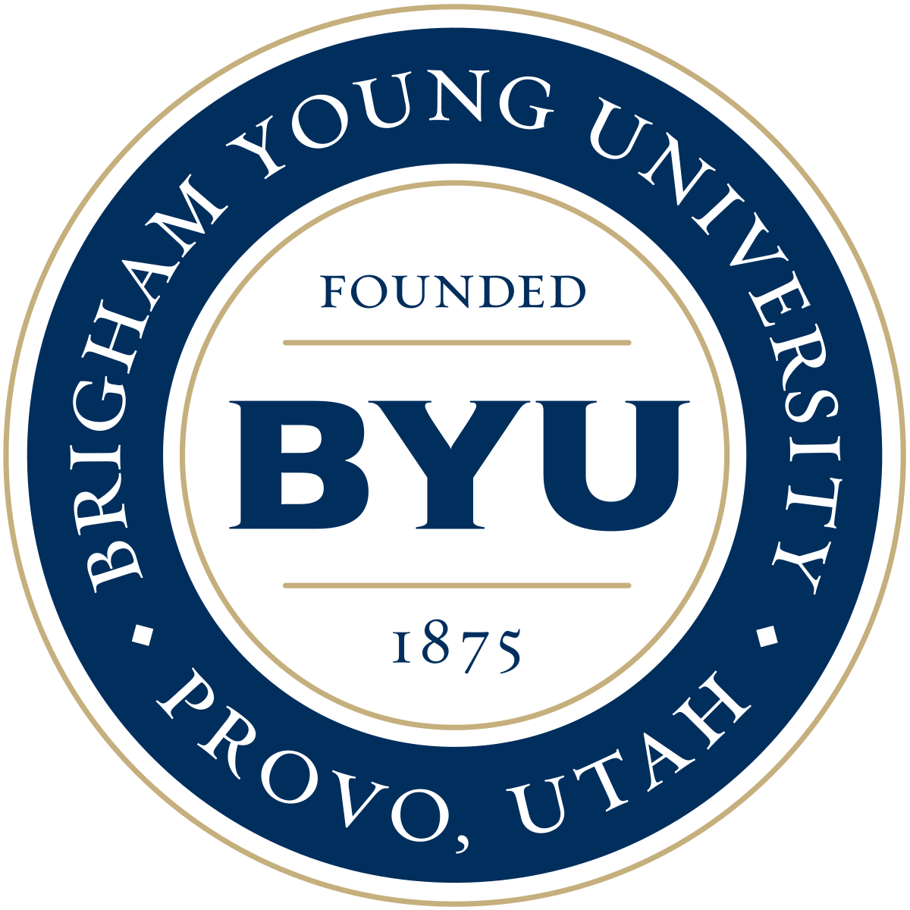
Performing Arts Management

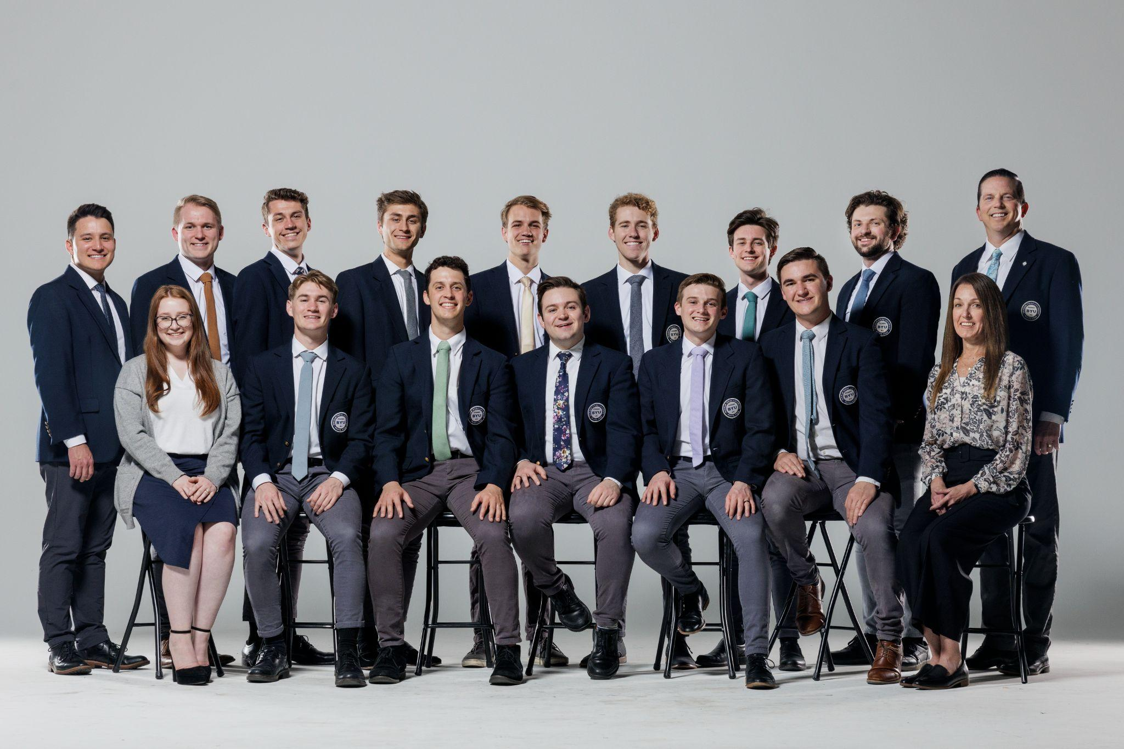

Vocal Point Creates Complex Music with Only 7 Voices
They have percussion without drums. They have a rhythm section without a bass. The only instruments on stage are the seven voices of the nationally renowned a cappella group Vocal Point. Brigham Young University’s Vocal Point captures audiences throughout the world with their stunning, high-energy performances and elaborate music videos.
With a wide range of vocal possibilities — and seeming impossibilities — these crowd-pleasers have it all: rock, pop, country, jazz and R&B that makes their family-friendly concerts a showstopper. Vocal Point takes the songs you are familiar with, revamps them and delivers a new rendition, complete with all the complex instrumentation done entirely with their mouths. Each Vocal Point member displays musicality, creativity and stage experience — a combination which adds up to original, skillful and spirited performances. “Well, that’s about the most professional group at the collegiate level anywhere,” says Deke Sharon, founder of the Contemporary A Cappella Society of America (CASA) and vocal producer of NBC’s The Sing-Off.
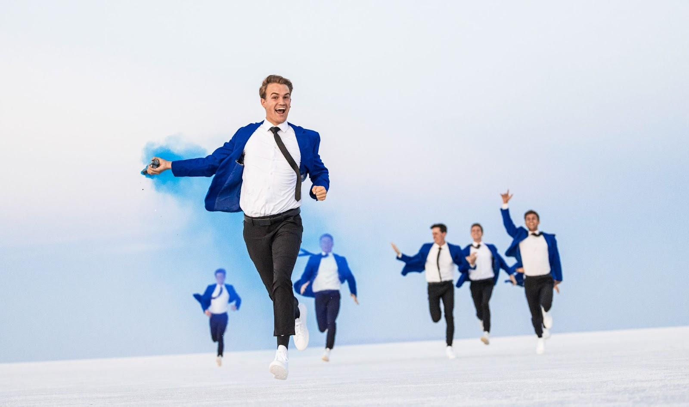


Vocal Point
In 2021, Vocal Point won an Emmy for their music video “Tarzan at the museum”. They also won the Gold Telly Award in 2021 and 2022 for their videos “We Don’t Talk About Bruno.” featuring Adassa and One Voice Children’s Choir and “What a Beautiful Name” featuring David Archuleta
In addition, the group was awarded CASA awards for Best Holiday Song, Best Religious Song, and Bet Lower Voices Collegiate Album. Besides performing on stage, recording albums and appearing on television, Vocal Point has produced over 50 music videos. In February of 2016, YouTube awarded Vocal Point’s channel with the Silver Play Button for surpassing 100,000 subscribers. As of 2024, they have more than 794,000 subscribers and 184 million total views. Vocal Point has performed live with legendary artists such as Ben Rector, Gladys Knight, Kristin Chenoweth, Colbie Caillat, Lee Greenwood, Lexi Mae Walker and Peter Hollens.

Artist Manager Performing Arts Management Vocal Point
Shane W. Wright 306 Hinckley Center originates in the office of
801-422-3579 Provo, UT Performing Arts Management
shane_wright@byu.edu 801-422-3576 at Brigham Young University
perform@byu.edu in Provo, Utah.
pam.byu.edu

