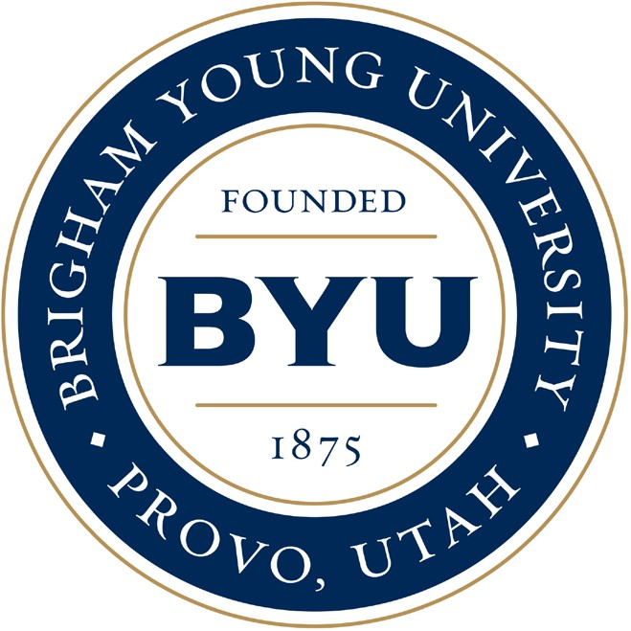
FOR IMMEDIATE RELEASE

News Release Young Ambassadors
2021-22 Season Performing Arts Management
801-422-3576 | pam.byu.edu

(To get the text version of this file, visit pam.byu.edu/young-ambassadors)

Young Ambassadors celebrate 50 years of singing and dancing

The BYU Young Ambassadors are celebrating the 50th Anniversary of their first appearance in the international spotlight at Expo ’70, in Osaka, Japan. Throughout the last 50 years, 1700 Young Ambassadors have traveled thousands of miles, visited 68 countries and met millions of new friends who long remember the group’s fast-paced choreography and beloved melodies. Young Ambassadors have captured the hearts of young and old through half a century of tours. Young Ambassadors continue their energetic tradition of song and dance as they recall their past travels in their new show — Souvenirs.
Young Ambassadors feature 20 of BYU’s best singers and dancers, and 10 of BYU’s finest instrumentalists in the Young Ambassador Showband. This showband is conducted by Professor Eric Hansen and features three show-stopping pieces, adding dynamic energy and class to Souvenirs. Come see the high-energy performance at (place) on (date) at (time).

Young Ambassadors

Young Ambassadors is a group filled with members who are excited to share their talents, experiences and love through their show, Souvenirs. The world-traveled troupe shares decades of the best in entertainment with music by recording artists Ed Sheeran, Billy Joel, Judy Garland, the Beach Boys, Rascal Flatts, Brad Paisley and Frank Sinatra. The Young Ambassador new show, Souvenirs, celebrates international friends around the globe whose association have influenced Young Ambassador company members while performing at home and in faraway places. Souvenirs features numbers from Broadway’s Dear Evan Hansen, Hairspray, Crazy for You, Dreamgirls, Bandstand and Spamalot, as well as songs from beloved children’s movies. International hits from pop stars such as the Beatles and Stevie Wonder round out their lineup for a memorable journey through some of your favorite songs over the past 50 years.
Since 2000, Young Ambassadors have been to Africa, Argentina, Australia, Brazil, Canada, China, Hong Kong, Japan, Korea, Russia, Scandinavia, Tasmania, the 2002 Winter Olympics, and throughout the U.S. Young Ambassadors have also performed for heads of state in Britian, Egypt, India, Japan, Jordan and the United States. Prominent past members include former Miss America Sharlene Wells Hawkes, Diamond Rio’s Dan Truman and Broadway favorites Christeena Michelle Riggs and Candese Marchese.
Throughout the world, Young Ambassadors are followed by a strong reputation as wholesome, professional entertainers. The group recently traveled to China this past summer to share their message and show. This year, they will take their show to cities in California, Idaho, Nevada, Wyoming and Japan.
Young Ambassadors represents the School of Music in cooperation with the Department of Dance from the College of Fine Arts and Communications at Brigham Young University in Provo, Utah. BYU is one of America’s largest private universities with more than 30,000 students from all over the United States and 100 foreign countries.

Artistic Director | Randy Boothe

In 1970, 18-year-old Young Ambassador member, Randy Boothe had no idea that only a few years later, in 1977 until the present day, he would travel the globe as Young Ambassadors’ artistic director. In addition to his work with Young Ambassadors, Boothe has directed Walt Disney Productions, Jackson Hole Playhouse and Hawaii’s Polynesian Cultural Center. Boothe’s productions have taken him around the globe with live and televised appearances in over 43 countries. His work was even seen during the 2002 Olympic Winter Games where he co-directed a major production involving hundreds of cast members. His musical groups have performed for children in hospitals and orphanages and for royalty and government officials in elegant concert halls.

Artistic Director | Eric Hansen
Eric Hansen’s time with Young Ambassadors began thirty years ago as a member of the group’s live band; he now returns as Young Ambassadors’ music producer and show band director. An alumnus of Johns Hopkins University’s Peabody Conservatory, Hansen has been able to turn his music education into a thriving career performing as principal bass with groups such as the Winnipeg Symphony Orchestra, Manitoba Chamber Orchestra, Musik Barock Ensemble, Talbot Chamber Orchestra, Great Music West Festival Orchestra and the National Chamber Orchestra in Washington, D.C. On returning to work with Young Ambassadors, Hansen says, “It is a deep joy and privilege for me to now be one of the directors, and particularly to be able to once again serve on the front lines of actively sharing the image, message, stature and values of BYU to the world.”

Upcoming Performances

January 8, 2022 at 7:00 p.m.
Maple Mountain High School
Spanish Fork, Utah

January 15, 2022 at 7:30 p.m.
Idaho Falls Civic Auditorium
Idaho Falls, Idaho

February 1, 2022 at 7:00 p.m.
Centennial Performing Arts Center
Boise, Idaho

February 2, 2022 at 7:00 p.m.
Art Fuller Auditorium
Kennewick, Washington

February 3, 2022 at 7:00 p.m.
Skyview High School
Vancouver, Washington

February 4, 2022 at 7:00 p.m.
Auburn Performing Arts Center
Auburn, Washington

February 5, 2022 at 7:00 p.m.
Washington Center
Olympia, Washington

March 5, 2022 at 2:00 p.m.
Conference Center Theater
Salt Lake City, Utah

March 5, 2022 at 7:00 p.m.
Conference Center Theater
Salt Lake City, Utah

Artist Manager Shane W. Wright 801-422-3579
shane_wright@byu.edu
Performing Arts Management 306 Hinckley Center
Provo, UT 801-422-3576
perform@byu.edu pam.byu.edu
Young Ambassadors originates in the School of Music and Department of Dance from the College of Fine Arts and Communications at Brigham Young University located in
Provo, Utah.

