FOR IMMEDIATE RELEASE

News Release
2022-23 Season

Young Ambassadors
Performing Arts Management 801-422-3576 | pam.byu.edu

(To get the text version of this file, visit pam.byu.edu/young-ambassadors)

The Young Ambassadors Present Thank You for the Music

It has been just over 50 years since the Young Ambassadors had their first appearance in the international spotlight at Expo ’70, in Osaka, Japan. Since then, 1700 Young Ambassadors have traveled thousands of miles, visited 68 countries and met millions of new friends who long remember the group’s fast-paced choreography and beloved melodies. Young Ambassadors have captured the hearts of young and old through half a century of tours. Young Ambassadors continue their energetic tradition of song and dance as they recall their past travels in their new show — Thank You for the Music.
Young Ambassadors feature 20 of BYU’s best singers and dancers, and 4 of BYU’s finest instrumentalists in the Young Ambassador Showband. This showband is conducted by Jarom Hansen and features show-stopping pieces, adding dynamic energy and class to Thank You for the Music. Come see the high-energy performance at (place) on (date) at (time).

Young Ambassadors
Young Ambassadors is a group filled with members who are excited to share their talents, experiences and love through their show, Thank You for the Music. The world-traveled troupe shares decades of the best in entertainment with music by the iconic Queen, ABBA, Whitey Houston, and a touch of the new Ed Sheeran, BTS, and Disney. The new Young Ambassador show, Thank You for the Music, presents the great musical hits of radio, stage, and screen, celebrating the songs by which we live our
lives. The songs from radio, tv, movies, and the Broadway stage have made us all who we are today and

the Young Ambassadors commemorate them through their mesmerizing musical escapade on stage. Thank You for the Music features numbers from Broadway’s "Guys and Dolls", "Wicked", "Newsies", and others round out their lineup for a memorable journey through some of your favorite songs over the past 50 years.
Since 1970, Young Ambassadors have been to Africa, Argentina, Australia, Brazil, Canada, China, Hong Kong, Japan, Korea, Russia, Scandinavia, Tasmania, the 2002 Winter Olympics, and throughout the
U.S. Young Ambassadors have also performed for heads of state in Britain, Egypt, India, Japan, Jordan and the United States. Prominent past members include former Miss America Sharlene Wells Hawkes, Diamond Rio’s Dan Truman and Broadway favorites Christeena Michelle Riggs and Candese Marchese.
Throughout the world, Young Ambassadors are followed by a strong reputation as wholesome, professional entertainers. The group recently traveled to Korea this past summer to share their message and show. This year, they will take their show to cities in Arizona, England, and Scotland.
Young Ambassadors represents the Department of Dance from the College of Fine Arts and Communications at Brigham Young University in Provo, Utah. BYU is one of America’s largest private universities with more than 30,000 students from all over the United States and 100 foreign countries.

Artistic Director | Nathan Balser

Nathan Balser is an associate professor of dance at Brigham Young University and the new artistic director of the Young Ambassadors. He completed his undergraduate degree from Brigham Young University with a BS in Therapeutic Recreation and his Master of Fine Arts in dance from the University of Utah.

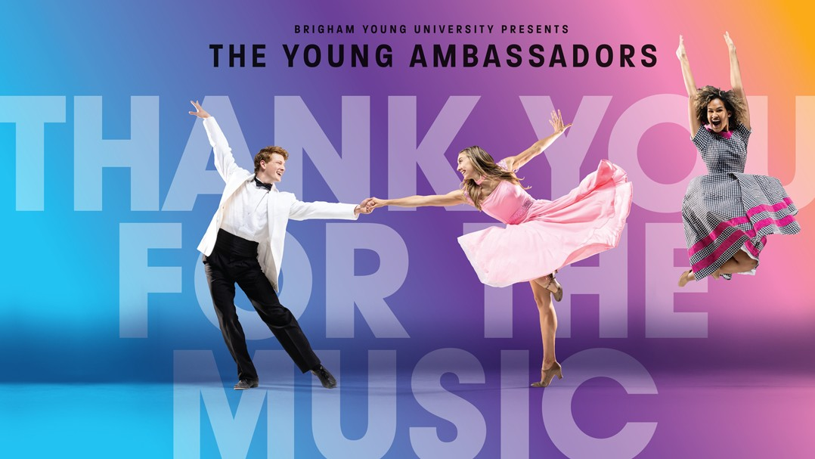
Nathan's professional career includes performing on Broadway in the revival cast of Promises, Promises with Kristen Chenoweth, 9 to 5: The Musical with Allyson Janney, Damn Yankees with Cheyenne Jackson, and Legally Blonde. He also appeared on CBS's Tony Awards, the Kennedy Center Honors, and the Macy's Thanksgiving Day Parade. Nathan danced professionally with choreographers and groups including Repertory Dance Theatre, Odyssey Dance, Molissa Fenley, John Malashock, Scott Rink, and Utah Regional Ballet.
Prior to his assignment as director of the Young Ambassadors, Nathan had multiple opportunities to set choreography on the group, traveling twice with them to China. Nathan also directed BYU's Contemporary Dance Theatre and choreographed at Sundance, Hale Center Theatre Orem, Lagoon Entertainment, Nauvoo, IL, and Utah COPA. He readily teaches workshops on dance, music, choreography and performance. He is married and has four beautiful children.

Upcoming Performances

November 1, 2022 at 7:00 p.m. George Gardner Performing Arts Center Holbrook, Arizona

November 2, 2022 at 7:00 p.m. David M. Player Center for the Arts
Safford, Arizona

November 3, 2022 at 7:00 p.m. Klein Center for the Performing Arts
Sierra Vista, Arizona

November 4, 2022 at 7:00 p.m.
Art Queen Creek Performing Arts Center Queen Creek, Arizona

November 5, 2022 at 7:00 p.m.
The Vista Center for the Arts Surprise, Arizona

Artist Manager Shane W. Wright 801-422-3579
shane_wright@byu.edu
Performing Arts Management 306 Hinckley Center
Provo, UT 801-422-3576
pam.byu.edu

Young Ambassadors originates in the School of Music and
Department of Dance from the College of Fine Arts and Communications at Brigham Young University located in
Provo, Utah.

