News Release
2021-22 Season

BYU Singers
Performing Arts Management 801-422-3576 | pam.byu.edu

FOR IMMEDIATE RELEASE

(To get the text version of this file, visit pam.byu.edu/byu-singers)

World Renowned Choral Ensemble to Appear in Concert

Directed by Dr. Andrew Crane, BYU Singers receives enthusiastic responses for its remarkable artistry and distinctive style. Since its formation in 1984, the ensemble has attracted international acclaim for spellbinding performances of music from a variety of genres, ranging from Renaissance motets to folk songs and spirituals. BYU Singers will be performing at (PLACE) on (DATE) at (TIME).

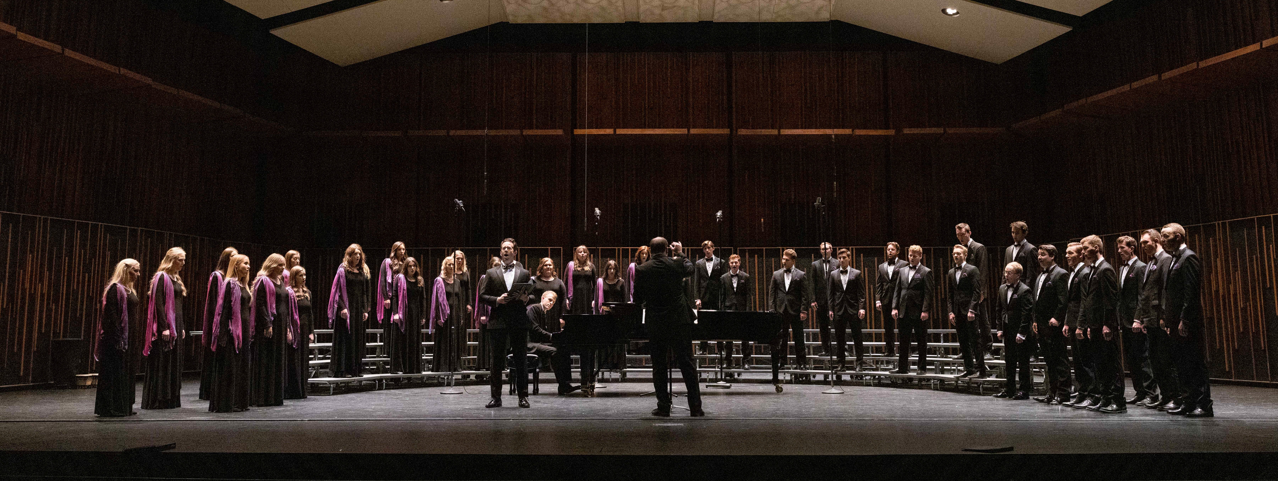

BYU Singers
The choir has performed in five continents and 27 countries including Russia, Romania, Vietnam, Austria, Indonesia, China, Italy, Israel, Egypt, New Zealand, and South Africa. In May 2021, BYU Singers placed first in the mixed choir category, and earned the overall Gran Prix award in the International Youth Choir Festival "Aegis Carminis." During the 2021-2022 season, the choir appeared with Broadway legend Brian Stokes Mitchell at the BYU Spectacular! and performed as part of "An Evening with Eric Whitacre and the BYU Choirs" in March 2022. BYU Singers will also embark on a tour of Estonia, Latvia, and Lithuania in the spring, during which they will perform by invitation at the 22nd International Stasys Šimkus Choir Competition.
The ensemble has received numerous awards and honors for performances given in choral festivals, at exclusive conferences, and in some of the most prestigious concert halls in the world. Former Director of Choral Studies at Northern Arizona University, Dr. Edith A. Copley, stated "I was very impressed with the choir's beautifully blended sound, clear diction, and expressive phrasing. Well-connected tone and impeccable intonation were present in every selection. Dr. Crane is a very fine conductor whose gestures free the voice and literally choreograph the music." BYU Singers consists of 40 students pursuing a variety of graduate and undergraduate degrees in such areas as physical science, law, accounting, social science, visual arts, and music. The ensemble originates in the School of Music of the College of Fine Arts & Communications at Brigham Young University in Provo, Utah. BYU is one of the nation’s largest private universities with an enrollment of more than 30,000 students from all parts of the United States and 120 foreign countries.

Artistic Director
Andrew Crane joined the BYU faculty in 2015, where his main duties include conducting the Brigham Young University Singers and teaching courses in the graduate conducting curriculum. Previous to this appointment, he served for four years as Director of Choral Activities at East Carolina University, and six years in the same position at California State University, San Bernardino. He is also the former choral director at Provo High School.
Choirs under his direction have appeared by invitation at multiple state, regional, and national conferences of the American Choral Directors Association, National Association for Music Education, and National
Collegiate Choral Organization. Recent examples include the 2019 ACDA national conference in Kansas City, the 2020 Utah Music Educators Association conference in St. George, and the 2020 Western Division ACDA conference in Salt Lake City. In 2022, Crane conducted the BYU Singers at the Western Division ACDA conference in Long Beach, CA.
International awards include BYU Singers’ first place distinction and overall Gran Prix win in the 2021 International Youth Choir Festival “Aegis Carminis.” In 2015, he conducted the East Carolina University Chamber Singers to first place honors at the 13th Maribor International Choral Competition Gallus, the only American choir to win in the history of the contest.
Dr. Crane is active as a conductor of honor choirs, clinician, adjudicator and presenter. He currently serves as Past President of Utah ACDA, and recently completed a four-year term on the national ACDA Standing Committee for Composition Initiatives. In addition, Crane curates a choral series under his name through Walton Music. He and his wife Casandria (also a BYU alumna) reside in American Fork, UT and are the parents of four children.

Upcoming Performances

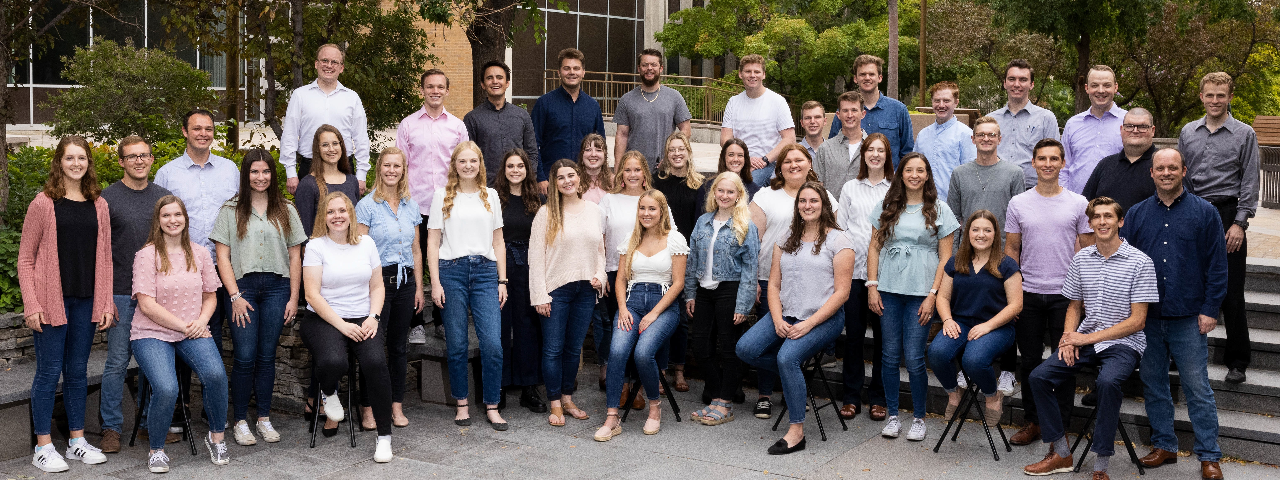
Artist Manager Stacey Christensen 801-422-3574
stacey_christensen@byu.edu
Performing Arts Management 306 Hinckley Center
Provo, UT 801-422-3576
perform@byu.edu pam.byu.edu
BYU Singers
originates in the School of Music of the College of Fine Arts and Communications at Brigham Young University in Provo, Utah.

