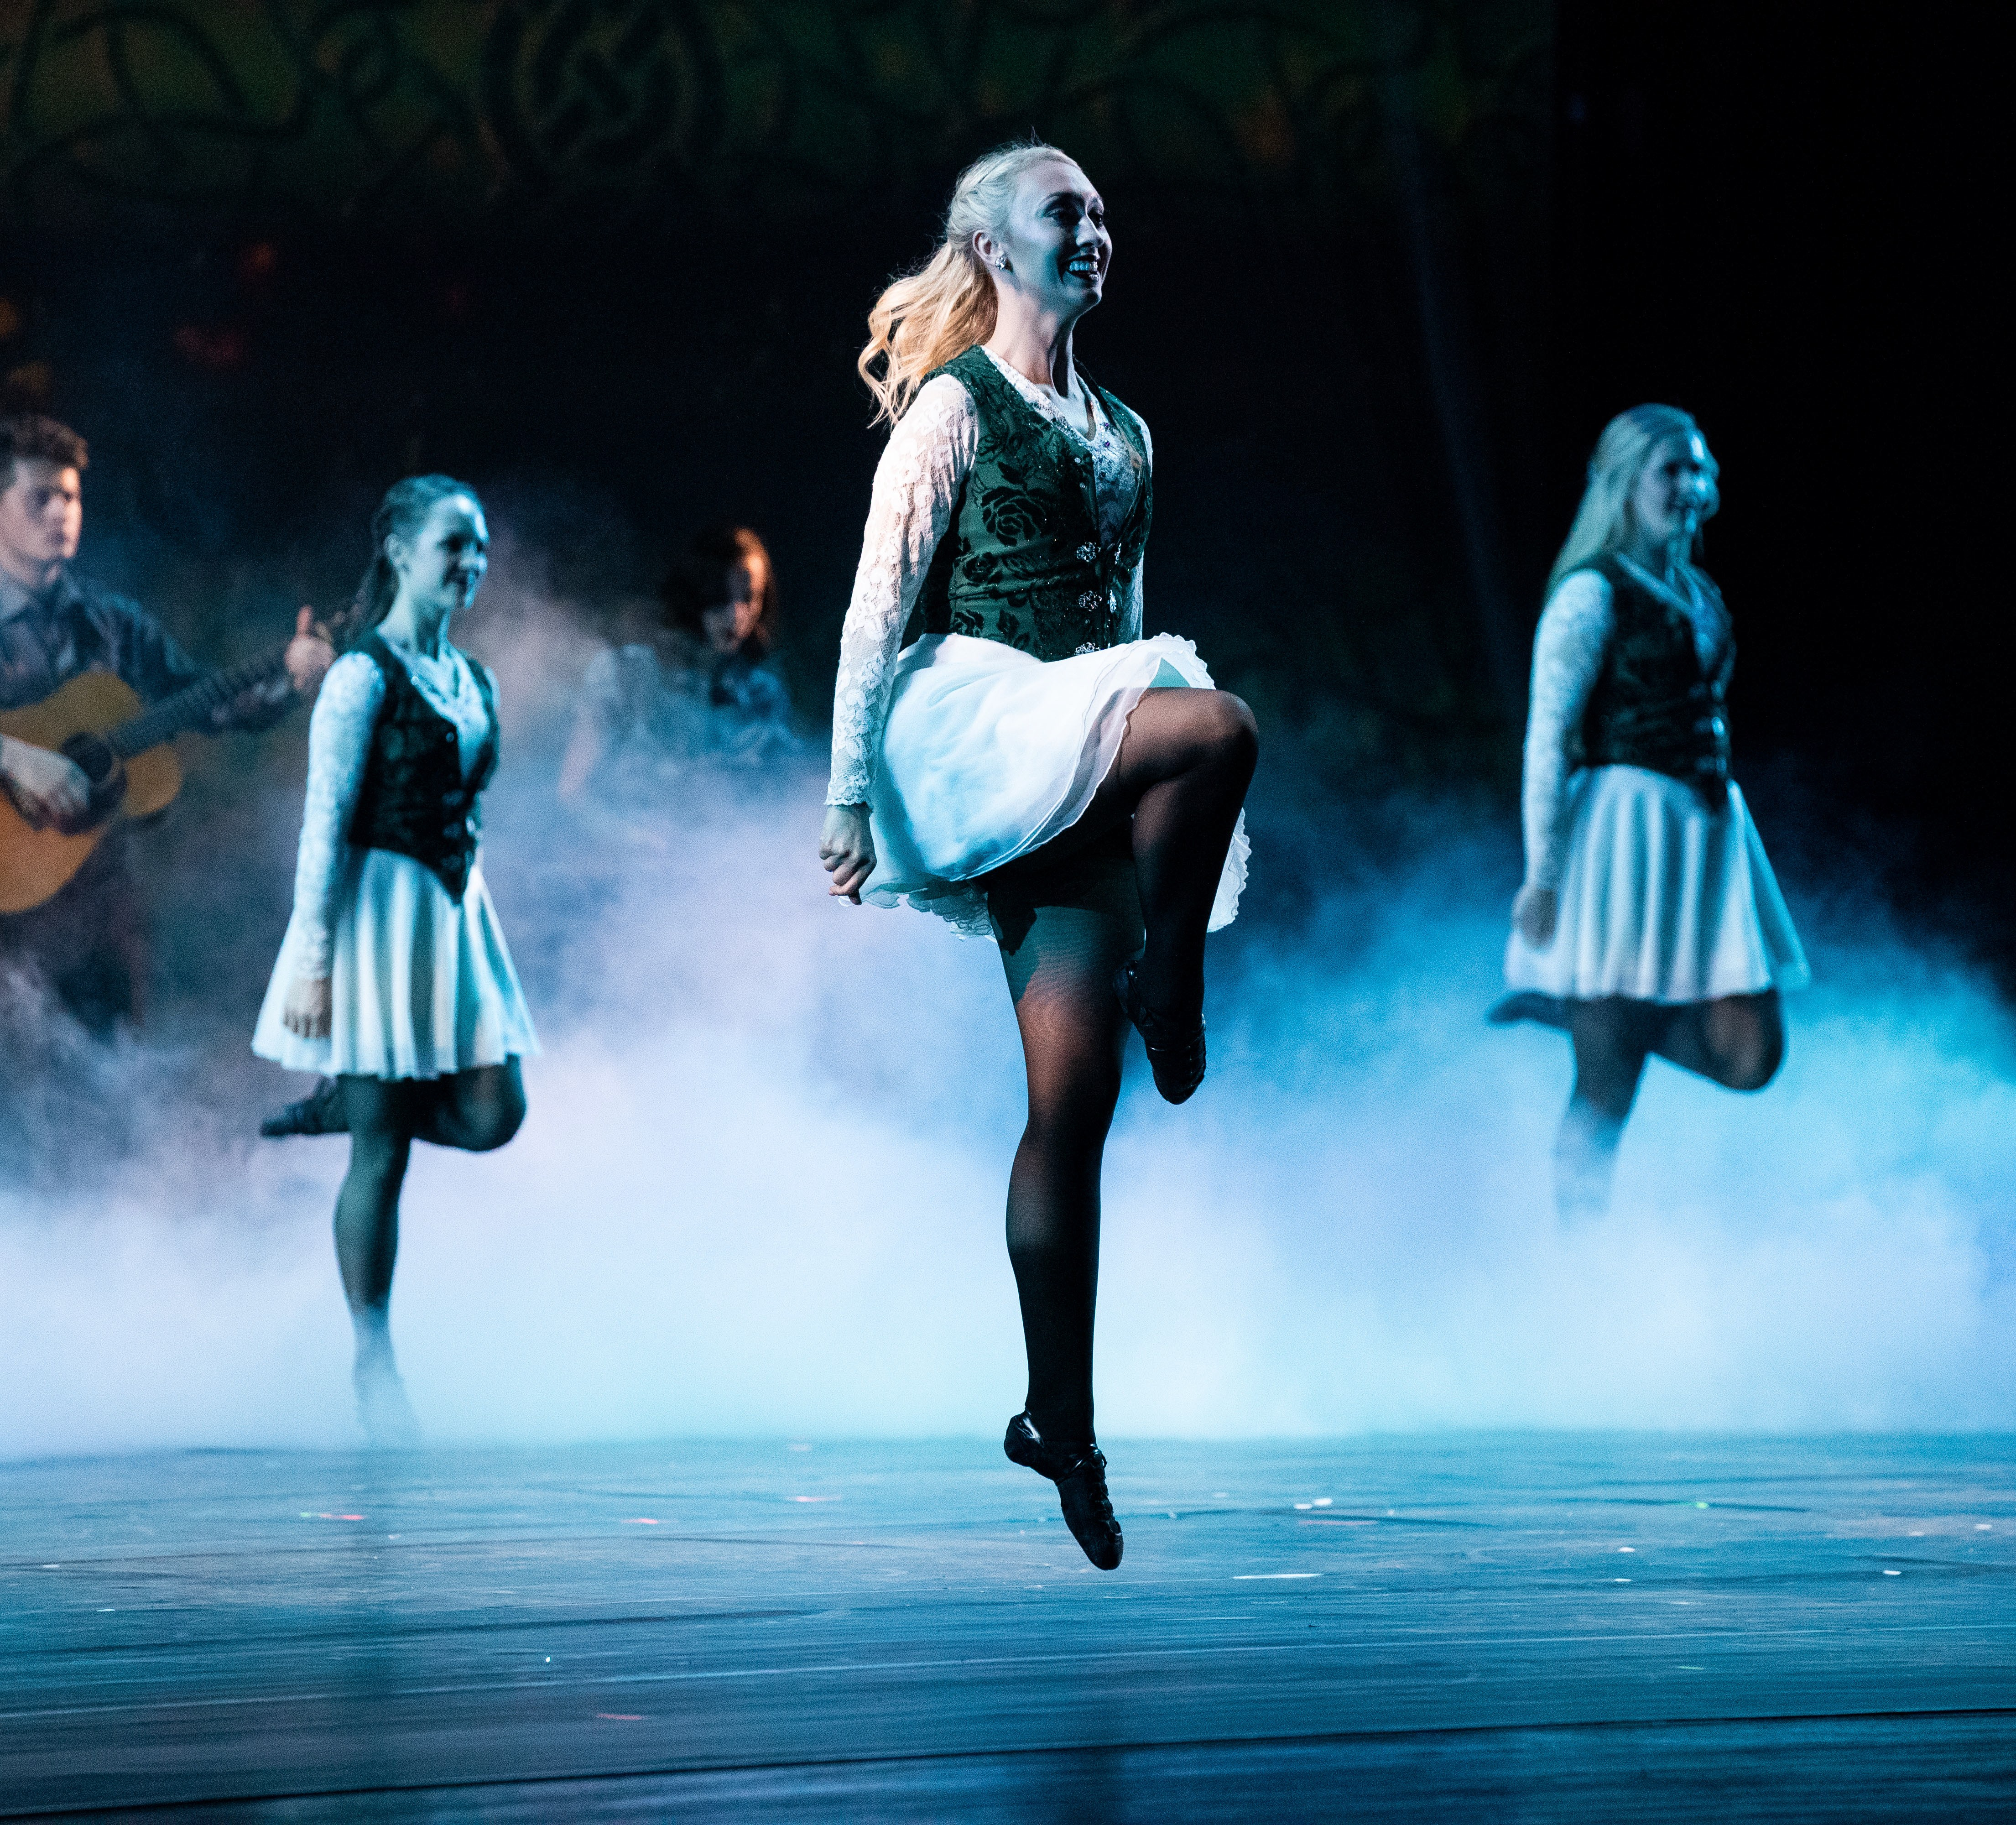
FOR IMMEDIATE RELEASE

News Release
2022-2023 Season
American Folk Dance Ensemble
Performing Arts Management 801-422-3576 | pam.byu.edu

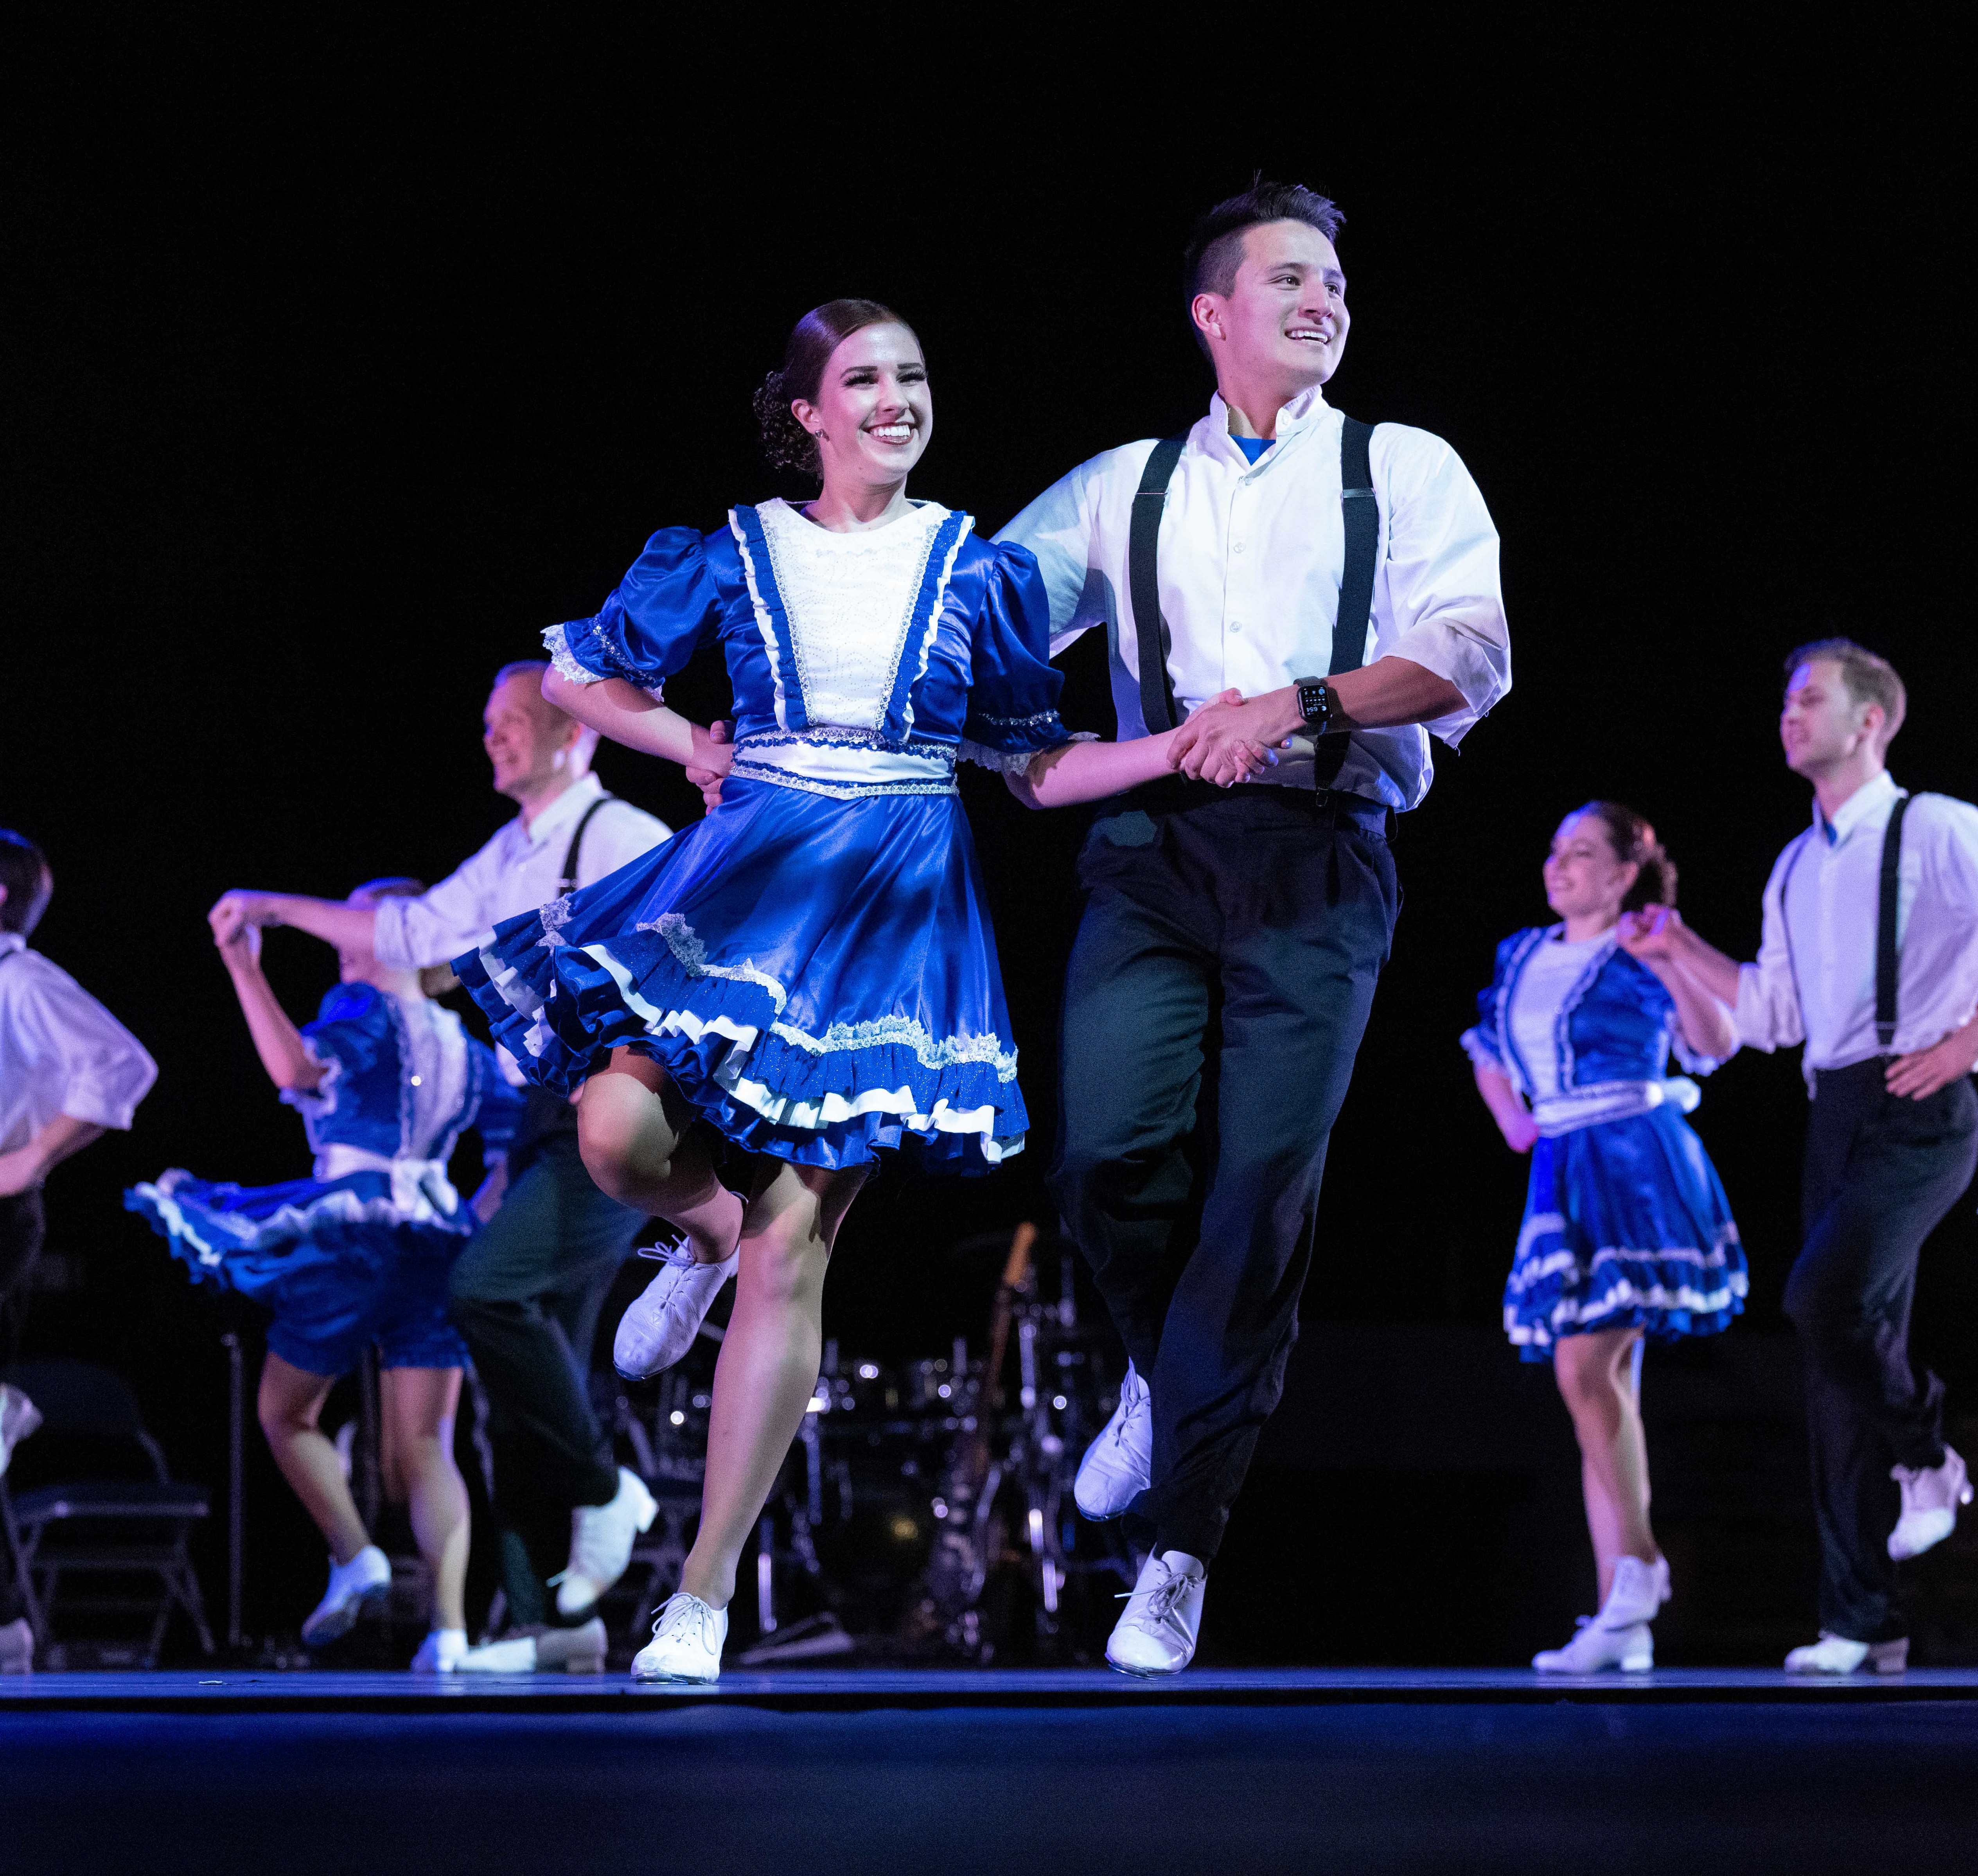

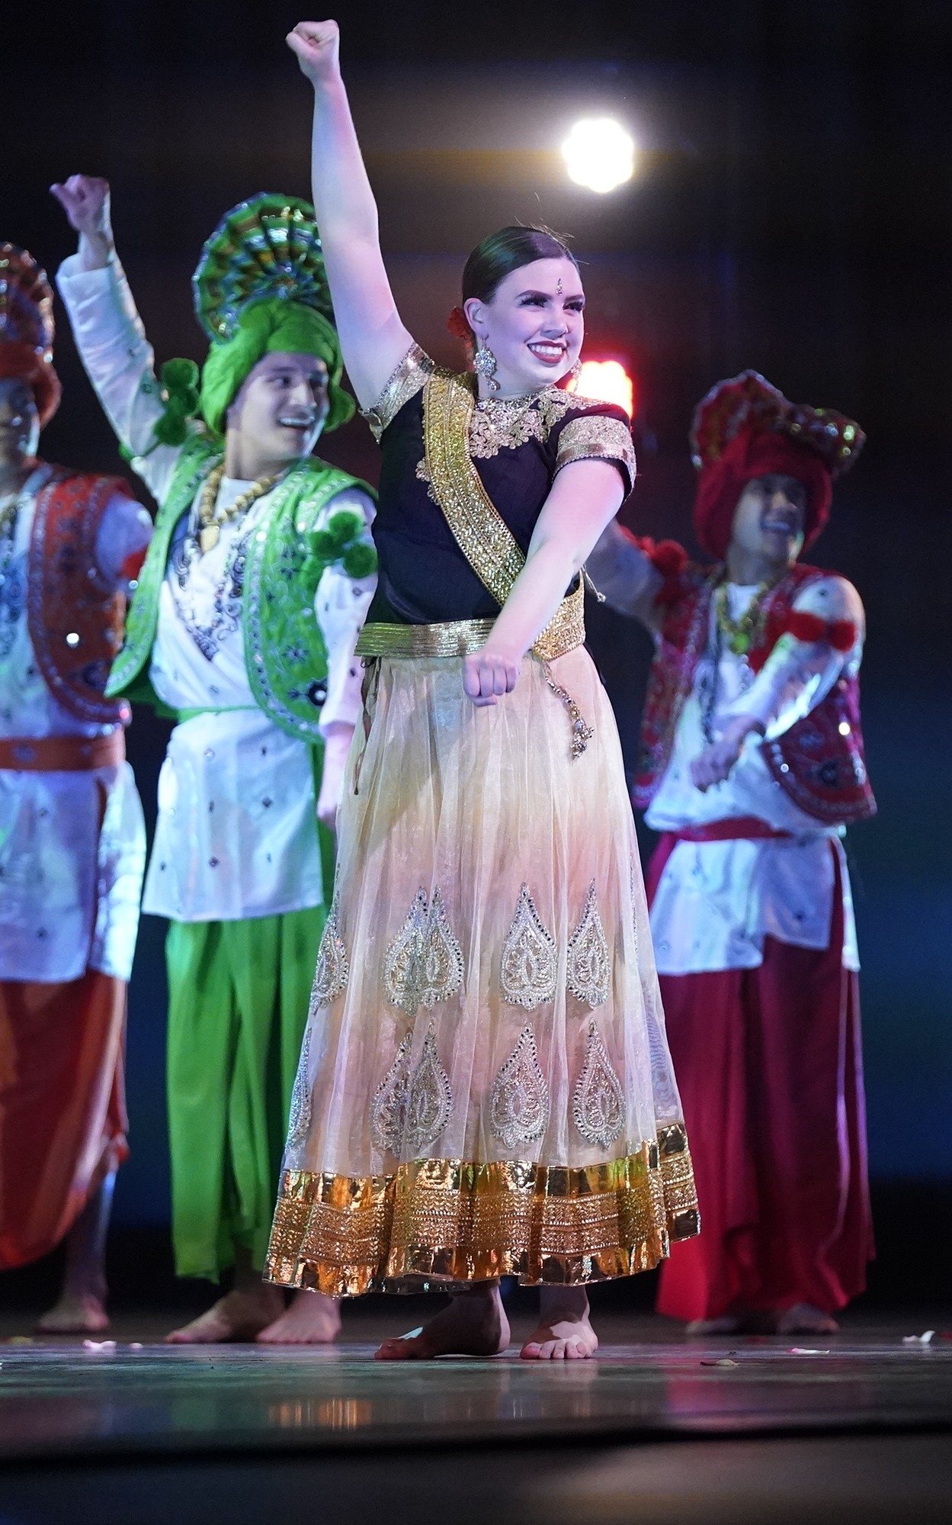
(To get the text version of this file, visit pam.byu.edu/international-folk-dance-ensemble)

International Folk Dance Ensemble Travels the World

Combining the ethnic traditions with exquisite costuming, Brigham Young University’s International Folk Dance Ensemble (IFDE) showcases the dance styles of the world and features the traditions of the United States at international folklore festivals. The ensemble offers one of the broadest spectrums of folk dance performed by a single group of its kind. Its extensive repertoire includes music and dance from all over the world including Europe, the Caribbean, and Asia. Members of IFDE are chosen by audition from among the most skilled performers involving more than 200 students.

International Folk Dance Ensemble

Under the artistic direction of Jeanette Geslison, the International Folk Dance Ensemble has achieved a global reputation for professionalism throughout the United States and in more than 40 countries worldwide. As an emissary of the United States and American traditions, the group has become internationally famous at the most prestigious folk dance festivals abroad, where they perform with many of the world’s finest dance companies. The ensemble was founded in 1956 and celebrated its 50th anniversary in 2006 by visiting the Baltic States and participating in the Mondial des Cultures de Drummondville, an international folk dance festival held in Drummondville, Quebec. In 2019, the ensemble took their repertoire to China as part of the BYU China Spectacular that included BYU groups such as Young Ambassadors, Vocal Point, Living Legends, the Cougarettes, the Dunk Team, and the Chamber Orchestra. In 2015, the group traveled throughout France where they performed in three festivals; The International Folklore Festival in Karlovac, Croatia; ‘Ciudad de Burgos’ International Folkloric Festival in Burgos, Spain; and the Extremadura Festival in Badajoz, Spain. Other prestigious festivals that have invited the group back at least five times include the International Folklore Festival in Haifa, Israel; the Festival de Confolens in Confolens, France; and the Billingham International Folklore Festival in Stockton-on-Tees, England.
The ensemble is made up of 28 dancers, 7 musicians, and 4 technicians. Combined, they form one of the most unique performing arts groups in the United States. Directed by Mark Geslison, IFDE’s folk music ensemble, Mountain Strings, provides the magic of live music for the group. Their traditional approach to music includes the banjo, the fiddle, and other acoustic instruments. They specialize in American, French-Canadian, and Celtic styles of music, the distinct sounds of spoons, bones, and bodhrans add percussive variety. The performers, all students at Brigham Young University, come from throughout the United States.
Careful attention is given to every detail of cultural representation in choreography. A spectacular variety of beautiful costumes recreate regional dress from throughout the country.
International Folk Dance Ensemble originates in the Department of Dance in the college of Fine Arts and Communications at Brigham Young University in Provo, Utah. BYU has the largest dance program of any university in the United States. BYU is among the nation’s largest private universities with more than 30,000 students from throughout the U.S. and 100 foreign countries.

Artistic Director

Working behind the scenes of the American Folk Dance Ensemble’s dazzling showcase of music and dance from the United States is artistic director Jeanette Geslison. Originating from Odense, Denmark Geslison was trained in classical ballet, jazz, and theatre. She attended Brigham Young University and performed with International Folk Dance Ensemble, another section of American Folk Dance from 1987-1991, and again from 1993-94.
Geslison has strong ties with the group; she has coordinated and directed program ensemble classes, has been a rehearsal specialist with IFDE since 1995, and has directed the group since 2011. Geslison received a Master’s in Fine Arts from the University of Wisconsin Milwaukee, where specialized in Hungarian dance. Her diverse background and wide array of experience has helped her to expand the repertoire of International Folk Dance Ensemble and allowed them to reach new horizons. Geslison currently serves as a committee chair for membership services in CIOFF-USA, an organization dedicated to safeguarding traditional and cultural folk arts as well as sponsoring international folk festivals.

Upcoming Performances

February 16, 2023 at 7:00 p.m.
Adams State University Alamosa, Colorado

February 17, 2023 at 7:00 p.m.
ENT Center for the Arts
Colorado Springs, Colorado

February 18, 2023 at 2:00 p.m.
Pace Center - Parke Arts Denver, Colorado

February 18, 2023 at 7:00 p.m.
Pace Center - Parke Arts Denver, Colorado

March 25, 2023 at 7:30 p.m.
Browning Center Ogden, UT

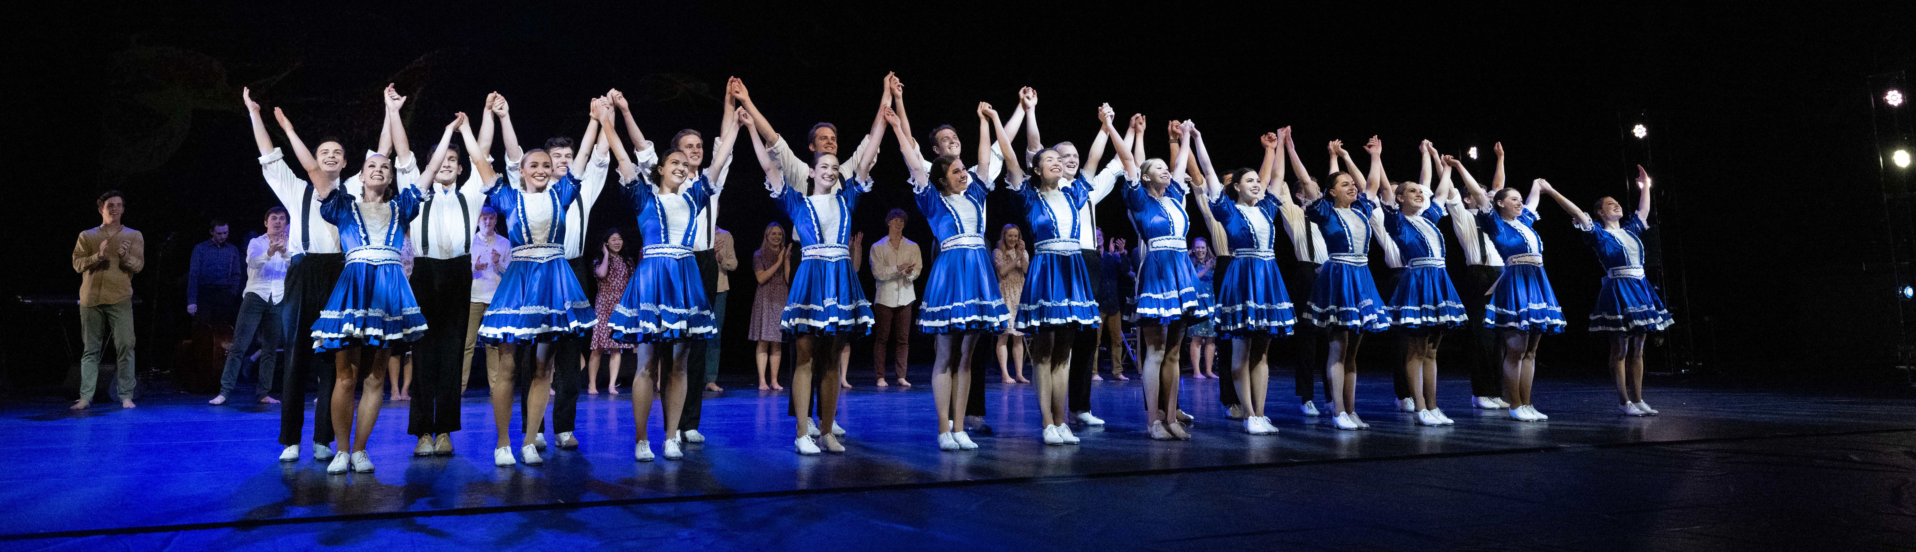
Artist Manager
Stacey Christensen
801-422-3574
stacey_christensen@byu.edu
Performing Arts Management
306 Hinckley Center
Provo, UT 801-422-3576
perform@byu.edu pam.byu.edu
American Folk Dance Ensemble
originates in the Department of Dance in the College of Fine Arts and Communications at Brigham Young University in Provo, Utah.

