
News Release American Folk Dance Ensemble
2024-2025 Season 801-422-3576 | pam.byu.edu
Performing Arts Management
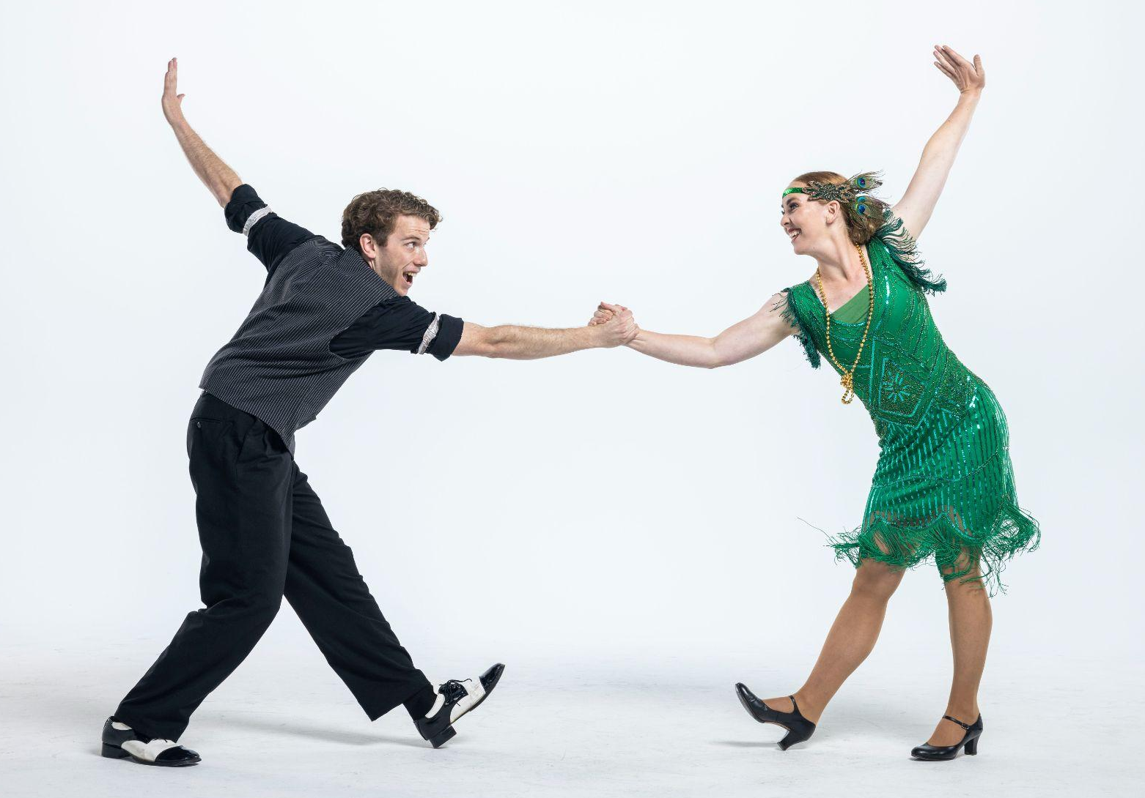


FOR IMMEDIATE RELEASE

(To get the text version of this file, visit pam.byu.edu/american-folk-dance-ensemble)

American Folk Dance Ensemble Relives History

Taking the back-country history of the United States around the world, the American Folk Dance Ensemble creates a colorful tapestry of the rich cultural history of the USA. Each performance is a cultural expression, strongly associated with a specific group or people as a reflection of American custom and belief. Their fast-paced, superbly staged program includes; Appalachian clogging, square dancing, western hoedown, western line and swing dancing, the classic Charleston and Lindy Hop, and other vibrant, energetic performances.
The American Folk Dance Ensemble not only brings the history of the U.S. to the stage through dance but also through weaving toe-taping music that explores the musical past of the U.S. The ensemble remains one of the most sought-after groups to perform at folk festivals around the world.

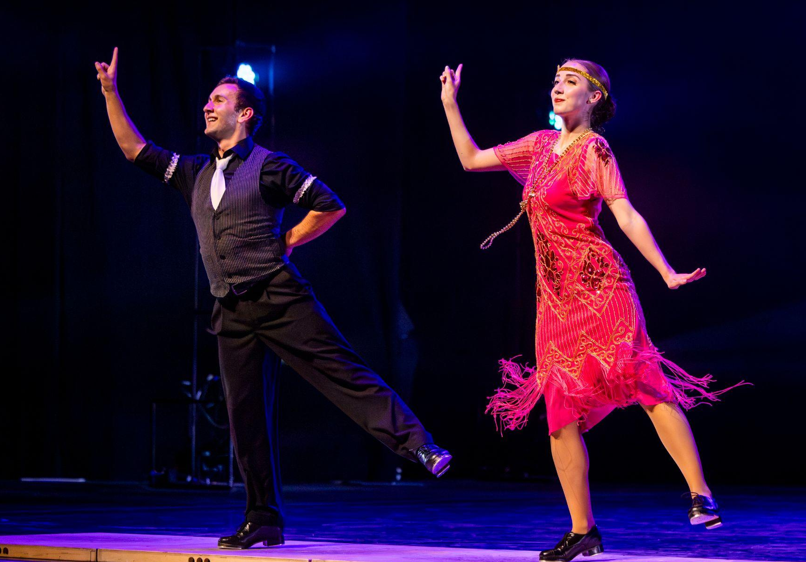
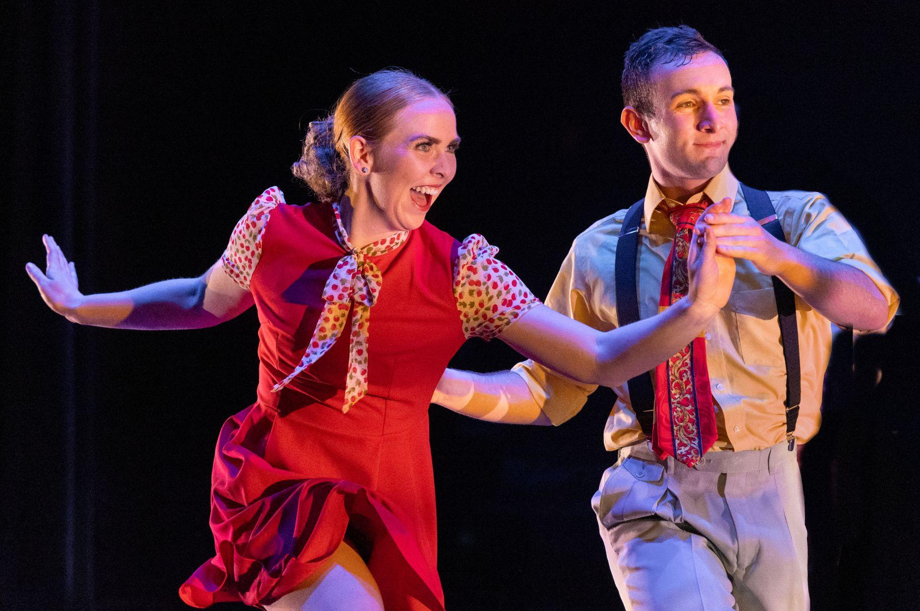
American Folk Dance Ensemble

The American Folk Dance Ensemble has attended 74 festivals in 37 countries since 1964. They have been invited back to the Mondial des Cultures de Drummondville in Quebec, Canada more than any other group in the festival’s history. In 2024, the ensemble performed in the Vallarta Azteca International Folk Dance Festival in Mexico before touring the Southern United States. In 2023, the group participated in the international CIOFF folk festivals in Czechia and the Danube Carnival Festival in Hungary. In 2022, they performed at Hello!Schoten Folk Festival and festivals throughout Belgium, Cacak, Serbia, and Bitola, Macedonia. Additionally, they enjoyed a cultural exchange with Folklorni Ansambl "Vila" in Novi Sad, Serbia. During 2019, the ensemble traveled to Europe to perform in both the Hello Schoten Festival in Belgium and the International Folklore Festival 'Eurofolk' in Zamosc, Poland. Other prestigious festivals have invited the group back at least five times, including International Folklore Festival in Haifa, Israel; the Festival de Confolens in Confolens, France; and the Billingham International Folklore Festival in Stockton-on-Tees, England.
The ensemble is made up of 28 dancers and 7 musicians. Combined, they form one of the most unique groups of performing arts in the United States. Mountain Strings, the group’s accompanying live band, is featured throughout the concert and adds the rhythm of bluegrass and old-time, foot-stomping music. Their sound makes use of the banjo, fiddle, mandolin, and other acoustic instruments. Their American musical styles range from Appalachian folk to bluegrass, Cajun, blues, and country. The performers, all students at Brigham Young University, come from throughout the United States.
“An extraordinary amount of time, talent, and resources go into a production of this size,” said former American Folk Dance Ensemble director, Edwin Austin. “The program, however, goes much deeper than pure entertainment. The production is steeped in tradition--an attempt to preserve fragments of the American past.” Careful attention is given to every detail of cultural representation in choreography and music. A spectacular variety of beautiful costumes recreate regional dress from throughout the country.

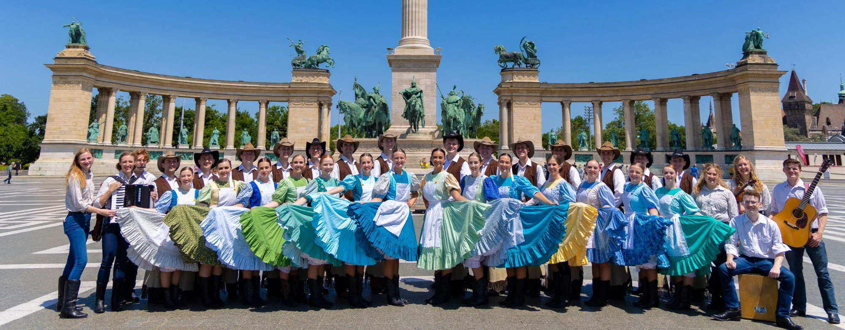
Artistic Director
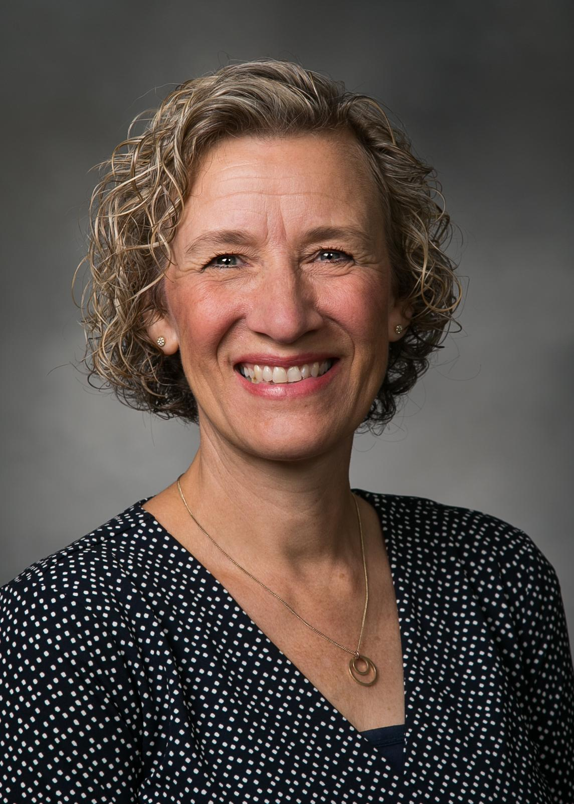
Working behind the scenes of the American Folk Dance Ensemble’s dazzling showcase of music and dance from the United States is artistic director Jeanette Geslison. Geslison is from Odense, Denmark where she was trained in classical ballet, jazz, and theatre. She attended Brigham Young University and performed with International Folk Dance Ensemble, another section of American Folk Dance from 1987-1991, and again from 1993-94.
Geslison has strong ties with the group; she has coordinated and directed program ensemble classes, has been a rehearsal specialist with IFDE since 1995, and has directed the group since 2011. Geslison received a Masters in Fine Arts from the University of Wisconsin Milwaukee, where she specialized in Hungarian dance. Her diverse background and wide array of experience has helped her to expand the International Folk Dance Ensemble's repertoire and reach new horizons. Geslison currently serves as a committee chair for membership services in CIOFF-USA, an organization dedicated to safeguarding traditional and cultural folk arts as well as sponsoring international folk festivals.

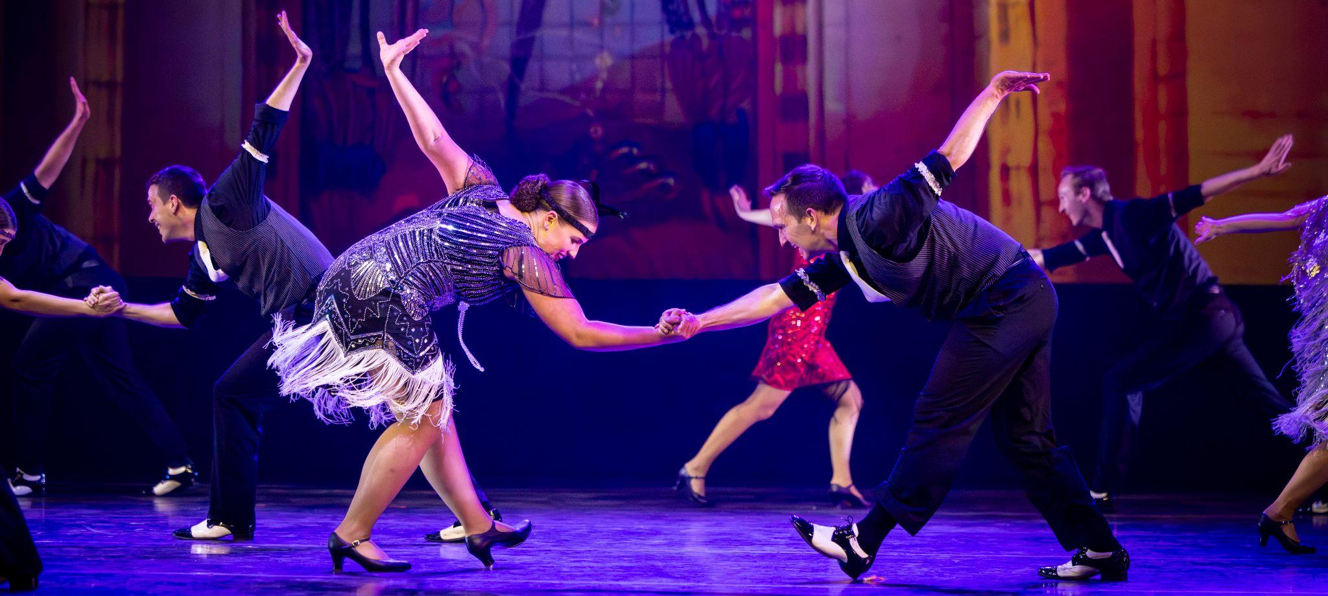
Upcoming Performances

November 4, 2024 at 7:00 pm
Caldwell Fine Arts
Caldwell, Idaho

November 5, 2024 at 7:00 pm
Four Rivers Cultural Center
Ontario, Oregon

November 6, 2024 at 7:00 pm
Sisters High School Auditorium
Sisters, Oregon

November 7, 2024 at 7:00 pm
The Dalles High School Auditorium
The Dalles, Oregon

November 8, 2024 at 7:00 pm
The LaSells Stewart Center
Corvallis, Oregon

November 9, 2024 at 7:00 pm
LCC Ragozzino Performance Hall
Eugene, Oregon
Artist Manager Performing Arts Management American Folk Dance Ensemble
Stacey Christensen 306 Hinckley Center originates in the School of Dance
801-422-3574 Provo, UT in the College of Fine Arts stacey_christensen@byu.edu 801-422-3576 and Communication at Brigham
perform@byu.edu Young University in Provo, Utah.
pam.byu.edu

