FOR IMMEDIATE RELEASE

News Release

2022-2023 Season
American Folk Dance Ensemble
Performing Arts Management 801-422-3576 | pam.byu.edu

(To get the text version of this file, visit pam.byu.edu/american-folk-dance-ensemble)

American Folk Dance Ensemble Relives History

Taking the back-country history of the United States around the world, the American Folk Dance Ensemble creates a colorful tapestry of the rich cultural history of the USA. Each performance is a cultural expression, strongly associated with a specific group or people as a reflection of American custom and belief. Their fast-paced, superbly staged program includes; Appalachian clogging, square dancing, western hoedown, western line and swing dancing, the classic Charleston and Lindy Hop, and other vibrant, energetic performances.
The American Folk Dance Ensemble not only brings the history of the U.S. to the stage through dance but also through weaving toe-taping music that explores the musical past of the U.S. The ensemble remains one of the most sought-after groups to perform at folk festivals around the world.

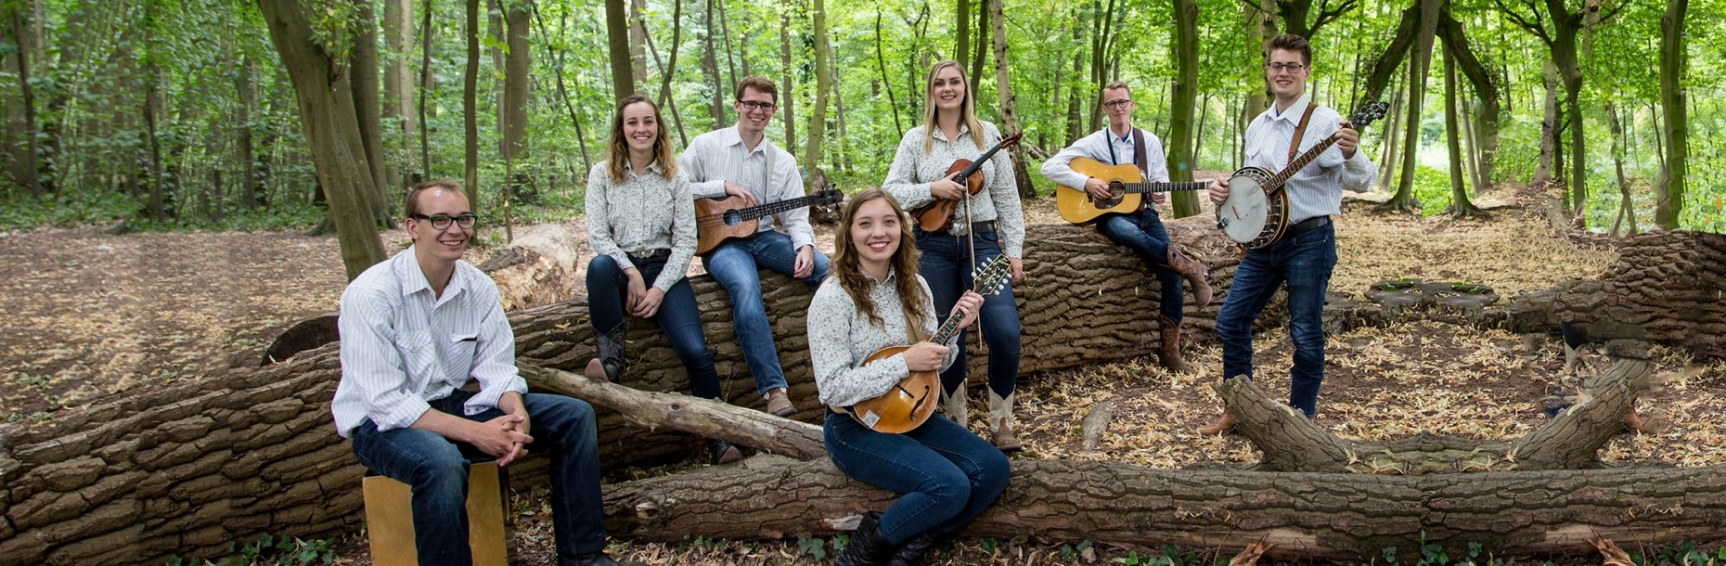
American Folk Dance Ensemble

American Folk Dance Ensemble has attended 34 festivals in 31 countries since 1964. They have been in- vited back to the Mondial des Cultures de Drummondville in Quebec, Canada more than any other group in the festival’s history. In 2022, the group participated in the international CIOFF folk festivals in Shoten, Belgium, Cacak, Serbia, and Bitola, Macedonia. Additionally, they enjoyed a cultural exchange with Folklorni Ansambl
"Vila" in Novi Sad, Serbia. During 2019, the ensemble traveled to Europe to perform in two international folk festivals; The Hello Schoten Festival in Belgium and the International Folklore Festival 'Eurofolk' in Zamosc, Poland. Other prestigious festivals have invited the group back at least five times, including International Folklore Festival in Haifa, Israel; the Festival de Confolens in Confolens, France; and the Billingham International Folklore Festival in Stockton-on-Tees, England.
The ensemble is made up of 26 dancers and 7 musicians. Combined, they form one of the most unique groups of performing arts in the United States. Mountain Strings, the group’s accompanying live music ensemble, is featured throughout the concert and adds the rhythm of bluegrass and old-time, foot-stomping music. Their traditional approach to music includes the banjo, fiddle, mandolin, and other acoustic instruments. Their American musical styles range from Appalachian folk to bluegrass, Cajun, blues, and country. The performers, all students at Brigham Young University, come from throughout the United States.
“An extraordinary amount of time, talent, and resources go into a production of this size,” said former American Folk Dance Ensemble director, Edwin Austin. “The program, however, goes much deeper than pure entertainment. The production is steeped in tradition--an attempt to preserve fragments of the American past.” Careful attention is given to every detail of cultural representation in choreography and music. A spectacular variety of beautiful costumes recreate regional dress from throughout the country.
American Folk Dance Ensemble originates in the Department of Dance in the college of Fine Arts and Communications at Brigham Young University in Provo, Utah. BYU has the largest folk dance program of any university in the United States. BYU is among the nation’s largest private universities with more than 30,000 students from throughout the U.S. and 100 foreign countries.

Artistic Director

Working behind the scenes of the American Folk Dance Ensemble’s dazzling showcase of music and dance from the United States is artistic director Jeanette Geslison. Geslison is from Odense, Denmark where she was trained in classical ballet, jazz, and theatre. She attended Brigham Young University and performed with International Folk Dance Ensemble, another section of American Folk Dance, from 1987-1991, and again from 1993-94. Geslison has strong ties with the group; she has coordinated and directed program ensemble classes, has been a rehearsal specialist with IFDE since 1995, and has directed the group since 2011. Geslison received a Masters in Fine Arts from the University of Wisconsin Milwaukee, where she specialized in Hungarian dance. Additionally, Geslison's choreographic interest extends to cultural representation—its preservation, adaptation, and modification—lies at the heart of her academic research. Her goal is to continue contribution to the field of cultural dance research and choreography in search of new ways to perpetuate the authenticity and increase the power of the communication of cultural dance expression.
Geslison's diverse background and wide array of experience has helped her
to expand the American Folk Dance Ensemble's repertoire and reach new horizons. Geslison currently serves as a committee chair for membership services in CIOFF-USA, an organization dedicated to safeguarding traditional and cultural folk arts as well as sponsoring international folk festivals.

Upcoming Performances

The American Folk Dance Ensemble has been invited to participate in international CIOFF folk festivals in June 2023, including the 28th Danube Carnival and IFF Strážnice.

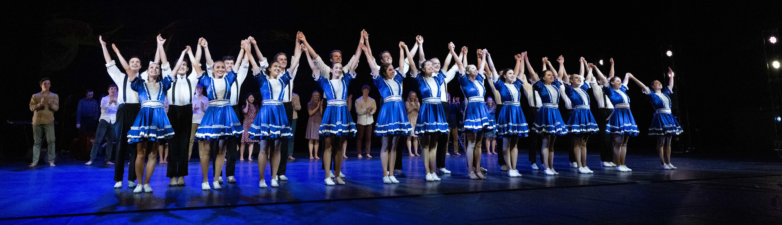
Artist Manager Stacey Christensen 801-422-3574
stacey_christensen@byu.edu

Performing Arts Management 306 Hinckley Center
Provo, UT 801-422-3576
perform@byu.edu pam.byu.edu

American Folk Dance Ensemble originates in the Department of Dance in the College of Fine Arts and Communications at Brigham Young University in Provo, Utah.

