News Release Noteworthy and 2023-2024 Season Vocal Point
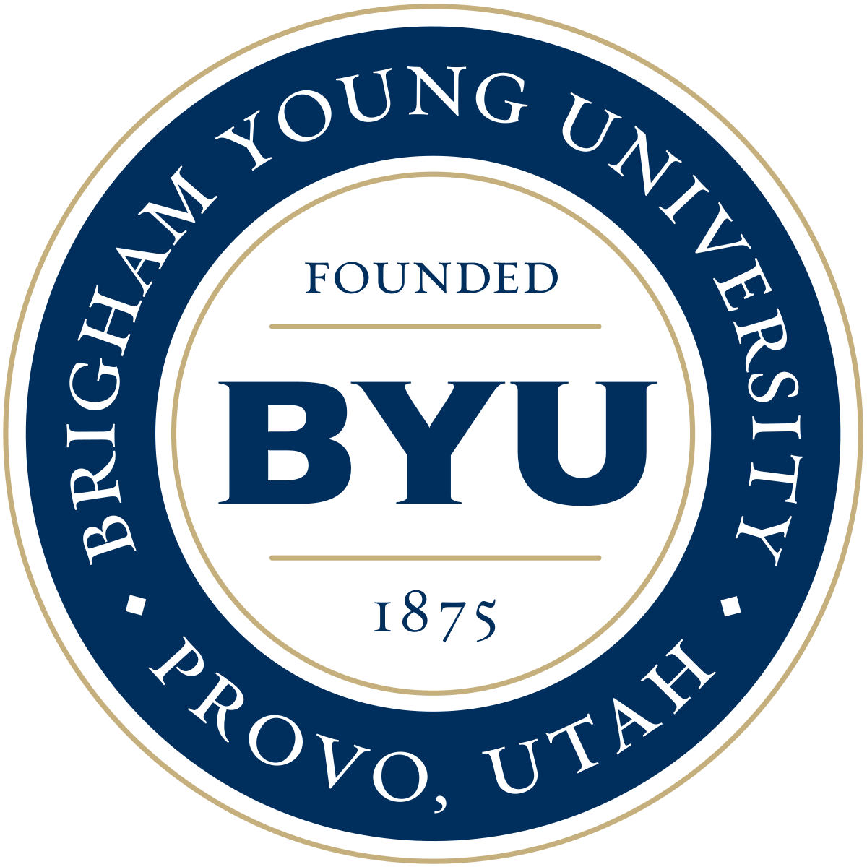
Performing Arts Management 801-422-3576 | pam.byu.edu

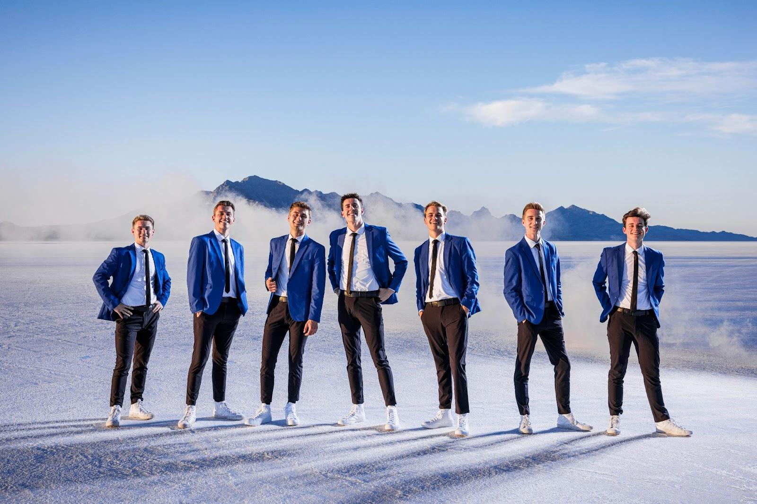
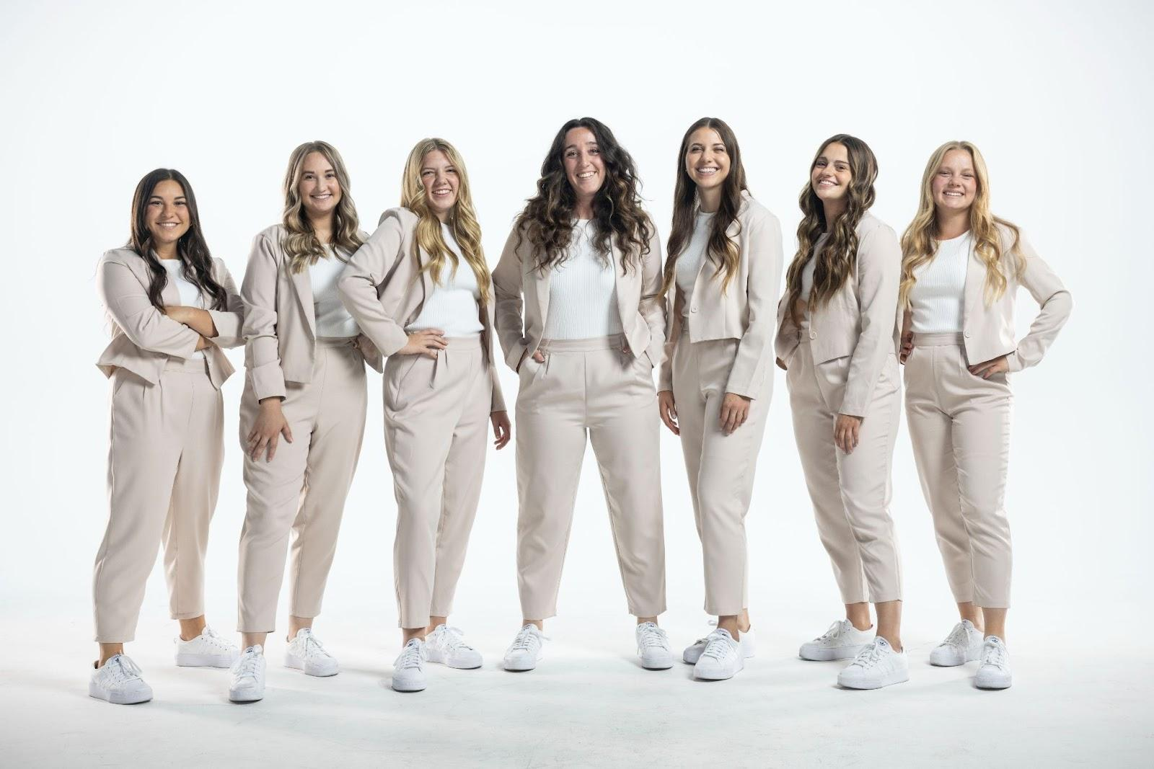

Noteworthy and Vocal Point: No Instruments, No Problem
They have percussion without drums. They have rhythm without a bass. The only instruments on stage are the fourteen voices of the nationally renowned a cappella groups Vocal Point and Noteworthy. Brigham Young University’s premier a cappella ensemble captivates audiences throughout the world with their stunning, high-energy performances and elaborate music videos.
With a wide range of vocal possibilities — and seeming impossibilities — these family-friendly crowd-pleasers have it all: rock, pop, country, jazz and R&B. Noteworthy and Vocal Point take the songs you are familiar with, revamp them and deliver a new rendition, complete with all the complex instrumentation done entirely with their mouths. Each ensemble member displays musicality, creativity and stage experience — which results in original, skillful and spirited performances. “Well, that’s about the most professional group at the collegiate level anywhere,” says Deke Sharon, founder of the Contemporary A Cappella Society of America (CASA) and vocal producer of NBC’s The Sing-Off.
Vocal Point and Noteworthy originate in the office of Performing Arts Management at Brigham Young University in Provo, Utah. BYU is one of the nation’s largest private universities with an enrollment of more than 30,000 full time students from throughout the United States and 100 foreign countries.

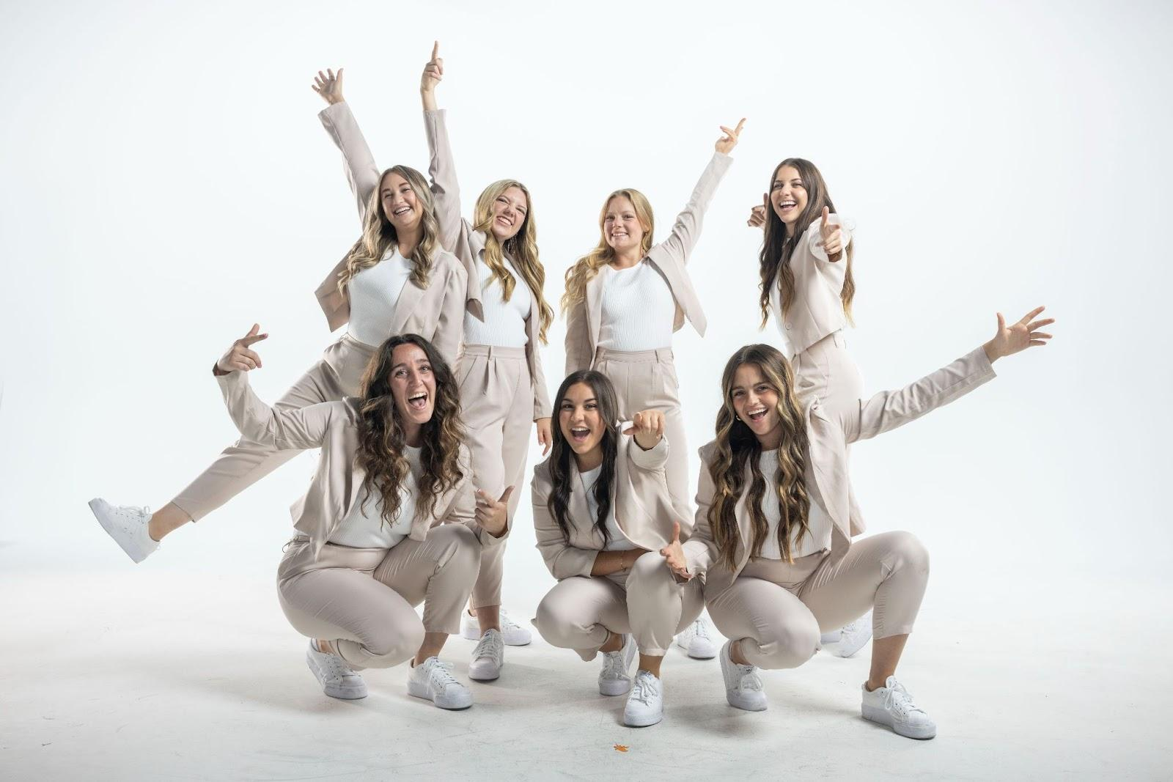
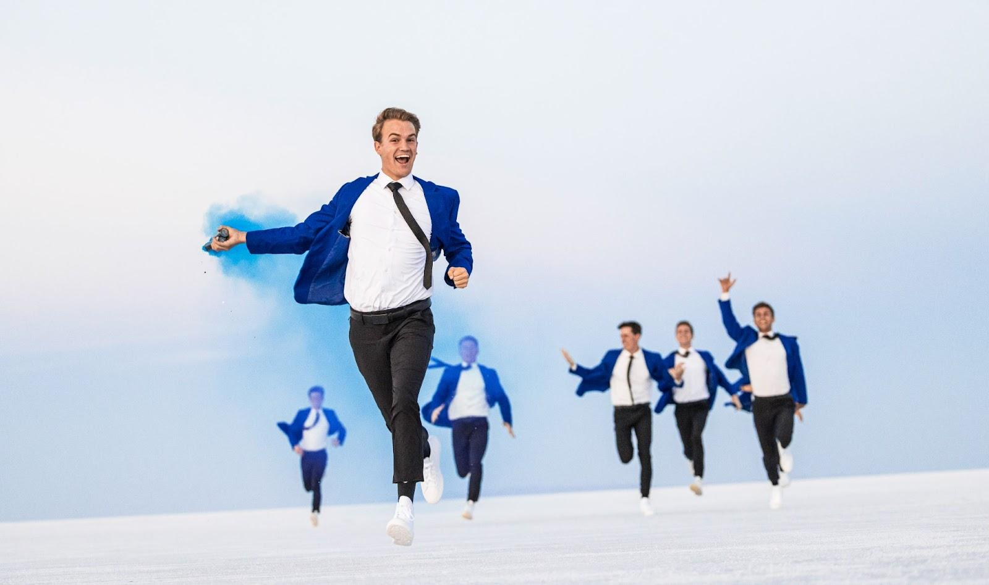

Vocal Point
In 2021, Vocal Point won an Emmy for their music video “Tarzan at the museum”. They also won the Gold Telly Award in 2021 and 2022 for their videos “We Don’t Talk About Bruno.” featuring Adassa and One Voice Children’s Choir and “What a Beautiful Name” featuring David Archuleta
In addition, the group was awarded CASA awards for Best Holiday Song, Best Religious Song, and Bet Lower Voices Collegiate Album. Besides performing on stage, recording albums and appearing on television, Vocal Point has produced over 50 music videos. In February of 2016, YouTube awarded Vocal Point’s channel with the Silver Play Button for surpassing 100,000 subscribers. As of 2024, they have more than 794,000 subscribers and 184 million total views. Vocal Point has performed live with legendary artists such as Ben Rector, Gladys Knight, Kristin Chenoweth, Colbie Caillat, Lee Greenwood, Lexi Mae Walker and Peter Hollens.

Noteworthy
In 2024 BYU Noteworthy won a Bronze Telly Award for their music video “O Holy Night”. Since then, Noteworthy has continued to pave their path to success with three CASA Awards for Best Pop Song, Best Upper Voices Collegiate Album and BEst Upper Voices Collegiate Song. Their presence online is ever-growing with more than 77 million views on YouTube. Over the years they toured to Texas, Alaska, Arizona, Idaho, Illinois, Nevada, Oregon, Texas, Utah, and Wyoming. In 2024, they embarked on their first international tour to South Korea, Japan, and Mongolia. Noteworthy has released several studio albums and collaborated with a wide variety of artists including violinist Keith Goodrich and the BYU Cougarettes.

Upcoming Performances

Noteworthy and Vocal Point will be touring Arizona in January of 2025.

Artist Manager Performing Arts Management Noteworthy and Vocal Point
Shane W. Wright 306 Hinckley Center originate in the office of
801-422-3579 Provo, UT Performing Arts Management
shane_wright@byu.edu 801-422-3576 at Brigham Young University
perform@byu.edu in Provo, Utah.

