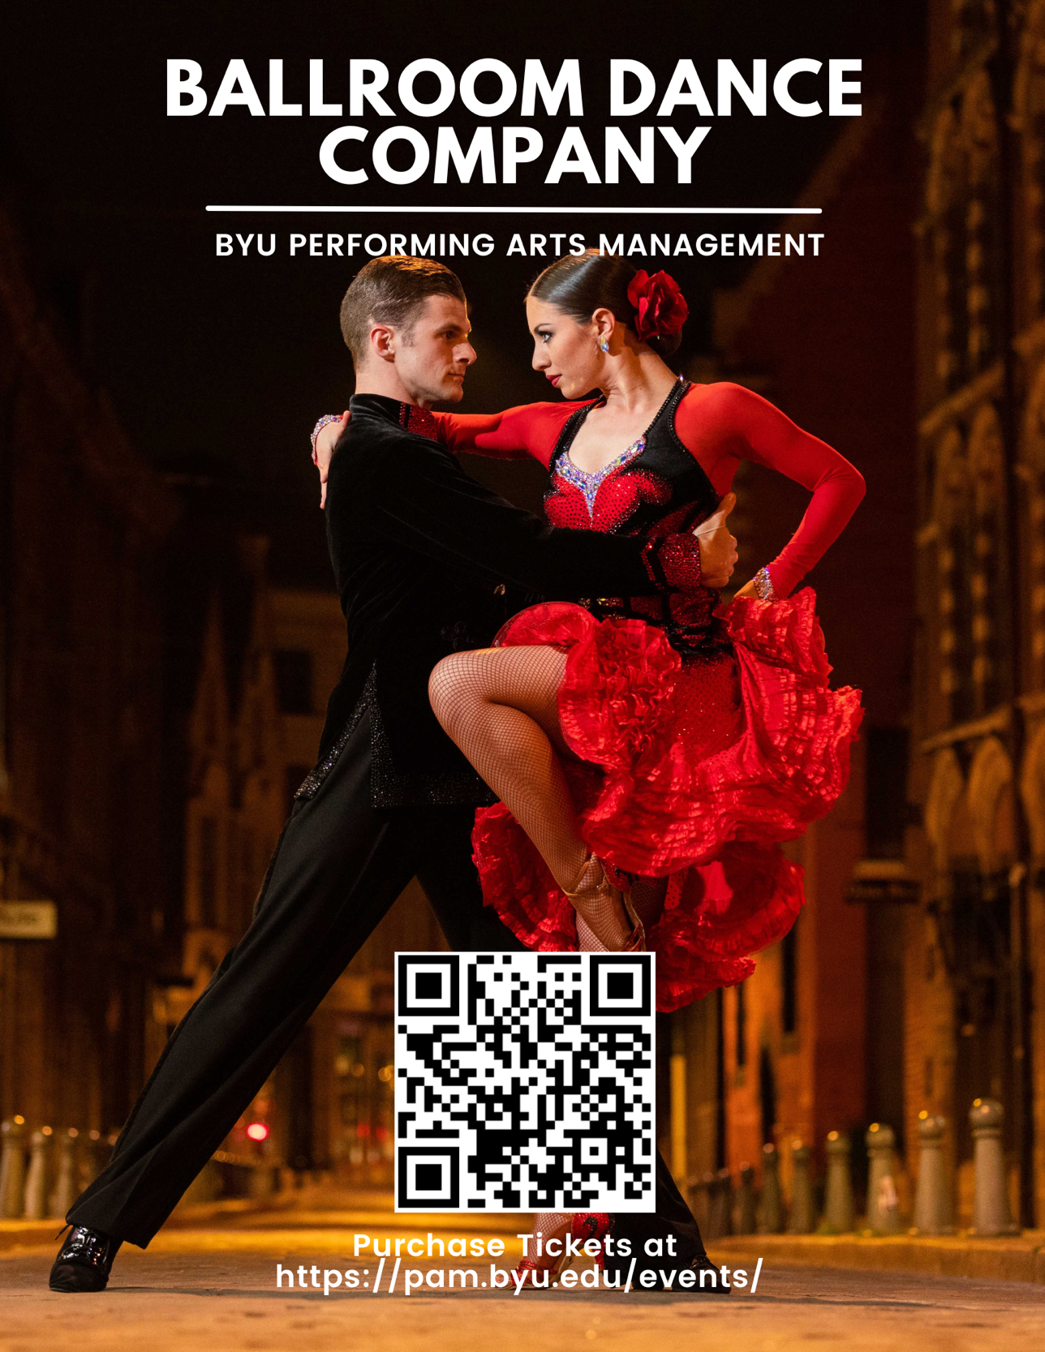
(NAME OF PERFORMANCE VENUE)
(Day of Week), (Date), at (Time)
Tickets: $(Price)

