
News Release Theatre Ballet
2023-2024 Season 801-422-3576 | pam.byu.edu
Performing Arts Management

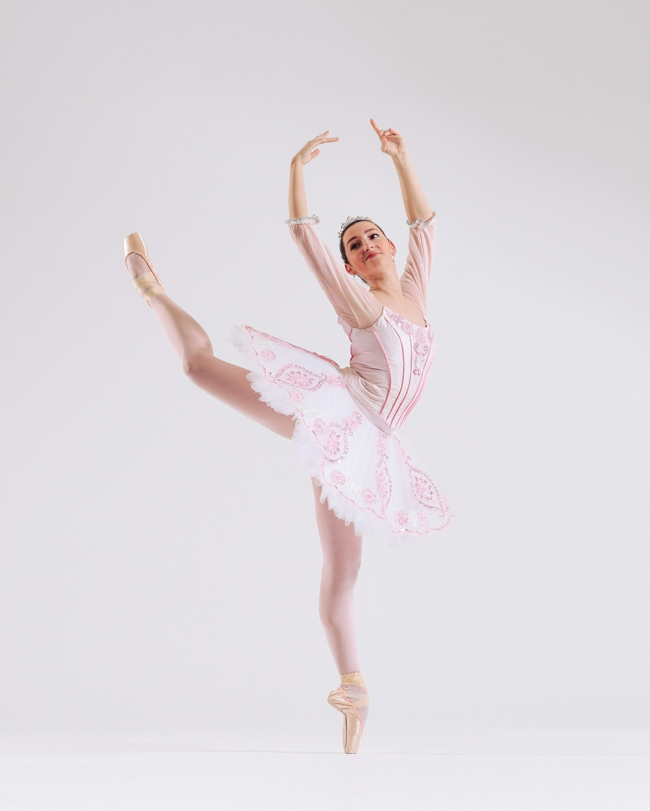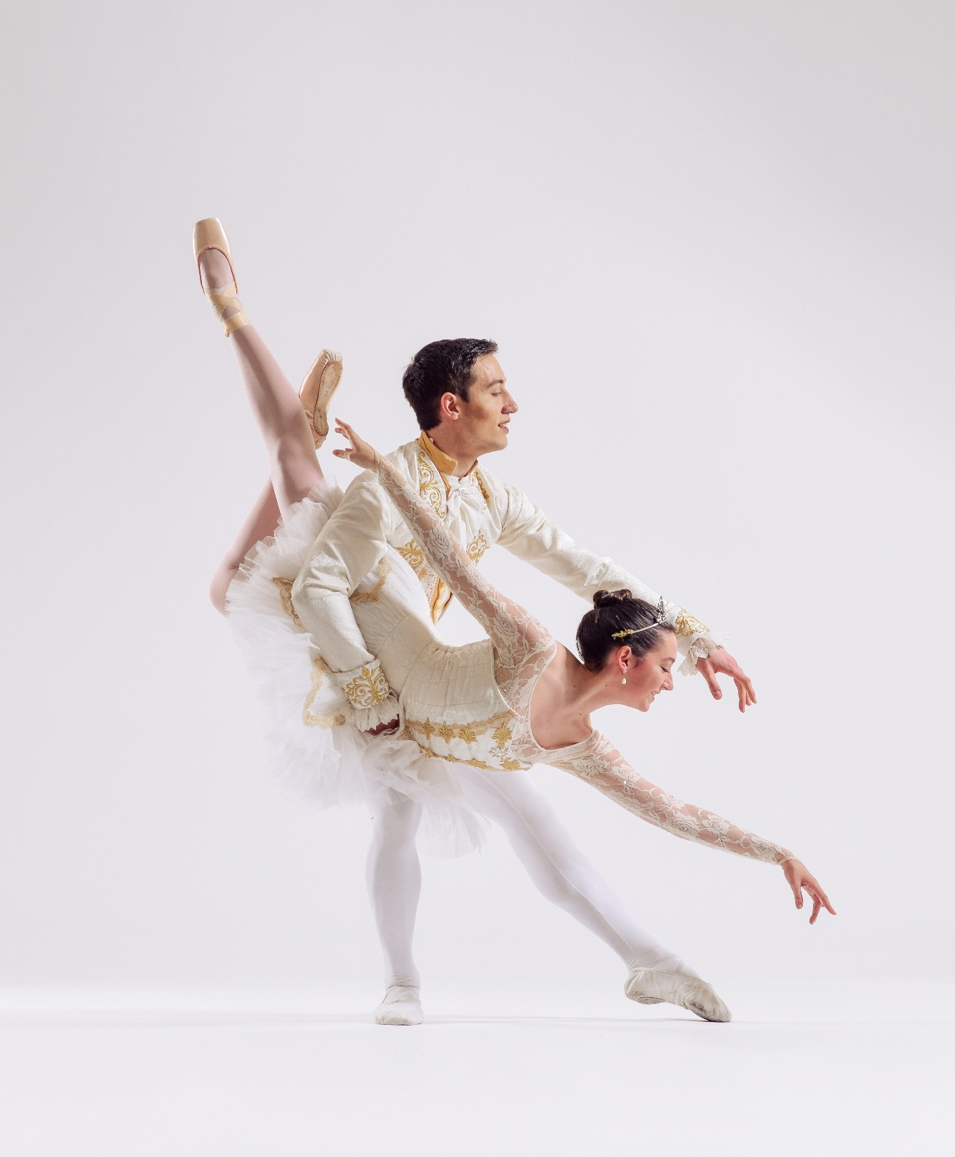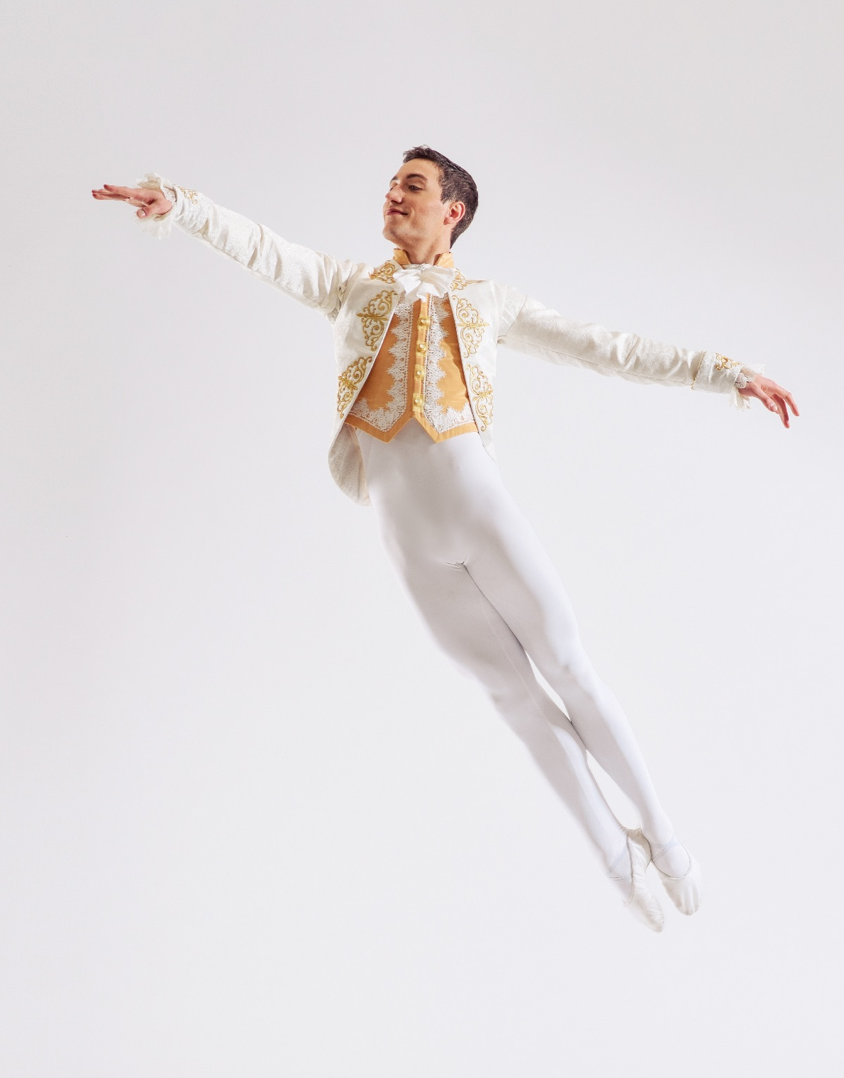

FOR IMMEDIATE RELEASE

(To get the text version of this file, visit pam.byu.edu/theatre-ballet)

BYU Theatre Ballet Exhibits Artistic Excellence

BYU Theatre Ballet exists to foster love and appreciation for ballet, recognizing it as an
artistic means of expression and communication. Striving for unequivocal excellence, Theatre Ballet seeks to be a gospel- oriented catalyst for students to achieve their highest potential. In seeking excellence, Theatre Ballet performs full-length story ballets in addition to works by George Balanchine, Gerald Arpino, Paul Taylor, Eva Stone, and José Limón. Original works are also choreographed on the company by visiting choreographers and BYU professors. BYU Theatre Ballet students participate in numerous study abroad experiences where the students study at the Hamlyn Ballet school in Florence, Italy and La Scala Theatre Ballet School in
Milan, Italy. Classes include Cecchetti-method ballet technique, Baroque dance, and contemporary styles.



Theatre Ballet

BYU Theatre Ballet is Brigham Young University’s mainstage ballet performing company. Students in BYU Theatre Ballet regularly perform on campus in traditional full-length classical ballets (including Swan Lake, Giselle, and The Sleeping Beauty) and innovative contemporary choreographic works. BYU Theatre Ballet also works closely with The George Balanchine Trust and The Gerald Arpino Foundation to provide students opportunities to perform masterworks from these influential choreographers. In recent years, Theatre Ballet has performed Balanchine’s Serenade and Walpurgisnacht Ballet, as well as Arpino’s Confetti, Birthday Variations, Reflections, and Viva Vivaldi. Through these experiences, students work closely with professional répétiteurs, further developing their technique and artistic expression. Additionally, BYU Ballet has been host to several masterclasses from incredible artists and educators including Cameron Basden, Christina Johnson, Melinda Howe, Kevin Thomas, Michael Bearden, Christina Hampton, and the late Debby Hadley. Students also develop their technique and receive professional feedback as they participate in American Ballet Theatre Student Examinations. Theatre Ballet students have unique opportunities to perform off campus. In the fall of 2023, Theatre Ballet was the only university program invited to perform at the Arpino Centennial Celebration in Chicago where they performed Arpino’s Viva Vivaldi. Members of Theatre Ballet have performed and received honors at the Puerto Rico Classical Dance Competition, the Women in Dance Leadership conference in Pennsylvania, and regionally at The Ballet Alliance festivals for the past many years where students are able to take master classes, educational courses, and perform. Selected students also have the opportunity to present their original choreography at The Ballet Alliance festivals and receive feedback from professional adjudicators.
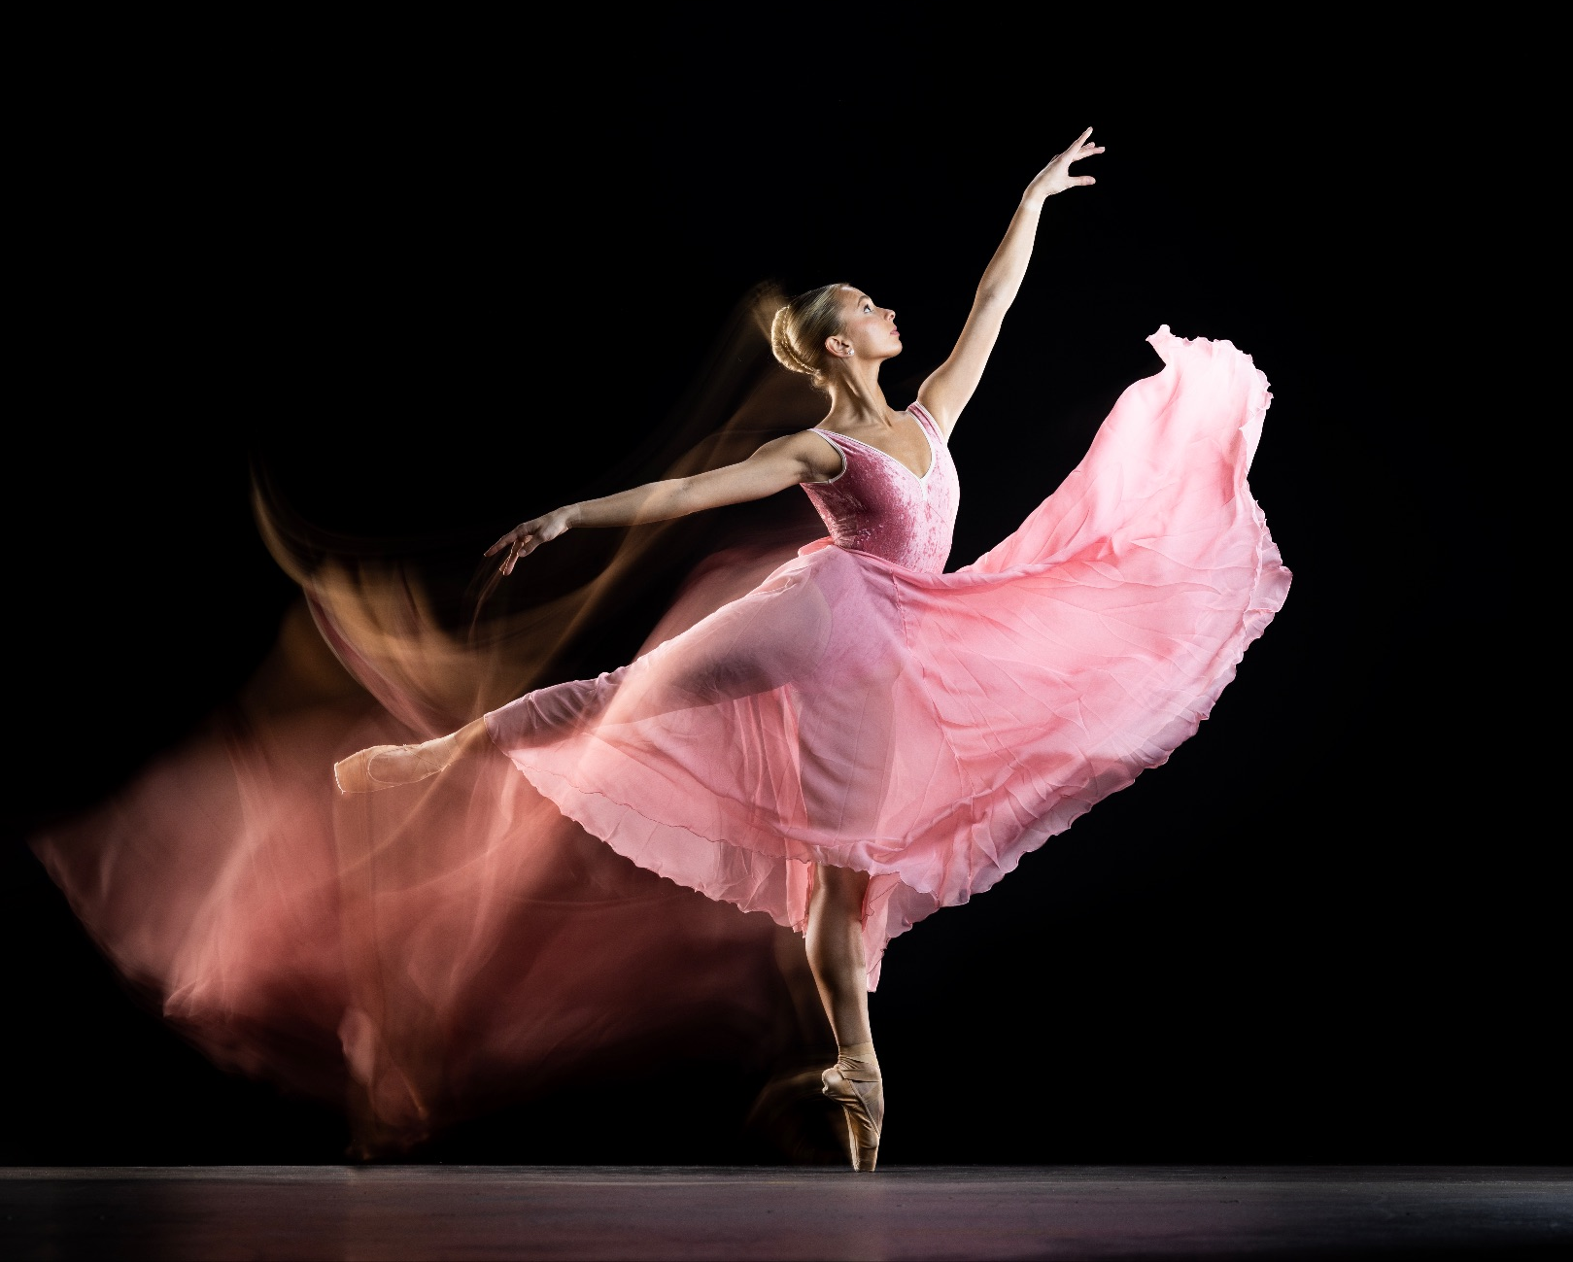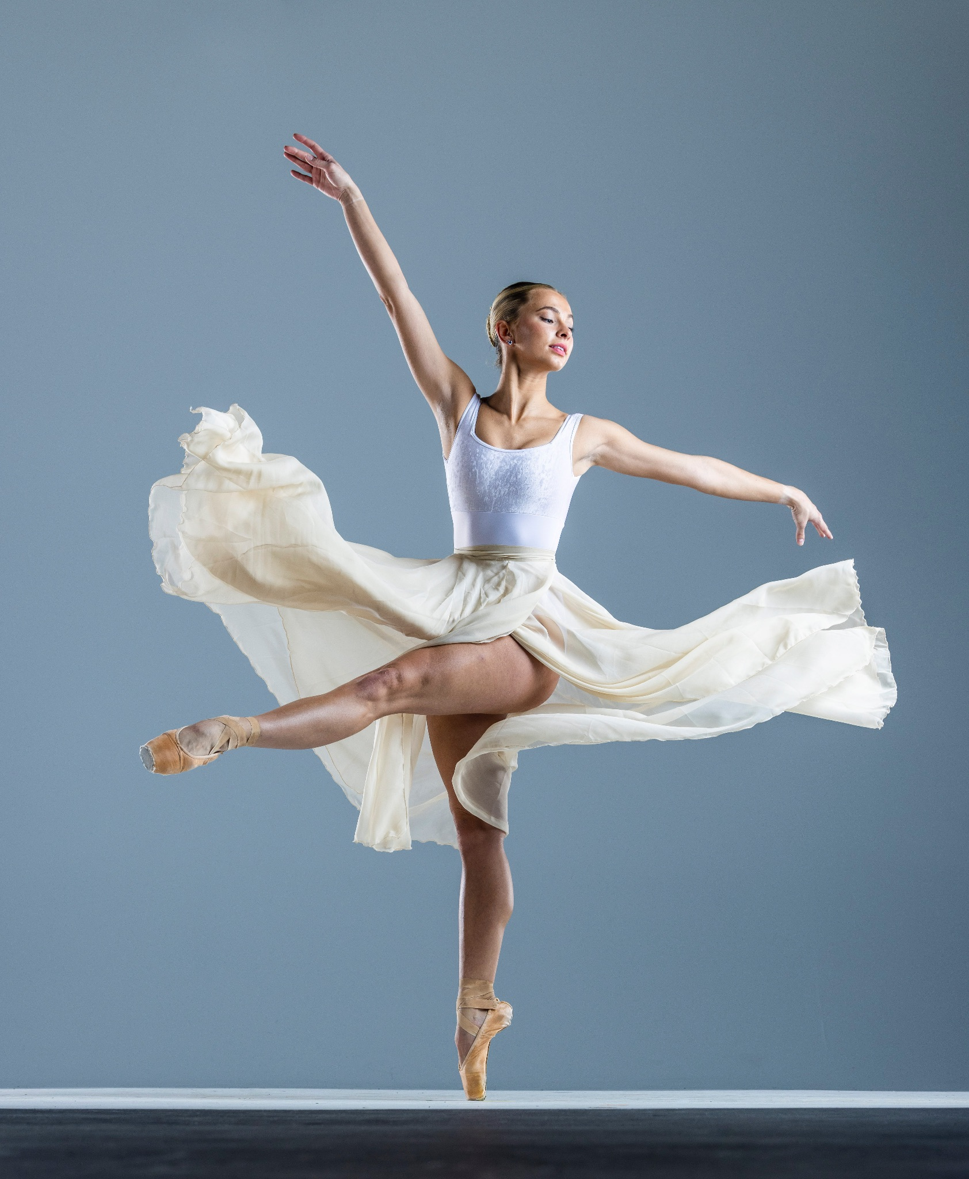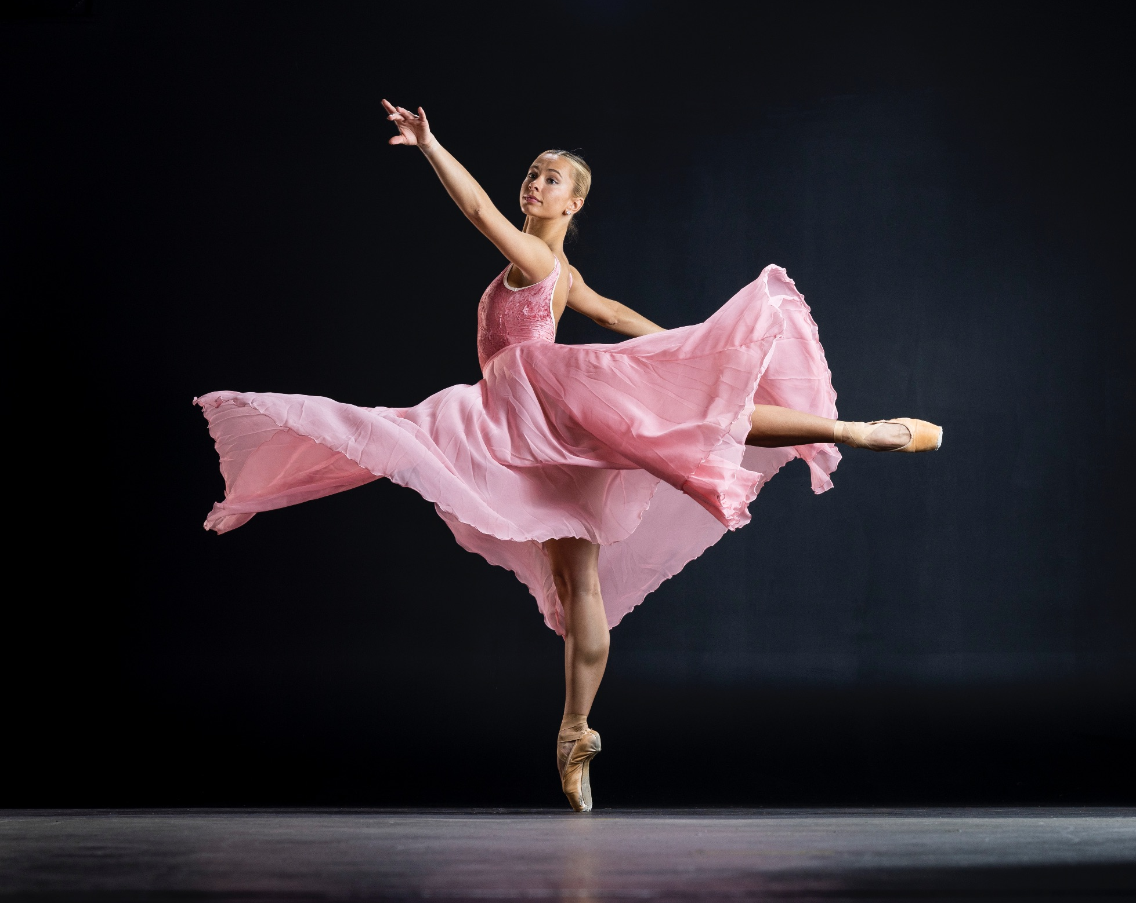

Theatre Ballet has created three dance films in recent years. Department of Dance Chair
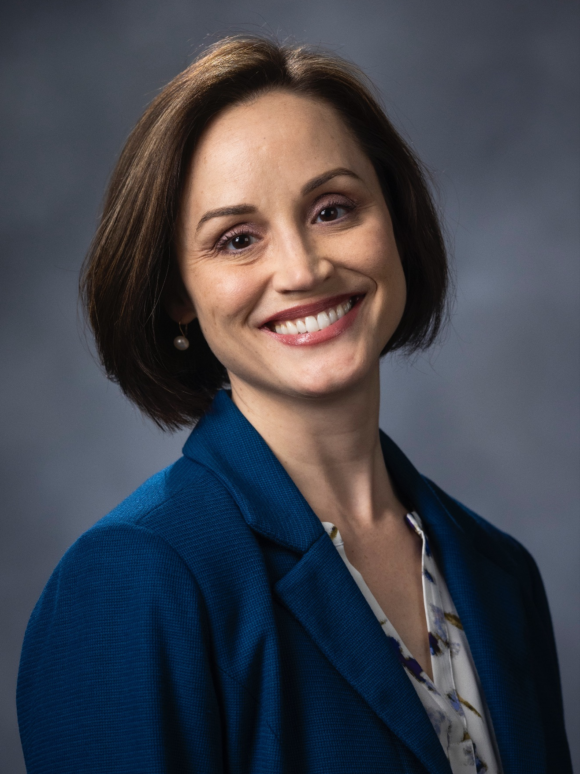
Shayla Bott worked with Theatre Ballet members and the BYU School of Music to create her film Tutti featuring her original choreography. Theatre Ballet director Ashley Parov worked as the producer and choreographer for the film Giselle, presented at the Utah Dance Film Fest, the New York Arts & Entertainment Film Festival, and the Experimental Dance and Film Festival. Ashley Parov also collaborated with choreographer Eva Stone to create a film centered around Stone’s original choreography entitled O Dear Blossom.

Artistic Director

Ashley Ivory Parov began her early ballet training under the tutelage of Richard Cammack and Zola Dishong at the Contra Costa Ballet Centre in Walnut Creek, California. Ms. Parov spent her youth training under some of the country’s most notable teachers and subsequently joined the San Francisco Ballet as an apprentice at the age of 17. After three years at SFB, Ms. Parov came to Brigham Young University to pursue her BA in Dance. Upon graduation, she returned to the San Francisco Bay Area to join Company C Contemporary Ballet. While at Company C, Ms. Parov danced lead roles in works by Twyla Tharp, David Parsons, CharlesAnderson, Val Caniparoli, Michael Smuin, Amy Seiwart, and Lar Lubovich. Ms. Parov is a certified Pilates instructor. Ms. Parov’s current teaching assignments include BYU’s Theatre Ballet, pas de deux, and pilates Mat and reformer classes. As a self-proclaimed ballet nerd, Ms. Parov especially enjoys continuing education in ballet pedagogy.
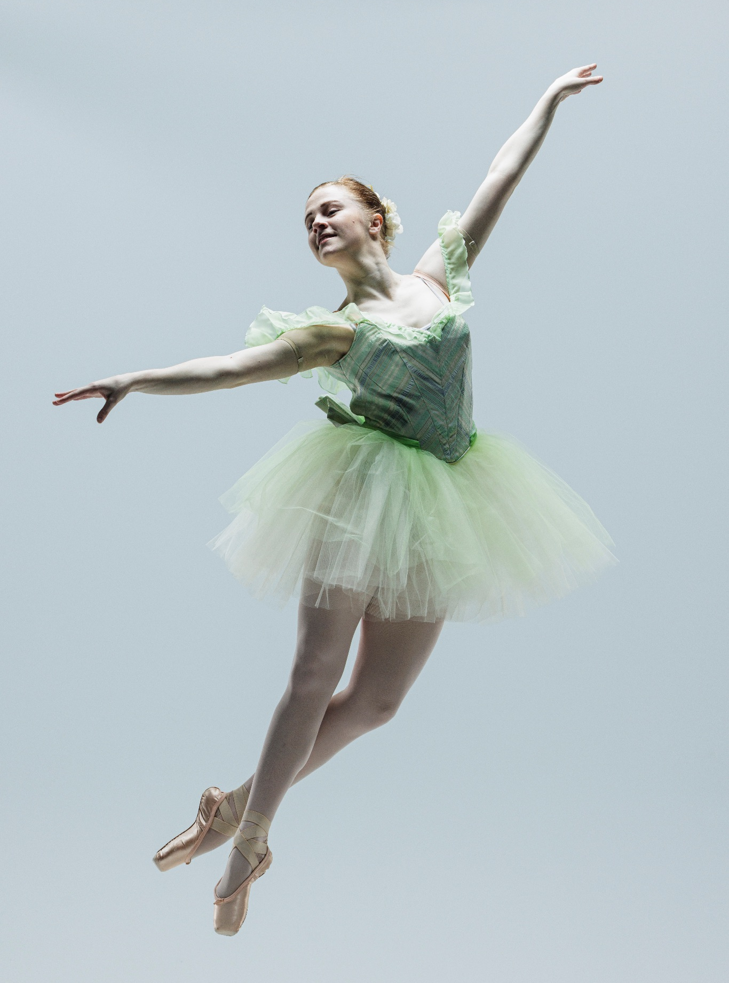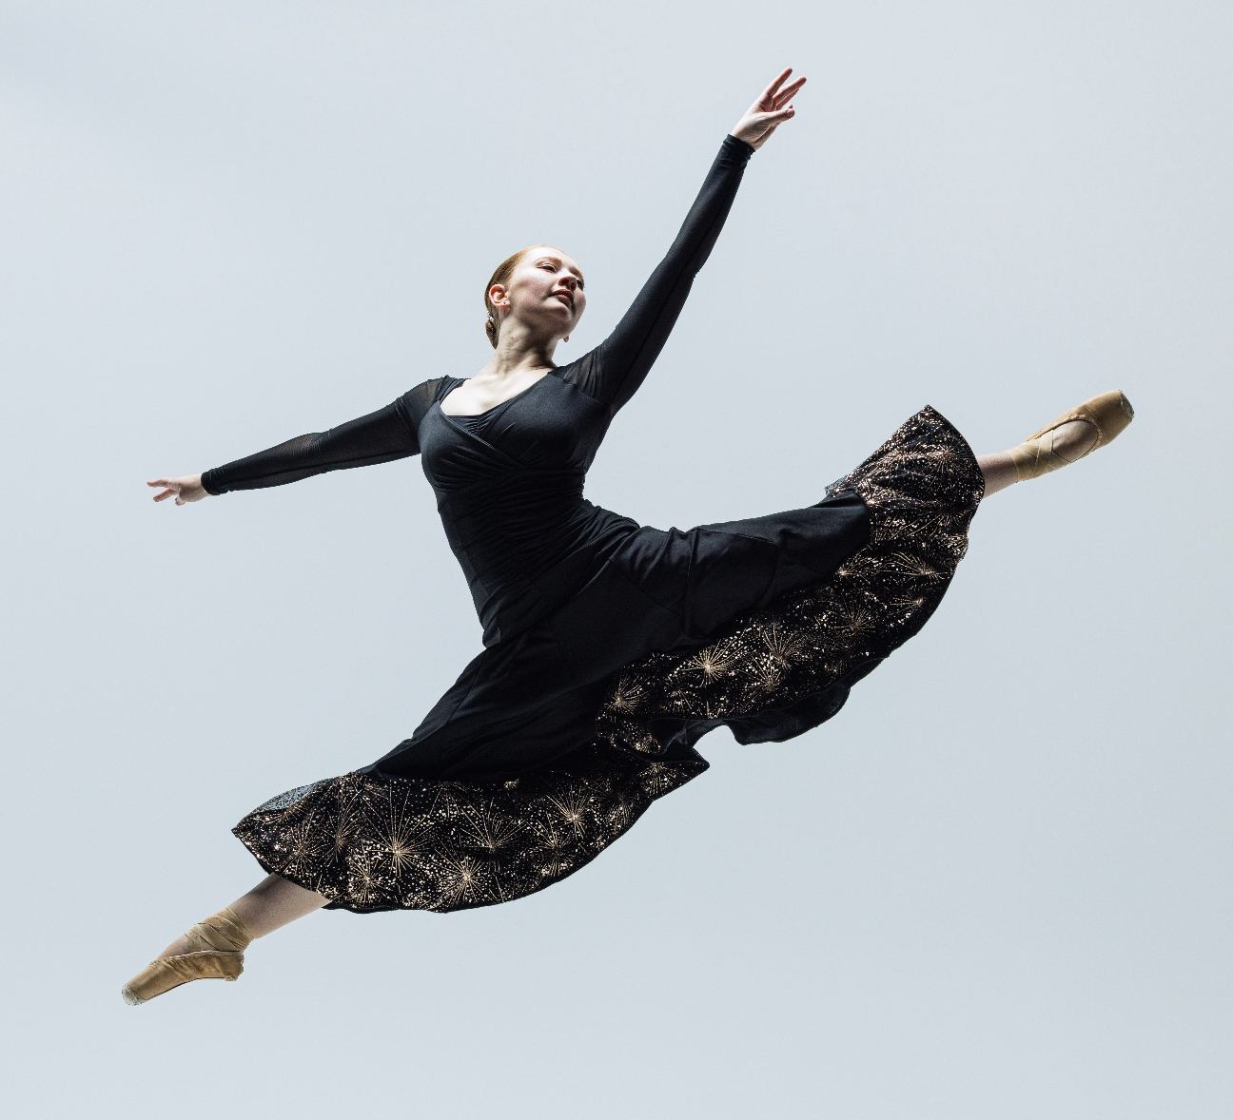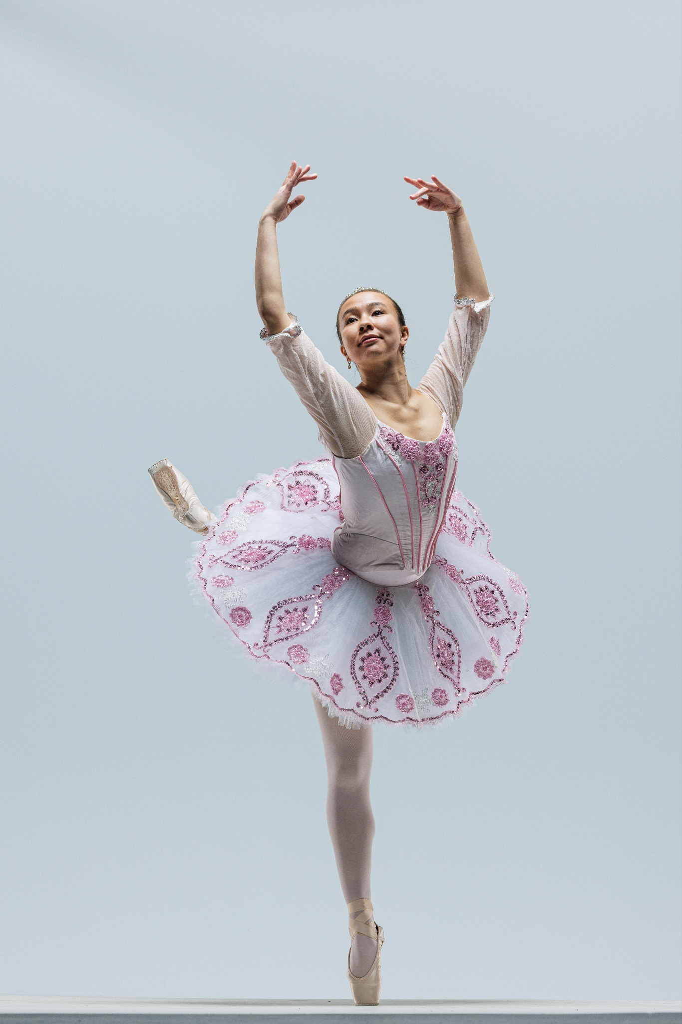

Upcoming Performances

March 9, 2024 at 7pm
Conference Center Theater
Salt Lake City, UT

Artist Manager Performing Arts Management Theatre Ballet
Karson Denney 306 Hinckley Center originates in the Department of
801-422-3575 Provo, UT Dance in the College of Fine Arts karson_denney@byu.edu 801-422-3576 and Communication at Brigham
perform@byu.edu Young University in Provo, Utah.
pam.byu.edu

