
News Release BYU Singers
2023-2024 Season 801-422-3576 | pam.byu.edu
Performing Arts Management

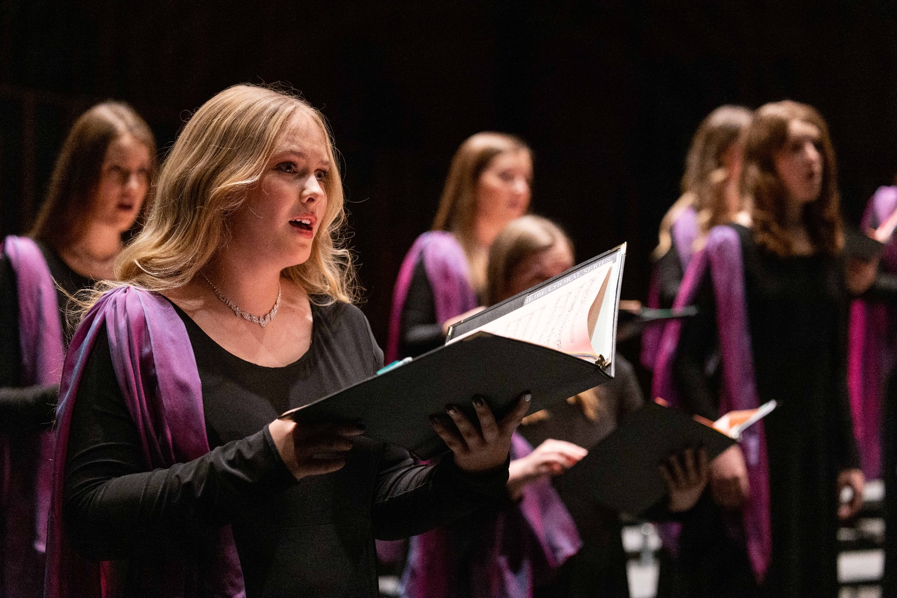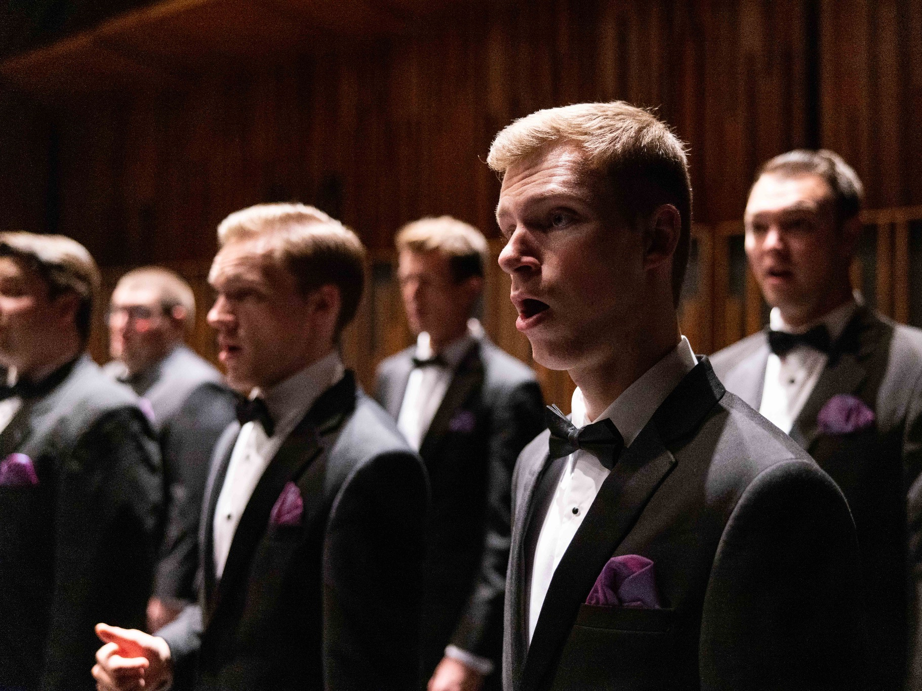

FOR IMMEDIATE RELEASE

To get the text version of this file visit https://pam.byu.edu/ensembles/byu-singers

World Renowned Choral Ensemble to Appear in Concert

Directed by Dr. Andrew Crane, BYU Singers receives enthusiastic responses for its remarkable artistry and distinctive style. Since its formation in 1984, the ensemble has attracted international acclaim for spellbinding performances of music from a variety of genres, ranging from Renaissance motets to folk songs and spirituals. They recently released a new music video on youtube singing “It’s You I Like” and have many others on the platform that showcase their talent. In May 2024 BYU Singers will take their skill and perform at the Cork International Choral Festival in Ireland.
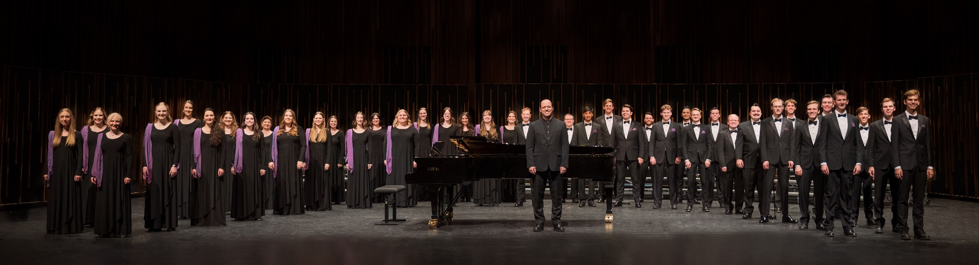

BYU Singers
The choir has performed in five continents and 28 countries including Russia, Romania, Vietnam, Austria, Indonesia, China, Italy, Israel, Egypt, New Zealand, and South Africa. In 2023, the group had performances in the Northwest United States and part of the choir made it to the Caribbean and led choral workshops on Guadeloupe Island before closing their time with a concert that brought the community and BYU Singers together for a beautiful night of song. In 2022, they performed as part of "An Evening with Eric Whitacre and the BYU Choirs,” were invited to perform at the 22nd International Stasys Šimkus Choir Competition in Lithuania, and competed in the 53rd Tolosa Choral Contest, where they also received multiple prizes and cash awards in Spain. In 2021, the choir appeared with Broadway legend Brian Stokes Mitchell at the BYU Spectacular! BYU Singers also placed first in 2020 in the mixed choir category, and earned the overall Gran Prix award in the International Youth Choir Festival "Aegis Carminis."
The ensemble has received numerous awards and honors for performances given in choral festivals, at exclusive conferences, and in some of the most prestigious concert halls in the world. Former Director of Choral Studies at Northern Arizona University, Dr. Edith A. Copley, stated "I was very impressed with the choir's beautifully blended sound, clear diction, and expressive phrasing. Well-connected tone and impeccable intonation were present in every selection. Dr. Crane is a very fine conductor whose gestures free the voice and literally choreograph the music." BYU Singers consists of 40 students pursuing a variety of graduate and undergraduate degrees in such areas as physical science, law, accounting, social science, visual arts, and music.


Artistic Director
Andrew Crane joined the BYU faculty in 2015, where his main duties include conducting the Brigham Young University Singers and teaching courses in the graduate conducting curriculum. Previous to this appointment, he served for four years as Director of Choral Activities at East Carolina University, and six years in the same position at California State University, San Bernardino. He is also the former choral director at Provo High School.
Choirs under his direction have appeared by invitation at numerous state, regional, and national conferences of the American Choral Directors Association, National Association for Music Education, and National Collegiate Choral Organization. Recent examples include the 2022 ACDA Western Division conference in Long Beach, CA, the 2019 ACDA national conference in Kansas City, MO, the 2020 ACDA Western Division conference in Salt Lake City, UT, and the 2017 NCCO national conference in Baton Rouge, LA.
In May 2022 Dr. Crane led the BYU Singers to multiple first place prizes at the 22nd International Stasys Šimkus Choir Competition (Klaipėda, Lithuania), including the Grand Amber award for best choir; as well as first place in the Mixed Choir division and overall Grand Prix winners in the 2020 International Youth Choir Festival “Aegis Carminis” (Koper, Slovenia). In 2015, he conducted the East Carolina University Chamber Singers to first place honors at the 13th Maribor (Slovenia) International Choral Competition Gallus, and in 2012 the same ensemble, under his direction, was named winner of The American Prize in Choral Performance, College/University Division.
Additionally, Crane has enjoyed a secondary career as a professional ensemble tenor, having appeared with such groups as Seraphic Fire, Santa Fe Desert Chorale, Yale Choral Artists, Spire Chamber Ensemble, Carnegie Hall Festival Chorus, and many others. As a soloist, he has performed the tenor roles in much of the standard concert repertoire for chorus and orchestra.
Active as a conductor of honor choirs, clinician, adjudicator and presenter, Crane has appeared in these capacities in 20 U.S. states as well as in Switzerland, China, Indonesia, Vietnam, and the French Caribbean. In addition, Crane curates a choral series under his name through Walton Music. He and his wife Casandria (also a BYU alumna) reside in American Fork, UT and are the parents of four children.

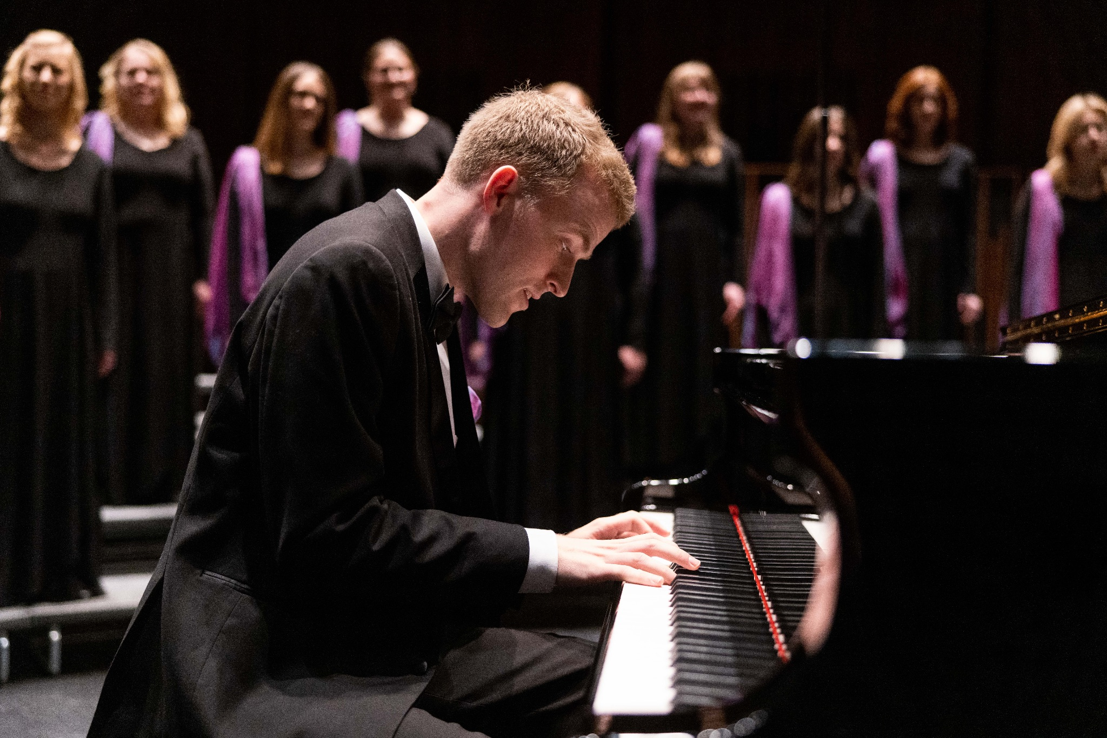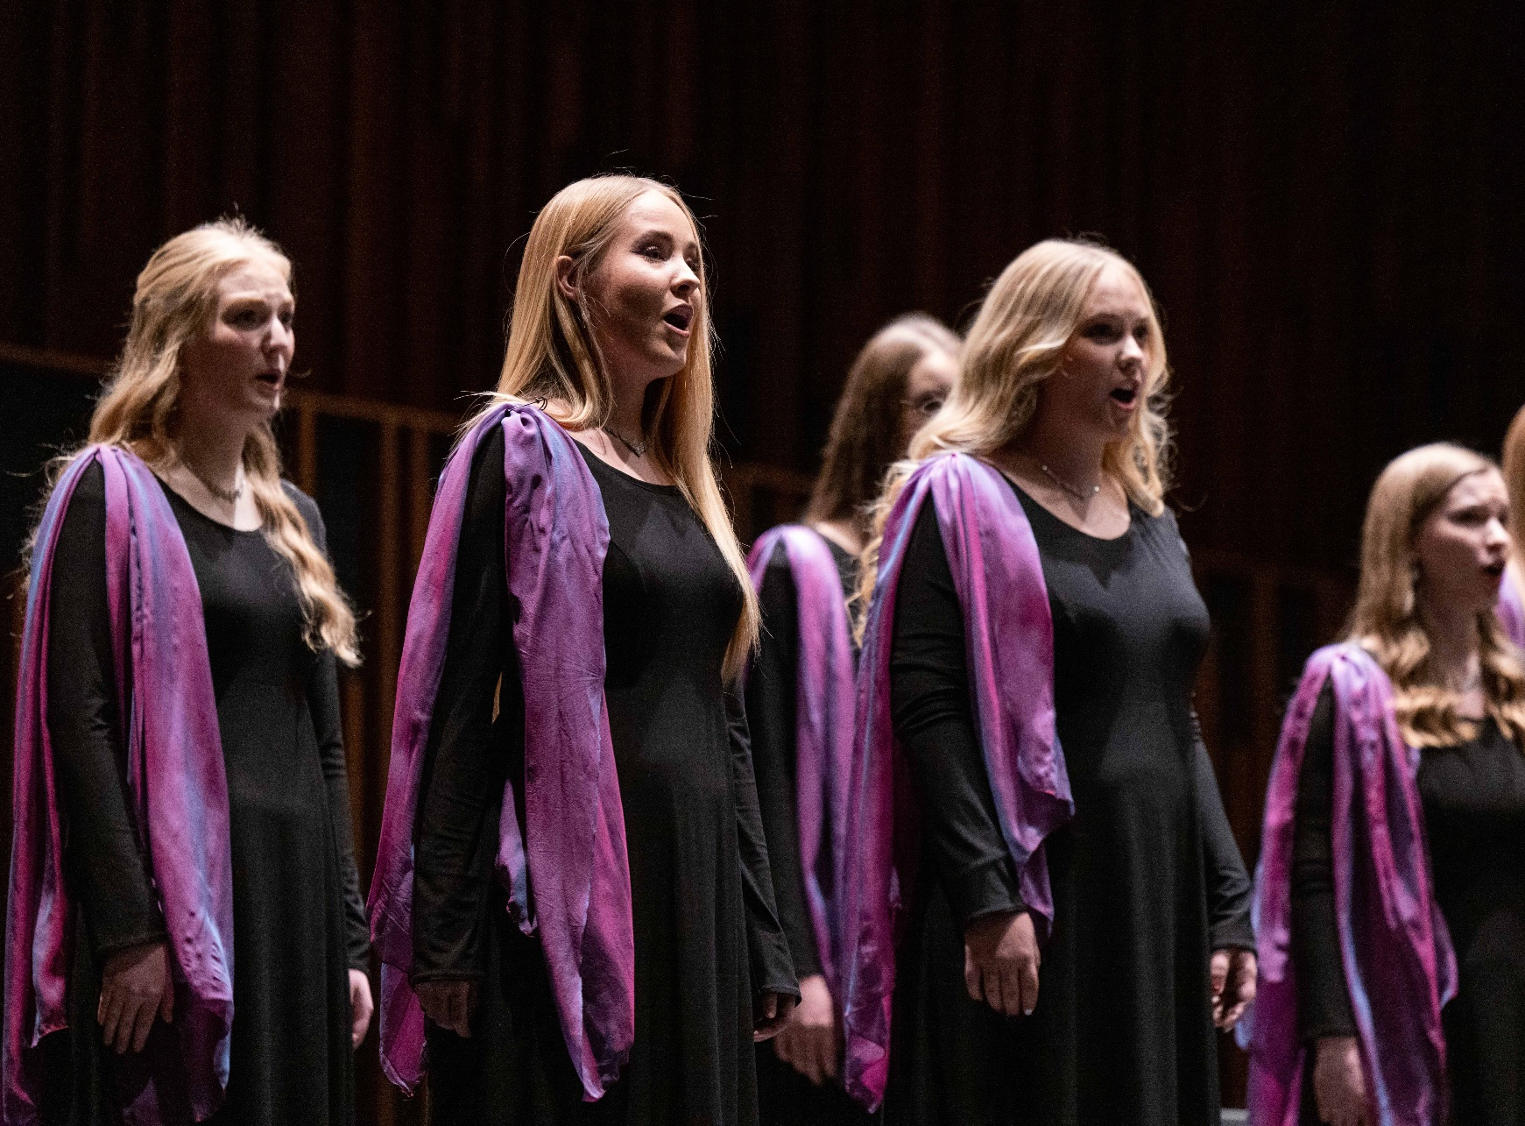

Upcoming Performances

March 13, 2024 at 7:30pm
Concert Hall
School of Music Building
Provo, Utah

May 1-5, 2024
Cork International Choral Festival
Cork, Ireland

Artist Manager Performing Arts Management BYU Singers
Stacey Christensen 306 Hinckley Center originates in the School of Music
801-422-3574 Provo, UT in the College of Fine Arts stacey_christensen@byu.edu 801-422-3576 and Communication at Brigham
perform@byu.edu Young University in Provo, Utah.
pam.byu.edu

