

News Release

2025-2026 Season

Women's Chorus
Performing Arts Management
801-422-3576 | pam.byu.edu

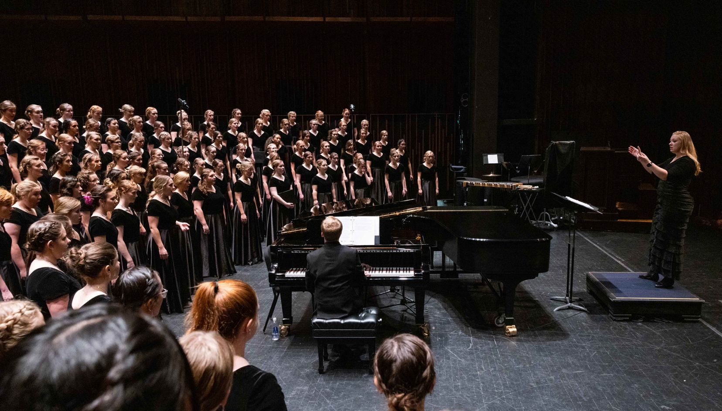

FOR IMMEDIATE RELEASE

(To get the text version of this file, visit pam.byu.edu/womens-chorus)

The Elegant Voices of Women’s Chorus
Comprised of more than 180 members, the Brigham Young University Women’s Chorus never ceases to provide meaningful artistic and spiritual experiences for its singers and audiences. Under the direction of Dr. Sonja Poulter, the ensemble honors the female voice by showcasing their incredibly focused technique and well-rehearsed sound in a diverse repertoire. The BYU Women’s Chorus recently released a music video for “Abide With Me.”

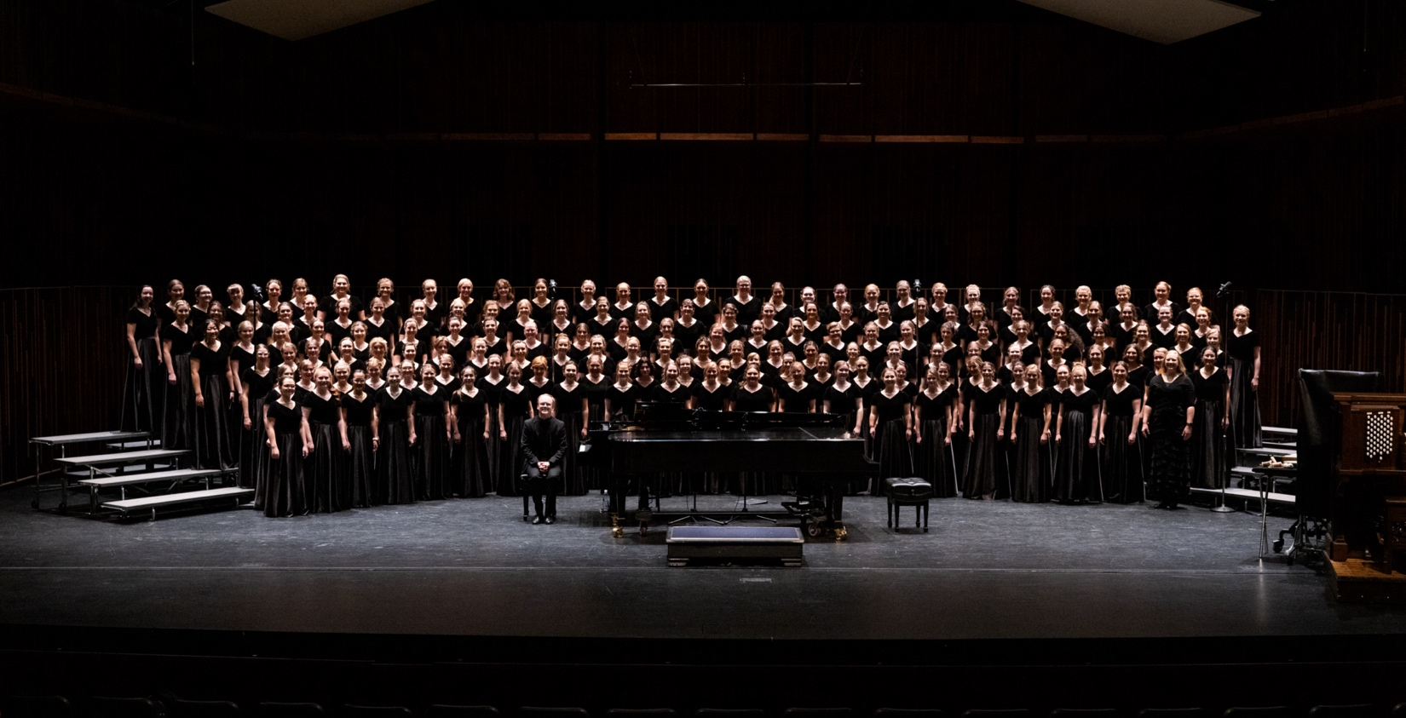

Women's Chorus

Women’s Chorus continues to garner attention from domestic and international audiences as it showcases a harmonious blend of voices and depth of sound. BYU Women’s Chorus is held in very high esteem as they have been featured, on multiple occasions, in the American Choral Director’s Association, a national group, that holds conventions both regionally and nationally each year.
The choir has released three full length albums and their repertoire is from all eras and styles, meant to spotlight beauty in word and music. Diversity of genre and voice allows the choir to produce a range of musical experience from soothing reverence to full-bodied resonance. The choir empowers the divine attributes of women alongside the skillful creation of music to empower its singers and audiences in peace-finding and faith-promoting experiences.
Women’s Chorus is one of four prestigious auditioned choirs at Brigham Young University. Women’s Chorus welcomes aspiring singers from all majors with significant choral experience, holding auditions annually.

Artistic Director

Dr. Sonja Poulter is an adjunct faculty member in the Choral Conducting and Ensembles Division and was named director of BYU Women’s Chorus in 2019. A native to Germany, Dr. Poulter previously received undergraduate degrees in Music Education, Musicology, and English at the University of Music and Performing Arts and Goethe Universities in Frankfurt, Germany. She obtained her Master of Music Degree and Doctor of Musical Arts in Choral Conducting and Vocal Performance, having studied under Dr. Barlow Bradford and Professor Kiersten Gunlogson at the University of Utah.

Before her appointment at BYU, Dr. Poulter maintained a large vocal studio and remains a highly sought-after vocal instructor and diction coach. She is a choral clinician and adjudicator for secondary school chairs and community ensembles in great demand.

As the founder and conductor of the Kammerchor Vocalis, and acclaimed ensemble of Latter-day Saint Young Single Adults in Europe, she has performed all over Germany, and in cities such as Salzburg, Paris, London, Copenhagen, Prague, Budapest, and Zurich. She co-founded the AMAVI Chorale, a project-based chamber ensemble with highly trained and experienced choral singers from along the Wasatch Front. The ensemble has established a reputation of innovative programming, refined sound, and expressive artistry. She presently serves as the conductor and artistic director.

Additionally, Poulter enjoys a career as a mezzo-soprano, performing as a soloist as well as a member of various choral ensembles, including the Tabernacle Choir at Temple Square.

Dr. Poulter serves on the Hymnbook Committee of the Church of Jesus Christ of Latter-day Saints and cheerfully resides in Draper, Utah with her husband and a BYU Men’s Chorus alumnus, and their son, Samuel.

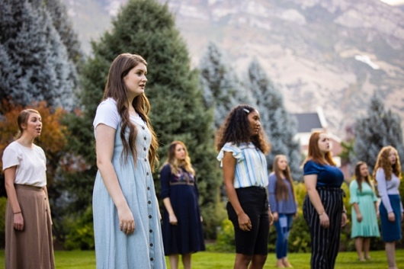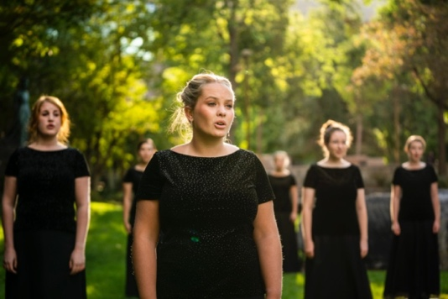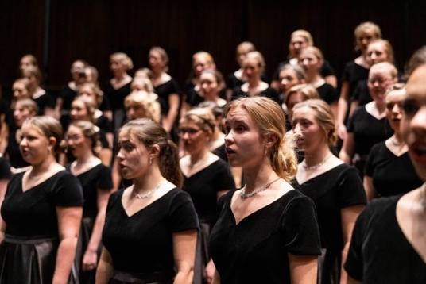

Upcoming Performances

BYU Women’s Chorus will join with the BYU Men’s Chorus, Concert Choir, BYU Singers, and the Philharmonic Orchestra for the Celebration of Christmas on December 5-6, 2025 at the Music Building.

Artist Manager
Stacey Christensen
801-422-3574
stacey_christensen@byu.edu

Performing Arts Management 306 Hinckley Center
Provo, UT 801-422-3576
perform@byu.edu pam.byu.edu

Women’s Chorus
originates in the School of Music in the College of Fine Arts and Communications at Brigham Young University in Provo, Utah.

