
News Release Wind Symphony
2023-2024 Season 801-422-3576 | pam.byu.edu
Performing Arts Management

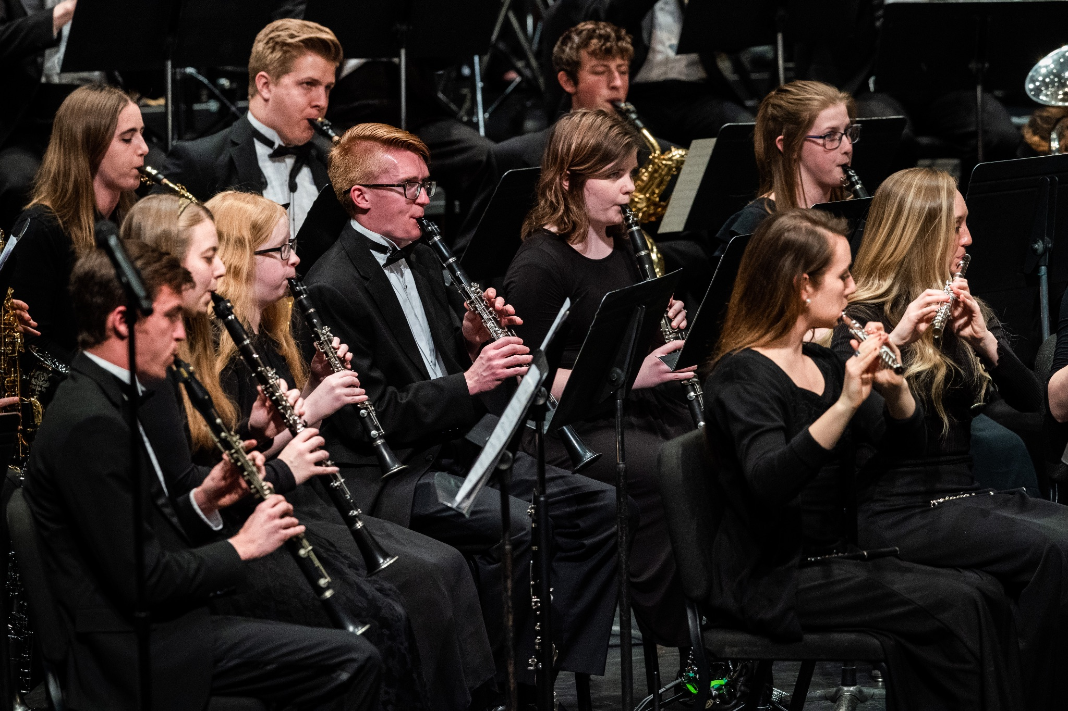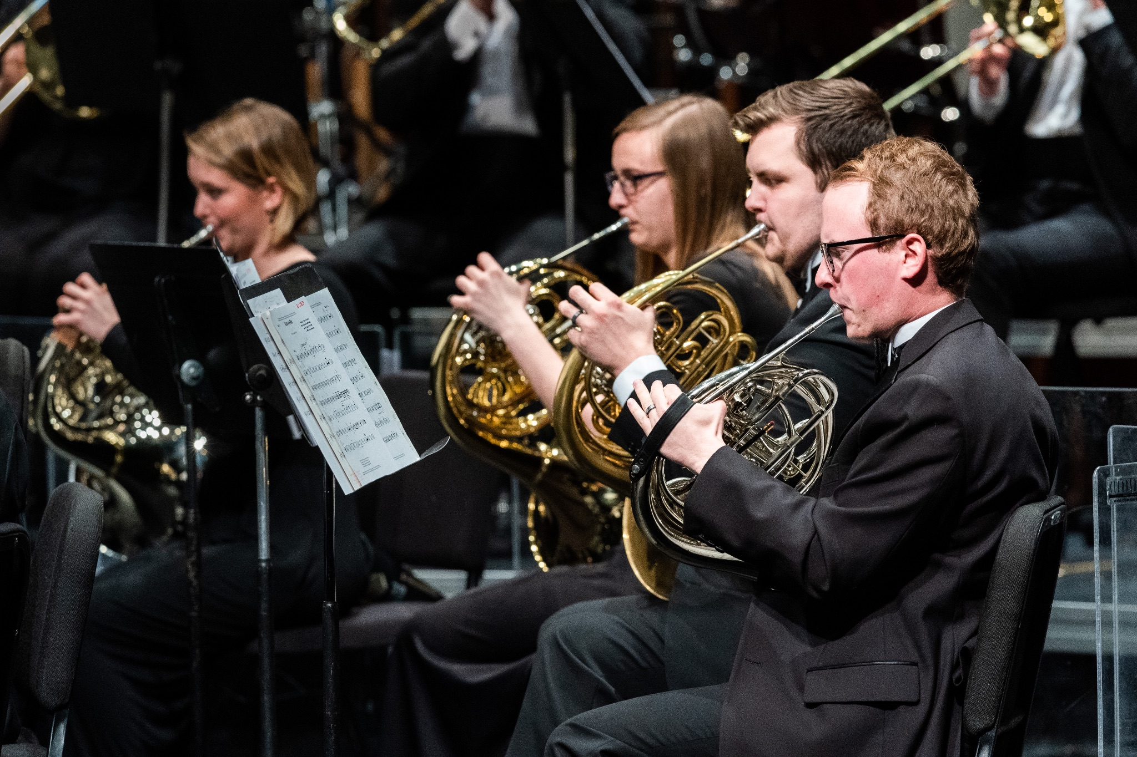

FOR IMMEDIATE RELEASE

To get the text version of this file visit https://pam.byu.edu/ensembles/wind-symphony

BYU Wind Symphony Dazzles with Mighty Sound

Wind Symphony is Brigham Young University’s premier wind ensemble comprised of the top 50 wood- wind, brass, and percussionists at the university. It is also one of America’s most traveled collegiate wind bands. Led by director Shawn Smith, the band performs a variety of genres that have wide appeal to most audiences. The BYU Wind Symphony’s extensive repertoire includes pieces from classical and modern composers such as John Philip Sousa, Dmitri Kabalevsky, Leroy Anderson, and Bruce Broughton. BYU Wind Symphony provides an exhilarating musical experience with the sounds that transport listeners to distant lands and cultures.
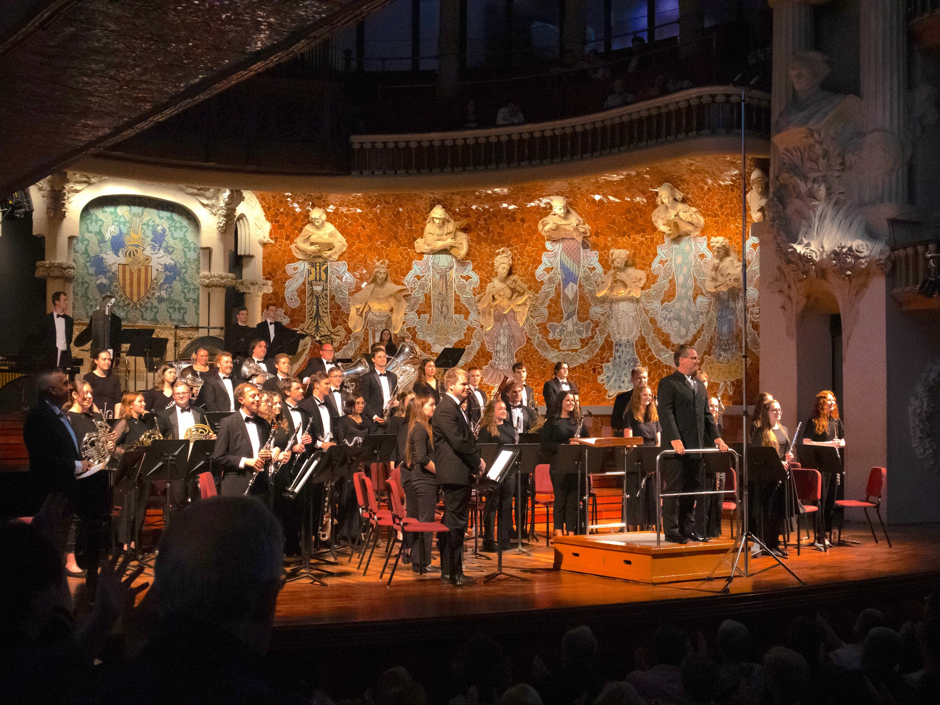
Wind Symphony
The BYU Wind Symphony is one of America's most traveled wind bands. The ensemble has performed in Asia, Europe, the South Pacific, and the Baltic states. In February 2024 the band had two amazing performances, as they performed in a sold out show with world-renowned trombonist Joseph Alessi and soon after with four-time Grammy Award-winning contemporary chamber ensemble, Eighth Blackbird. In July 2024 the group looks forward to being a featured performer of the World Association of Symphonic Bands and Ensembles (WASBE) convention in Korea.
Some of BYU Wind Symphony's prior tours include travels to Germany, Netherlands, Belgium, and France. In May 2023, the band traveled to Spain and Portugal for a two-week extended performance tour. In November 2023 Wind Symphony performed a sold out show with Tony-nominated Derek Klena. Other notable accomplishments of BYU Wind Symphony is they were invited to perform in the 850th anniversary of Freiberg, Germany as well as the Liberation Celebration in the Netherlands. They shared the stage with Orkest Orventus at a performance titled, “Hands Across the Sea.” The group enchanted audiences, who called for as many as three encores in some cities. New Zealand newspaper, Northeastern Telegraph, once commented, “The faultless precision and control of the players… almost made one gasp with incredulous wonder.” Due to the professional quality of Wind Symphony’s performances, the ensemble has received prestigious invitations to perform for the College Band Directors National Association and for The American Bandmasters Association. The ensemble has been given a “recommended” rating from the American National Endowment for the Arts.

Artistic Director
Brigham Young University’s Wind Symphony is led by director Dr. Shawn Smith, who recently joined BYU’s faculty in 2022.
Dr. Smith received his Doctor of Musical Arts in Instrumental Conducting from Arizona State University, and his Master of Music and Bachelor of Music Education degrees from Louisiana State University and Boise State University respectively.
In high demand as a band and orchestra conductor, clinician, and adjudicator, Smith has been invited to conduct professional and educational ensembles throughout the United States, South America, and Europe.
Smith has also been invited to conduct region and all-state bands in Arizona, Idaho, Illinois, Montana, Nebraska, North Carolina, Texas, and Utah.
Equally at home with opera and musical theater productions, Smith has conducted pit orchestras for the Marriage of Figaro and a six-week run of Les Misérables. His performances have been heard numerous times on American Public Media's "Performance Today," the most popular classical music radio program in the United States. In 2015 Smith was awarded second place for the American Prize in the Conducting-Professional Band Division. Smith has been published in the Journal of the World Association for Symphonic Bands and Ensembles and in Alta Música. He has presented his research at national and international conferences in the United States, Europe, and South America.
Smith currently resides in Utah and serves as Associate Professor of Conducting and Director of Bands in the Brigham Young University School of Music.

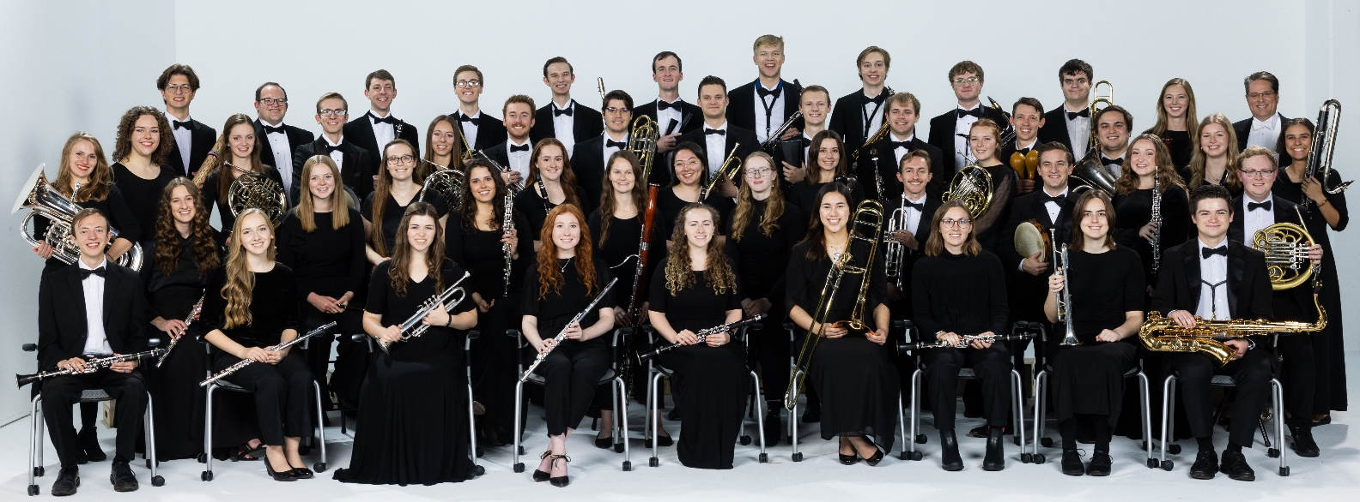

Upcoming Performances

March 8, 2024 at 7:30pm
Concert Hall
BYU Music Building
Provo, Utah

April 12, 2024 at 7:30pm
Concert Hall
BYU Music Building
Provo, Utah

July 16-20, 2024
WASBE Convention
Gwangju-Gyeonggi, Korea

Artist Manager Performing Arts Management BYU Singers
Stacey Christensen 306 Hinckley Center originates in the School of Music
801-422-3574 Provo, UT in the College of Fine Arts stacey_christensen@byu.edu 801-422-3576 and Communication at Brigham
perform@byu.edu Young University in Provo, Utah.
pam.byu.edu

