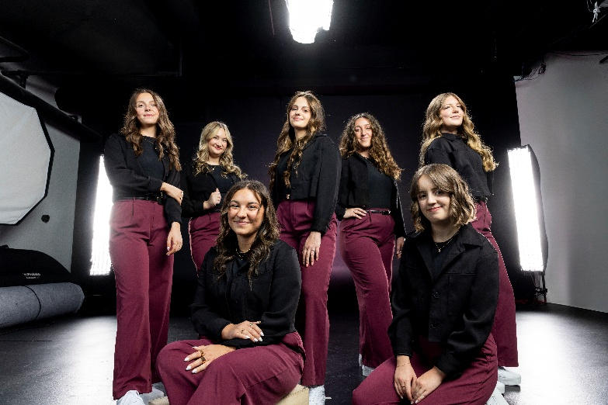
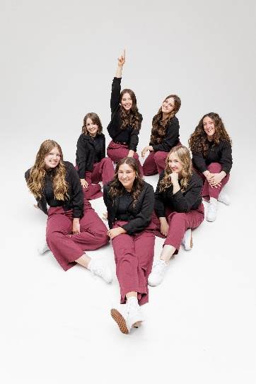

News Release
2025-26 Season

Noteworthy
Performing Arts Management
801-422-3576 | pam.byu.edu

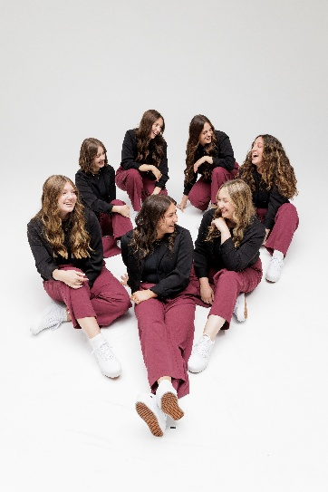

Noteworthy: No Instruments, No Problem

BYU’s top female a cappella ensemble delivers a power-packed concert that combines vocal percussion, humor, and tight harmonies. Noteworthy has appeared on NBC’s hit television show, The Sing-Off, and was crowned the International Championship of Collegiate A Cappella (ICCA) champion in 2007. Noteworthy’s varied repertoire includes everything: rock, pop, country, jazz, R&B, spiritual, and other musical styles, making them a crowd favorite. The performers take songs and rearrange them to deliver a new rendition without any accompaniment. They mimic complex instrumentation, hold a perfect pitch, and give beautiful harmony. Noteworthy is full of class and charm. All seven members are carefully selected through competitive auditions and are experts at displaying musical ability, creativity, and stage experience—resulting in original, skillful, and spirited performances. Don’t miss this talented a cappella group with amazing vocal abilities at (PLACE) on (DATE) at (TIME)
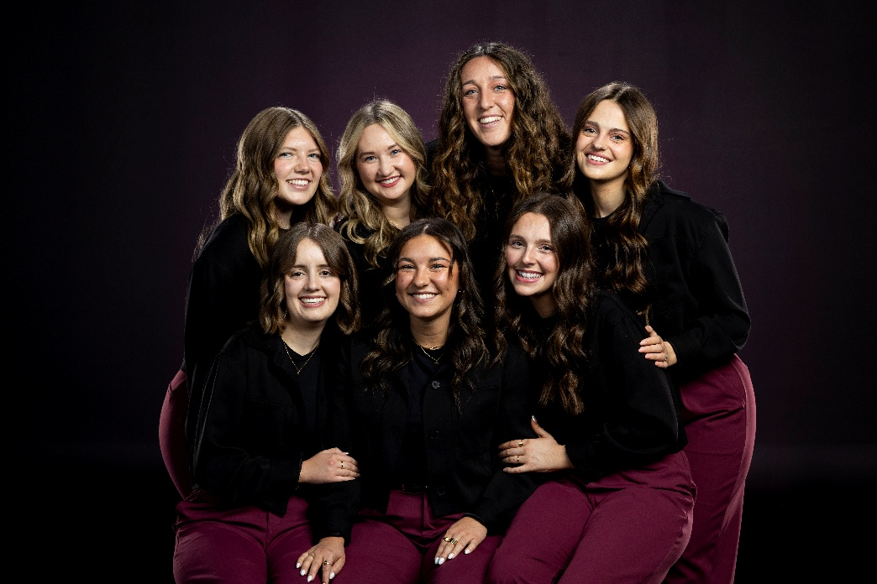

Noteworthy

In 2024 BYU Noteworthy won a Bronze Telly Award for their music video “O Holy Night”. Since then, Noteworthy has continued to pave their path to success with three CASA Awards for Best Pop Song, Best Upper Voices Collegiate Album and Best Upper Voices Collegiate Song. Their presence online is ever-growing with more than 77 million views on YouTube. Over the years they toured Texas, Alaska, Arizona, Idaho, Illinois, Nevada, Oregon, Texas, Utah, and Wyoming. In 2024, they embarked on their first international tour to South Korea, Japan, and Mongolia. Noteworthy has released several studio albums and collaborated with a wide variety of artists including violinist Keith Goodrich and the BYU Cougarettes.
By the end of the 2025-2026 season, Noteworthy will have released 2 EPS, several singles and music videos, and performed in China and the United States. This elite ensemble is looking forward to dazzling audiences for another season.



Artist Manager Karson B. Denney 801-422-3575
karson_denney@byu.edu
Performing Arts Management 306 Hinckley Center
Provo, UT 801-422-3576
perform@byu.edu pam.byu.edu
Noteworthy
Originates in the office of Performing Arts Management at Brigham Young University in Provo, Utah.

